Problem
Solving

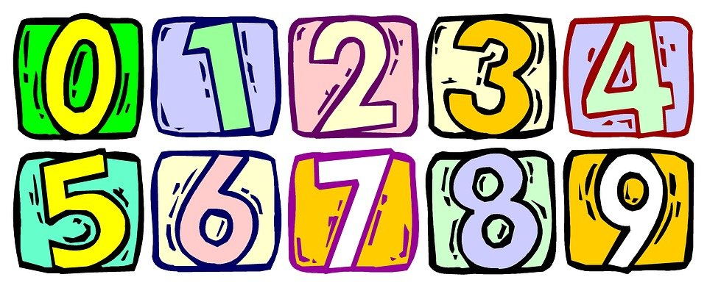

Name: ___________________

Introduction
In this booklet we aim to investigate the numerical operations of addition (adding) and subtraction (taking away) using number sentences.
This allows everyday maths to be brought to life for pupils, by visualising actual objects and using words to aid understanding of the numerical operations and processes. Creating a number story helps your child to gain practical understanding of the concepts addition and subtraction.

Word Mats
These are common words for both adding and subtracting. Throughout this booklet, your child will see these words and will be able to relate to the word mat to see which type of operation is required.

Strategies to help with worksheets
Highlighting
Your child may like to read the number sentence and highlight the operational word.
e.g. Abdul had four green bricks in his tray and he added three blue bricks . How many bricks does Abdul now have in his tray?


Sets
Abdul puts four bricks in circle one and three bricks in circle two and adds them up.

Encourage your child to use a number line or a hundred square to help them with counting forwards (on) and backwards (back).
Ensure your child uses their fingers to move along the line while counting forwards and backwards.

Number line
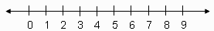

Visualisation
Encourage your child to draw out the number story, e.g. I got one star for Literacy and two stars for Numeracy. I now have ___ stars altogether.
Moving on from this, your child can use squares for larger numbers, e.g. I have twenty sweets in my bag. On the way home from school I eat 11 sweets. How many sweets have I got now? ___

take away minus
less back decrease
difference fewer
remain subtract
add plus
total increase
sum more and
many altogether
Word Mat for Addition and Subtraction
Sort the words on the next page into the correct box. Get an adult to help, if needed.

less | sum | difference
add | subtract | fewer
take away | plus | altogether
remain | add | minus
total | many | back
decrease | more | increase
Numberline
1 2 3 4 5 6 7 8 9 10
Addition Problems
  What is 4 plus 3? |   I have 6 pencils and Sam has 3. How many do we have altogether?
    I went to the shops. I got 2 apples and 6 pears. How many pieces of fruit do I have in total? | What is the sum of 9 and 1?

Subtraction Problems
Addition and Subtraction Problems
  Sam had 10 Lego people and he gave 6 away to Bob. How many has Sam got now? |   Sam had 9 coats. He put all his coats on to see which still fitted him. He had to take away 3 as they were too small. How many coats still fit him?
  I went to the park. I saw 3 small dogs and 3 large dogs. How many dogs did I see altogether? |   I have 2 blue caps, 1 white cap and 4 red caps.  How many do I have in total?
Answers
Addition
Answer 7 | Answer 9
Answer 8 | Answer 10

Subtraction
Answer 4 | Answer 5
Answer 6 | Answer 7

Addition and Subtraction
Answer 4 | Answer 6
Answer 6 | Answer 7

