

Alphabet Arc
Education Authority SENIS (Cognition and Learning)

The alphabet arc is a useful tool to reinforce letter recognition, sounds and names. It also helps with spelling and sequencing, letter orientation and visual discrimination (for example between b, d and p, q). The alphabet arc in this document is also beneficial when exploring vowels (helper letters) and consonants, the vowels are coloured in red for easy identification. These alphabet mats can be used when the child knows 4-5 letters which can then be added to.

Ideas for the alphabet arc

You will need magnetic/wooden/foam letters or letter flashcards for some of the activities.
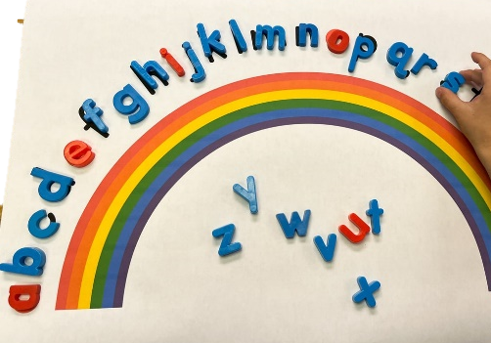
- Sequence the letters of the alphabet using magnetic letters/wooden letters using the alphabet arc template. Use the completed alphabet arc initially, where the child has to simply find the correct letter and place it on top of the corresponding letter on the mat. Once the child is comfortable with this you can challenge them with a partially completed mat and they must put the letters in the correct order from memory.

- Invite the child to close their eyes, remove 2-3 letters from the completed alphabet arc. Ask the child to open their eyes and see if they can identify the letters which are missing. You can also swap roles and they can remove the letters and you guess which letter they took away and this will allow you to see if they know the name/sound of the removed letters.

- Runaway Train is an activity where the child places his/her finger at the beginning and then move along the alphabet arc, then you hold up a stop sign, the child has to say the name of the next letter and the correct sound it makes.

- Encourage the child the say the names or the sounds of the letters (depending on the focus) as they follow along the arc. When they come to a vowel they have to stop and clap their hands before returning to the correct place on the arc.

- Give clues to the child for them to guess the letter you are describing. They have to find and show you the correct letter on the arc. For example, this is small letter, it is near the start of the alphabet, and the name of an animal that makes a miaow sound starts with this letter. What is it? (c)

- Talk about the vowels and set them above the alphabet arc. You could come up with a rhyme to help the child remember them (for example, ‘an elf is often upset’
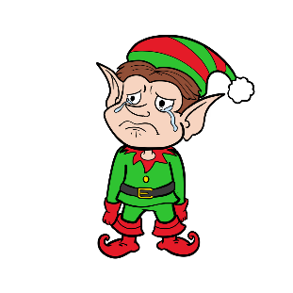

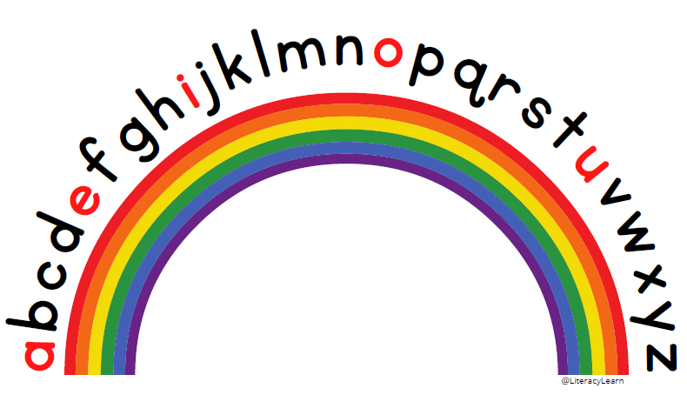
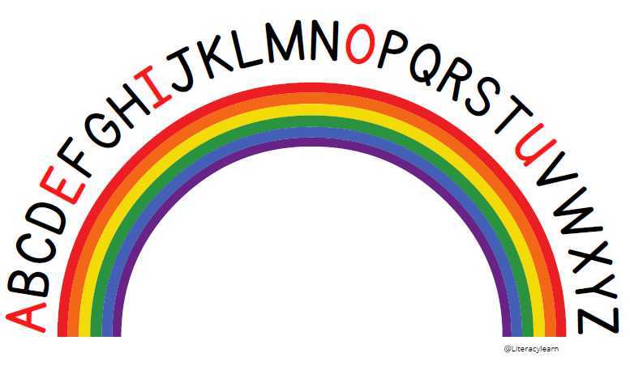

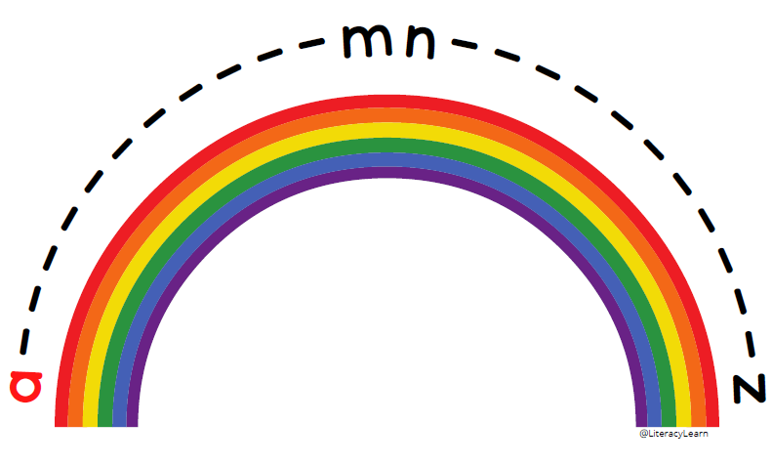

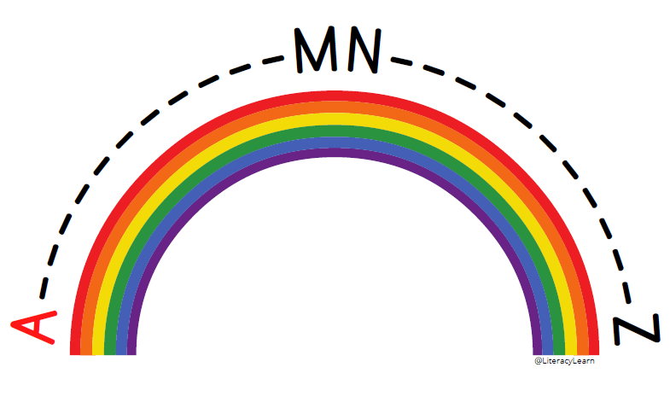

Bibliography

Katie (2022) Alphabet arc: 8 free printable mats & how to use them!, Literacy Learn. Available at: https://literacylearn.com/alphabet-arc-printable-mats/ (Accessed: 01 June 2023).

