

CVC workbook

This is a spelling workbook. It contains both CVC and Key words.
Pupils should concentrate on 10 spellings per week.
Every day, ask your child to spell the key words, both orally and in writing, after they have completed the ‘Look, Say, Trace and Cover’ activity.
During the week, pupils should complete the two activities on each set of spellings.

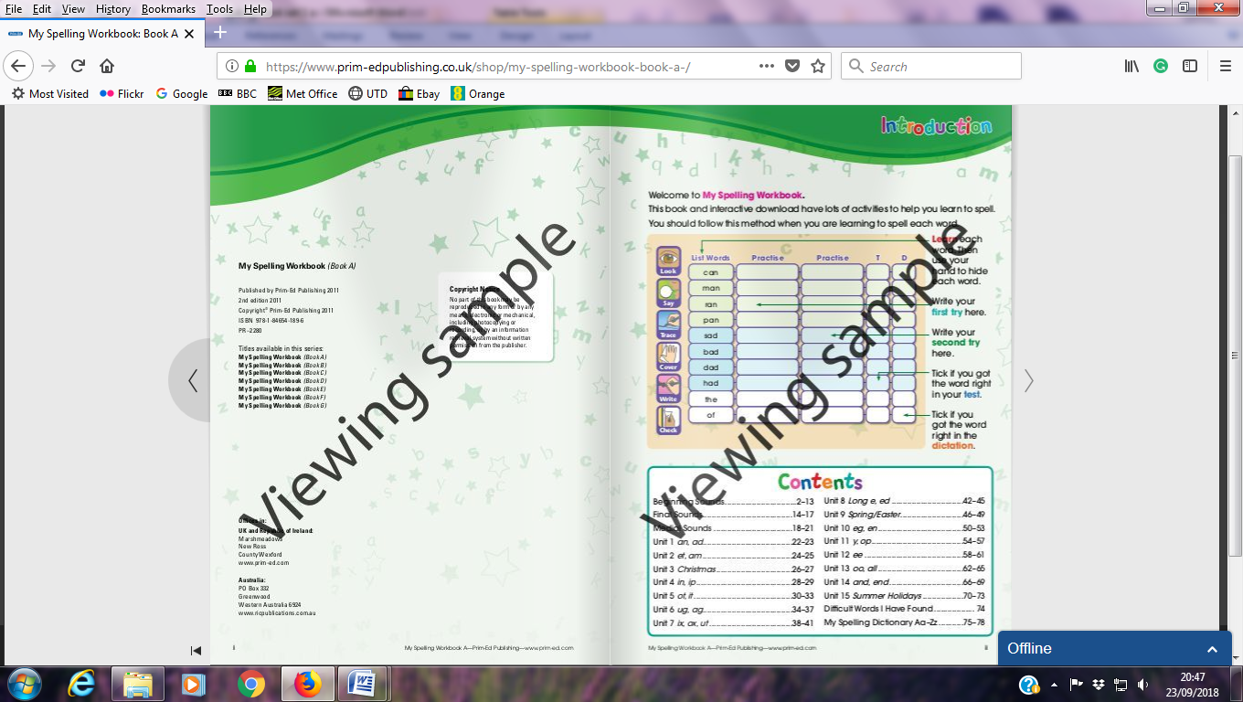  Look, Say, Trace, Cover | Write | Check
sad
bad
Dad
had
mad
in
was
I
is
he

Colour : had – blue was – red he - green
hadsadbadwasIbadhadmadinwashe
hehadwasinissadbadhadinwasishe

How many? had was he

Fill in the missing words.
1. I ____ a sweet today.
2. Another name for upset is _____.
3. A robber is a _____ man.

Look, Say, Trace, Cover | Write | Check
pet
bet
met
jam
ram
it
a
the
that
to

Colour : that – Blue jam – red pet - green
thatsadbetjamIbadthatmetinjampet
petthatraminthesadbadthattojamispet

How many? that jam pet

Fill in the missing words.
1. My dog is my _______.
2. I like to eat strawberry _____.
3. A male sheep is a ______.
Look, Say, Trace, Cover | Write | Check
win
bin
dip
zip
lip
and
of
are
for
you

Write a sentence using: you

Fill in the missing words.
1. A _____ is on my coat.
2. It is good to put rubbish in the _____.
3. I want to go ____ a walk.

