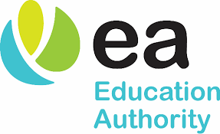

Consonant Vowel Consonant Word Activities

CVC words are simply words that follow the consonant-vowel- consonant (CVC) pattern.
Example: cat bin
C V C C V C

Table of Contents
CVC Word Activities 1
Activity 1: CVC Spy Game 3
Activity 2 – CVC Snakes and Ladder (at word ending) 7
Activity 3: Snail VC Word Game 9
Bibliography 11

Activity 1: CVC Spy Game
  - Using the letters s, a, t, p, i, n)

Resources:
Magnifying glass
Pencil
Evidence Record Printed

Activity:
Ask your child to find a VC word on the next page using the magnifying glass and record the word on their evidence record.
Now ask your child to make up a spy sentence using their VC word, e.g. ‘I saw the man at the shop’. Repeat activities until all thirteen words have been found.
A VC Spy badge can be awarded to your child!

I Spy...... 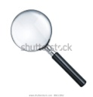

nap
pin

pan

sin

sit

sat

tan

tap

tip
pat

Evidence Record:
Record the word you have found. Say the word to an adult. Tick off the evidence.
Evidence Words
Evidence Words

Cut out CVC Spy badge when activity has been completed.

CVC Spy
Award

Name:

Activity 2 – CVC Snakes and Ladder (at word ending)

You will need to use a dice and counters for each person playing.

- Place your counters at ‘START’.
- Each player rolls the dice and moves their counter that number of squares along. The arrows will show you what direction to go.
- Read the word your counter lands on. If you can’t read the word, move back to your previous position on the board.
- You can help your child read the word, first, so that they will know it for future success.
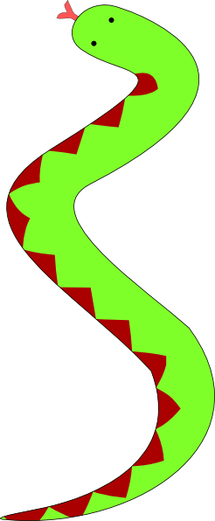
- If your counter lands at the bottom of a ladder, you can move up to the top of the ladder. If your counter lands on the head of a snake, you must slide down to the bottom of the snake.
4. The winner is the first person to reach ‘FINISH’

fat
bat
sat
rat
hat
at
cat
FINISH

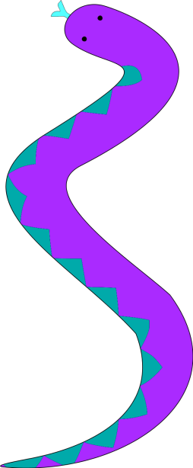


rat
bat
mat
START

bat
sat
rat
bat
rat
cat
bat
rat
sat
mat
sat
at
fat
hat
sat
cat
bat
rat
fat
mat
hat
cat
mat
fat
at
hat

Activity 3: Bin or Win

Resources:
Bin
Paper, at least A5 size (1/2 A4)
Small bin
Win
Activity sheet
Pencil

Activity:
- Write Grid 1 CVC words/non-words on individual pieces of paper. (Newspaper can be used but use labels or clear writing for pupil to see word).

- Scrunch up to make paper balls. Put the balls in the bin.

- Pupil uses Grid 1.

- Pupil takes a ball, reads the word and decides if it is a real word. If it is a real word, it is a ‘winner’ and goes in the win column. If it is not a real word, it is a ‘binner’ and goes in the bin column.

- Pupil repeats until all the balls have been placed in a bin or win section.

This resource can be repeated for other CVC words (see Grid 2 or make your own words to suit your child’s learning). This can be completed daily to fully embed CVC words to memory.

Grid 1
bat | cap | yat | hap
fap | vap | cat | gat
rat | tap | dap | jat
map | dat | rap | sat

Grid 2
sit | tin | bit | fin
pin | nit | vit | sin
kin | lit | rin | rit
yit | min | bin | fit

or

Win
Bin

Bibliography
Freepik . (2023). Retrieved from Cat up a tree clipart: https://www.freepik.com/free-vector/boy-climbing-help-cat-thats-stuck-tree-cartoon-isolated_11691083.htm#query=cat%20up%20a%20tree%20clipart&position=0&from_view=search&track=ais
Freepik. (2023). Retrieved from https://www.freepik.com/search?format=search&query=clown%20dress%20upclipart
Freepik. (2023). Cow. Retrieved from https://www.freepik.com/search?format=search&query=cow.
Freepik. (2023). Mother and daughter clipart. Retrieved from https://www.freepik.com/search?format=search&query=mum%20and%20daughter%20clipart
iHasco. (2019). Lost in translation: Recycling signs - what do they actually mean? Retrieved from https://www.ihasco.co.uk/blog/entry/2293/recycling-signs-what-do-they-mean.

