

Initial sounds activities
Contents
Activity 1: Hit the Roll 1
Activity 2: Mr Postie’s Initial Sounds Game 2
Bibliography 6

Activity 1: Hit the Roll

This game can be played with one or two players.
s
t
i
p
a
n

Resources
- Cardboard kitchen roll holders or toilet roll holders
- A soft ball/ping pong ball

Instructions
- Collect together kitchen roll cardboard holders.
- Write a different letter of the alphabet on each roll. (It is best to play with approximately six letters at a time).
- Place the rolls in a line.
- Call out a sound and ask your child to knock the roll holder by rolling a soft ball.
Make it more fun – if you have a Nerf gun, try hitting the roll with its bullet!

Activity 2: Mr Postie’s Initial Sounds Game



- Print out the post boxes and pictures below.

- Cut up the pictures and put in a pile to sort.

- Sort your images by ‘posting’ the initial sounds into the correct post box.

Remember to adjust to the game to suit your child’s ability. For example, it may be a good idea to sort 2 or 3 sets of sounds to begin with.

s
a
p

t
n
i
n

 |  | 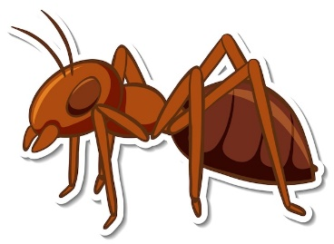
 |  | 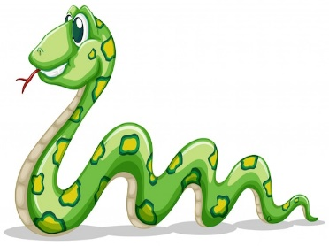
 |  | 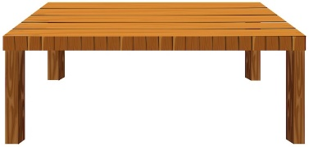
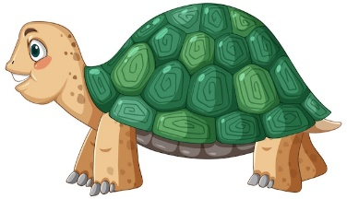 | 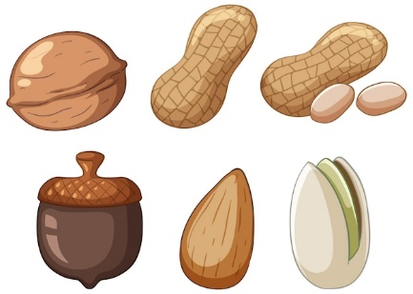 | 
 | 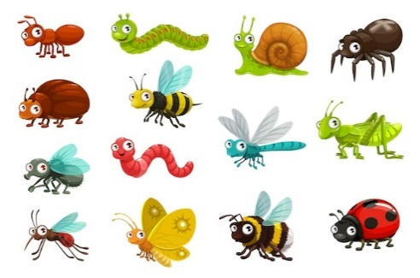 | 
 |  | 
 |  | 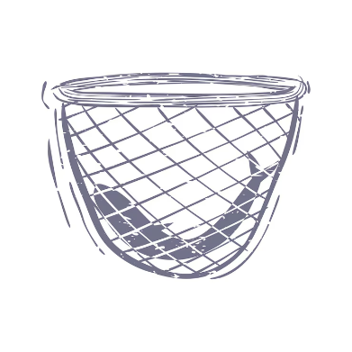
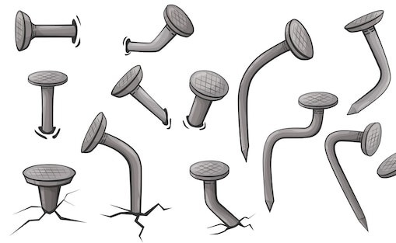 |  | 

Bibliography
FreepikCompany. (2023). Retrieved from https://www.freepik.com/

