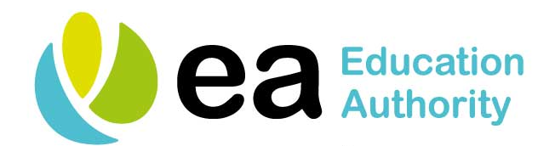
First 100 Keywords

This resource is a list of the first 100 keywords used by SENIS.

You may use this resource in various ways:
- Cut up words with the child. Choose words in groups of 5 and say the word, repeat the word, say the word, remember the word
(Break these down into manageable chunks such as 1-20, 1-30 etc.). Make sure words are mixed up each time you ask a pupil to say the word.

- Test keyword knowledge by asking the pupil, “What is the word with a blue heart?”

- Use a digital timer to time pupils recognising keywords. The aim is to get quicker each time at recognising keywords.
E.g. time for recognising keywords 1-20, Date: 05/01/2020 Time 16 seconds
Date: 06/01/2020 Time 15 seconds

a | in | is | to
the | and | I | he
it | see | you | can
are | go | we | up

one | me | two | on
big | she | look | my
here | little | all | at
into | like | has | for

of | with | get | not
her | they | his | if
by | was | do | off
so | this | have | be

said | him | will | come
call | some | down | that
but | old | did | your
out | make | no | or

had | from | as | an
them | new | then | well
what | there | were | made
back | just | over | now

came | about | when | been
their | who | more | before
want | where | our | must
first | could | right | other

which | much | only | went

