

Money

Contents
Activity 1 – Counting pennies to 10p 1
Activity 2 – Fruit and Vegetable Shop 3
Activity 3 – Sorting Coins Practical Activity 7
Activity 4 – Toy Shop 8
Bibliography 9

Activity 1 – Counting pennies to 10p
1p
1p
1p
1p
1p
1p
1p
1p
1p
1p

Count out pennies to make these amounts of money. Put the page on top of the pennies and use a crayon or a pencil to colour over the coins.

4p | 2p
7p | 5p
3p | 8p
1p | 9p
6p | 10p
Extension: Can you draw the the 2p, 5p and 10p coins in their correct boxes?

Activity 2 – Fruit and Vegetable Shop

This activity is used to introduce a pupil to shopping and exchanging money for an item. This fun resource can be mastered in any kitchen area. Real fruit/vegetables are a great way of bringing learning in a shop environment to life.
An adult is to set up a Fruit and Vegetable Shop. You can use different kinds of fruit/vegetables including frozen fruit/vegetables.
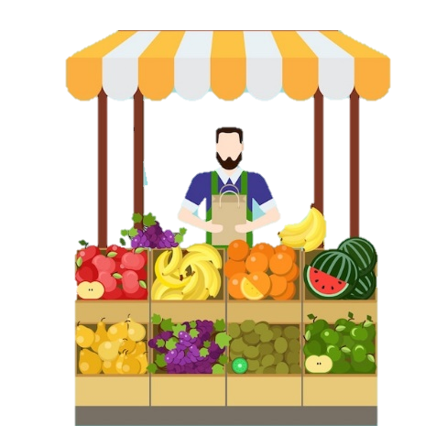
Set up using a fruit bowl or line up items (remember to use small bowls for frozen items). This activity can be linked to healthy break/snack or preparation of a snack/meal. E.g., a pupil may want to make a smoothie with banana, strawberries, orange, and apple.
An adult is to use labels with prices up to 5p to place on fruit or vegetables.
You can even charge 5p for a plastic bag!

Role play:
The pupil plays shopper and an adult plays shopkeeper. The pupil chooses to buy one item at a time and exchanges pennies from their purse/bag. The pupil hands these to the adult in exchange for an item. This is repeated for further items. The pupil can also involve other members of the family/class by buying on their behalf.
When the pupil is confident in exchanging money for the item, they can then reverse the role. An adult will become the shopper may buy from the pupil who is now the shopkeeper. The role of the pupil is to check that the adult has given the correct coins to purchase an item. The shopkeeper then gives the shopper the item.
Resources required:
- Labels (see Resource 1)
- 1 freezer bag/purse
- Recipe/ideas to make (Resource 2)
- 1 small plastic container as a till
- Reusable shopping bag or box
- 20 x 1p coins (or as many as needed). Real money is preferred.
- Fruit (apples, oranges, bananas, grapes, strawberries, pears, pineapple, sultanas, raisins etc).
- Vegetables (carrots, peas, broccoli, sweetcorn, courgette, lettuce, tomatoes etc).

Resource 1
1p

2p
5p
4p
3p

Cash Till 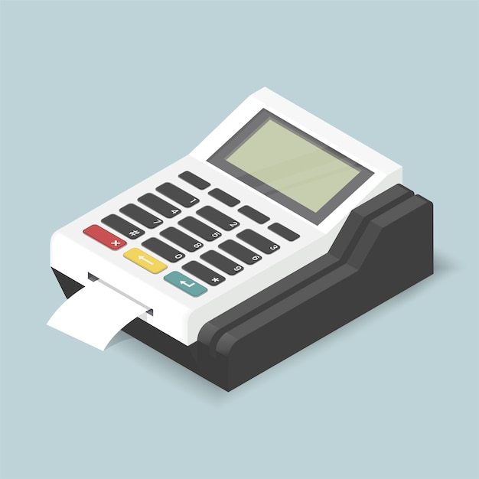

Resource 2
Ideas to make with real fruit:
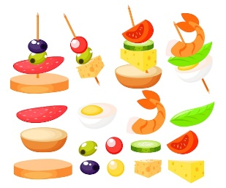 | 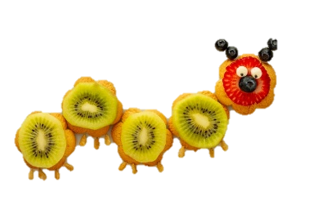

Fruit Smoothie Recipe:
8 hulled strawberries
1 banana
1 apple peeled and cored
1 tsp honey
400ml milk.
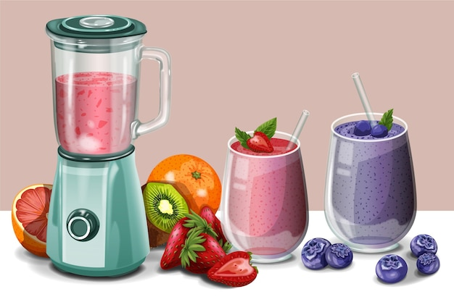
4 ice cubes
Method:
Put all ingredients in a blender and blend until smooth. Pour into glasses and serve.

Alternative???
Add ice-cream to make a milkshake!

Activity 3 – Sorting Coins Practical Activity

You will need a selection of 1p, 2p, 5p and 10p coins and some holders, e.g., pots/tins/boxes. Label each holder with each coin value and ask your child to sort the coins into the correct holders. Discuss the size, shape, and colour with your child.
Extension: Repeat this activity including coins with a larger value.
5p
1p

10p
2p

Activity 4 – Toy Shop
Use real coins to pay for each toy. Now, draw around the coins to show how you paid for each item,
9p

Teddy
6p

Car
8p
 Ball
7p

Doll
 Jigsaw
10p
Extension: Repeat this activity to pay for each toy in different ways.

Bibliography
FreepikCompany. (2023). Retrieved from https://www.freepik.com/

