

number
Contents
Activity 1 - One-to-One Correspondence
Activity 2 – Numerals 0-5
Activity 3 – Matching a Numeral to a Group of Objects
Activity 4 – Number Bonds to 10
Activity 5 – Go Fish Bonds to 10
Bibliography

Activity 1 - One-to-One Correspondence

Now you are starting to count items with your child. Remember to point to or touch each item and slowly count one at a time.
(FreepikCompany, 2023)items in a line rather than in a group.
Many activities in the home rely on counting.
- Counting out the cutlery together at mealtimes:
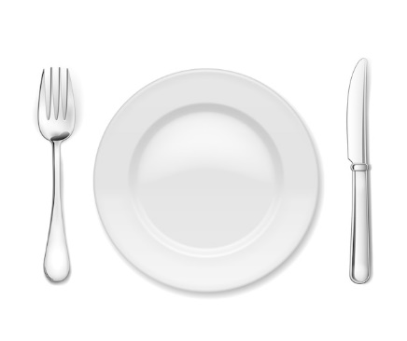
- Counting pieces of fruit:
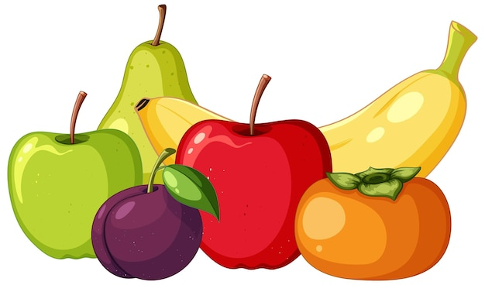
- Counting toys back into the toy box:
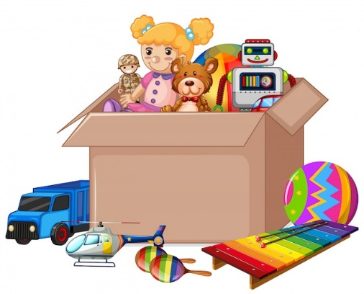

These are many great ways for your child to practise their counting with you at home!

Activity 2 – Numerals 0-5

Numerals are just the written form of a number.
Here are some fun activities you can do with your child to help them to understand the numerals 1 to 5:

- Write the numeral 1 on several pieces of paper and ask your child to find 1 object to go on each piece of paper. Your child could also colour in the number 1.

- Make the numeral 2 from dough. You can paint it together and add sand to give it texture. You could also make the numeral out of old wrapping paper or from magazines. Be as creative as you wish!



- Create a jigsaw. Draw a large 3 on a piece of paper and make draw lines onto it to make a jigsaw. Cut out the pieces and put the numeral 3 back together, like a jigsaw.
(This can be repeated using more lines to make the jigsaw more difficult).
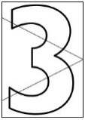

- Use pages from a colouring book you have. Add the numeral 4 to any pictures of 4 items. Colour in the numeral 4 and the pictures; counting as your child does so.
4

- Think about all the different ways to show 5. Collect items, make pictures and cut out a large 5 and stick your ideas of ‘what 5 looks like’ on the large 5.

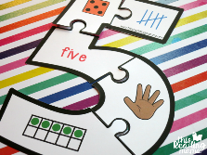

You can repeat these activities for different numerals to reinforce your child’s understanding of the numerals 1 to 5.

Now you are ready to match the numerals 1 to 5 to pictures or groups of objects.

Activity 3 – Matching a Numeral to a Group of Objects

Matching Activities:
- Make groups of objects, e.g., breakfast cereal, toy cars or colouring pencils. Write one numeral from 1 to 5 on a square of paper. Mix up the squares of paper and set them near to the group of objects you had made. Ask your child to match the numeral to the number of items. If it is food or sweets, you might even get to eat some!
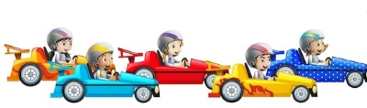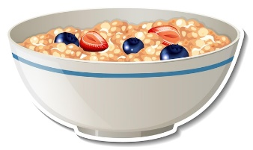
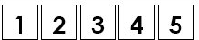

- Draw pictures of the same item (1 to 5) and write the numerals 1 to 5 on paper plates. Ask your child to count the number of items on each paper plate, reminding them to point to each item in turn as they count, and match the picture to the numeral.
7

5
7

- Counting slowly and pointing while counting will help your child count and match numerals correctly. In the picture below, the numeral 3 is reversed. Help your child to recognise the direction of the numerals 1 to 5 and you can reinforce this by tracing, ‘air’ writing and writing the number in sand.
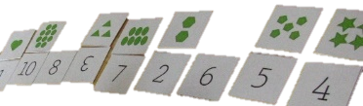

- Extension: When your child is confident with one-to-one correspondence and recognising and understanding the numerals 1 to 5, you can repeat the fun activities above for numbers greater than 5.

Activity 4 – Number Bonds to 10

You will need:
- Two sets of coloured counters
- A whiteboard and a cloth.

Instructions
- Print the grid and number squares below (or draw the grid on the whiteboard/a piece of paper and write the numbers on pieces of paper).
- Cut out the number squares 0 – 10.
- Place/write a number between 0 and 10 on the second line on the grid and ask your child to work out what number is needed to add to your number to make ten. Then ask your child to find this number on a paper square and place it on the first line/write it on.
- Next, ask your child to highlight the number bonds to 10 by placing counters on the grid, e.g. green counters on the numbers 3 and 7, blue counters on the numbers 0 and 10, etc.
- If you do not have counters, paint pieces of pasta or colour the squares with markers or crayons!

Number Bonds to 10

_________________ + ________________ = 10

0 | 1 | 2 | 3 | 4 | 5
5 | 6 | 7 | 8 | 9 | 10

Activity 5 – Go Fish Bonds to 10

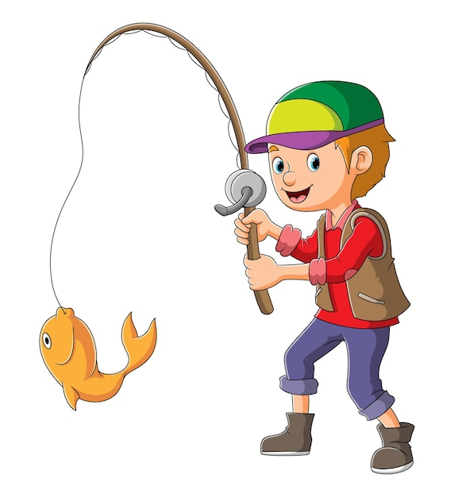
- Take a deck of playing cards and remove the picture cards and the ‘10’ cards.
- Deal 7 cards to each player and place the remaining cards face down in the centre of the table.
- Look at your cards and find pairs that add to 10; place these pairs of cards face down in front of you, e.g. 7 and 3.
- The first player turns to the person directly to their left and asks, ‘Do you have a ___?’ hoping that they will get a card to pair with one of their cards to make 10.
- If the player being asked for a card has it, they hand it to the player who asked for the card.
- If the player does not have the card, they say, ‘Go fish’ and the player who asked for the card takes a card from the top of the pile of cards in the centre of the table.
- Play continues in a clockwise direction until the first player has no cards left in their hand because they have paired them all.
- The game then stops and all players count their pairs. The winner is the player with the most pairs.
- This game can be played to make any number bond to 20, so choose your number and play again!

Bibliography
Becky. (2023). This Reading Mama. Retrieved from Printable number puzzle for number 5: https://thisreadingmama.com/printable-number-puzzles-1-10/printable-number-puzzle-for-number-5/
FreepikCompany. (2023). Retrieved from https://www.freepik.com/

