

Time
Contents
Activity 1 – Make a clock face.
Activity 2 – Loop Game o’clock
Activity 3 – O’clock Game Cards
Activity 4 – Match the Time (Half Past)
Activity 5 – Match the Time (A quarter past)
Activity 5 – My Day Time Game

Activity 1 – Make a clock face.
3
6
12
10
11
8
4
7
2
5
1

9
Use a split pin to put the hands on the clock.

Activity 2 – Loop Game o’clock

Instructions - Who has the time?

- Print and cut out the template so that you have six individual cards.

- The person who has the first card says, ‘I have the first card. It is 5 o’clock, who has 2 o’clock?’

- The person who has the 2 o’clock card must place the card on the table with the corresponding time.

- The game continues until all cards have been matched.

Who has the time?
I have the first card  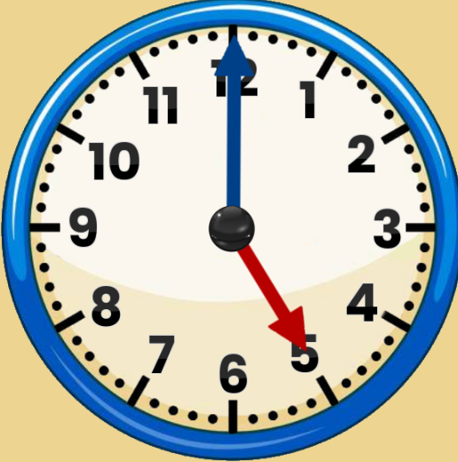  Who has | I have  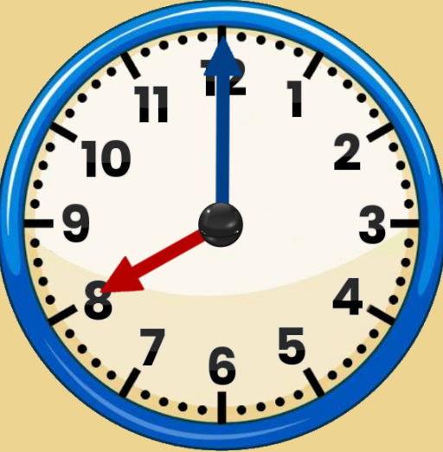  Who has | I have  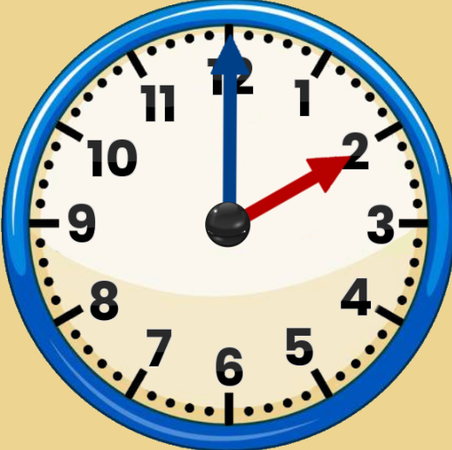  Who has
  2 o’clock?
  3 o’clock?
  10 o’clock?
I have  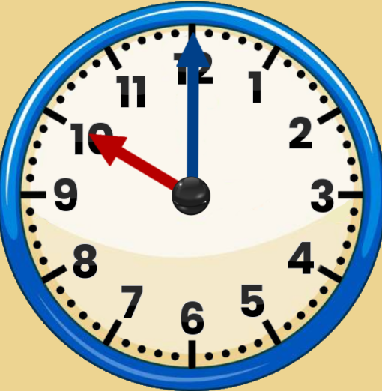  Who has  (RoomRecess.com, n.d.) | I have  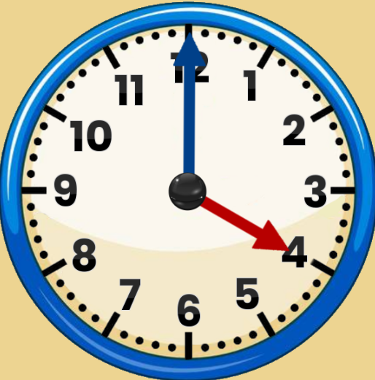  Who has | I have  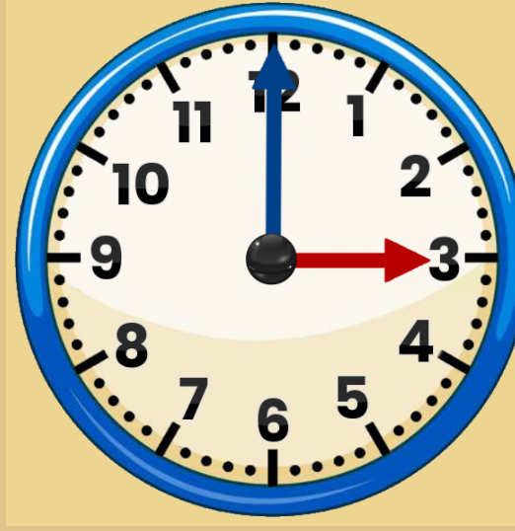  Who has
  8 o’clock?
  5 o’clock?
  4 o’clock?

Activity 3 – O’clock Game Cards

- ‘Snap’. Each player takes it in turn to put down a card in the middle of the table. If two cards are the same, they shout ‘snap!’. The winner is the person with the most cards at the end.

- ‘Matching Pairs’. Start with six cards, only. Shuffle the cards and place them so that the time faces down. Ask your child to turn one card over and then another, with the aim of finding the matching card. If it is not a match, turn the card face down again. Continue until all the cards are paired, encouraging your child to look carefully at where each card is. As the child becomes more confident, add more cards until eventually all cards are used in the game.

- You will need an analogue clock. Use one set of cards and place them face down on the table. Ask your child to turn over a card and read the time aloud. Next, ask your child to show this time on the analogue clock face. Remember to reinforce that the shortest hand on the clock is the ‘hour hand’, the longest hand is the ‘minute hand’ and when the minute hand is at twelve, this is ‘o’clock’.

- ‘Story telling’. Using one set of cards, each player takes it in turns to take a card and make up a sentence, e.g. ‘At 1 o’clock I have my lunch’. The next player repeats the sentence and adds a new sentence, e.g. ‘At 1 o’clock I have my lunch, at 2 o’clock I brush the floor’. If a player misses a word, they are out, and the winner is the player who can remember the list of times and their activities!

- You will need a hula-hoop. Place the hula-hoop flat on the floor or the ground outside and draw the numbers of the clock around the inside of the hoop. Ask your child to turn over a card and use chalk to draw the hands to show the time on the card. Wipe off with a damp cloth and continue until all the time cards have been used.

Cards to print.
1 o’clock   | 2 o’clock  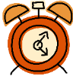 | 3 o’clock  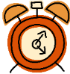 | 4 o’clock | 5 o’clock   | 6 o’clock
1 o’clock  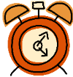 | 2 o’clock | 3 o’clock | 4 o’clock | 5 o’clock | 6 o’clock

7 o’clock | 8 o’clock | 9 o’clock | 10 o’clock | 11 o’clock | 12 o’clock
7 o’clock | 8 o’clock | 9 o’clock | 10 o’clock | 11 o’clock | 12 o’clock

Activity 4 – Match the Time (Half Past)

- Print out and cut up your time cards (below). Have one set of clock face cards and one set of yellow time word cards. Shuffle the cards.

- Try to match the clock face card with the correct time word card and ask your child to say the time aloud while doing so.

Matching Pairs Game
- Print out and cut up your time cards. Have one set of clock face cards and one set of yellow time word cards.

- Have one side for clock face cards and one side for yellow clock word cards. Turn the cards face down. Take it in turns to choose a card from each side. If they match, keep the pair and if they don’t match, turn the cards face down again.

- The winner is the person with the most pairs at the end of the game.

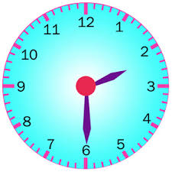 | Half past two
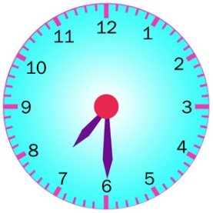 | Half past seven
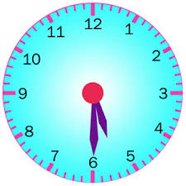 | Half past five
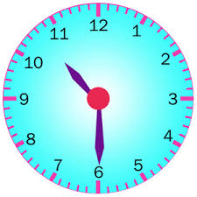 | Half past ten
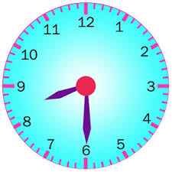 | Half past eight
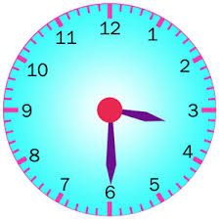 | Half past three
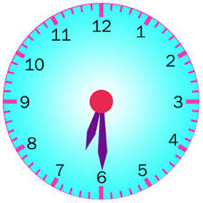 | Half past six
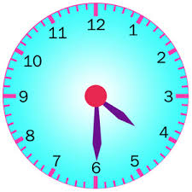 | Half past four

Activity 5 – Match the Time (A quarter past)

- Print out and cut up your time cards (below). Have one set of clock face cards and one set of yellow time word cards. Shuffle the cards.

- Try to match the clock face card with the correct time word card and ask your child to say the time aloud while doing so.

Matching Pairs Game
- Print out and cut up your time cards. Have one set of clock face cards and one set of yellow time word cards.

- Have one side for clock face cards and one side for yellow clock word cards. Turn the cards face down. Take it in turns to choose a card from each side. If they match, keep the pair and if they don’t match, turn the cards face down again.

- The winner is the person with the most pairs at the end of the game.

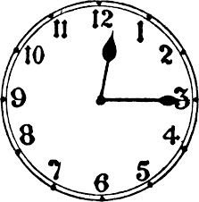 | Quarter past twelve
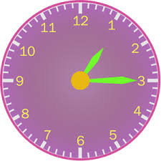 | Quarter past one
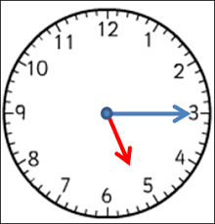 | Quarter past five
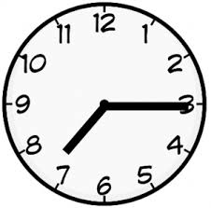 | Quarter past seven
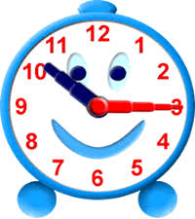 | Quarter past ten
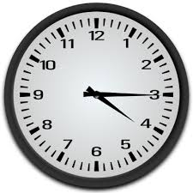 | Quarter past four
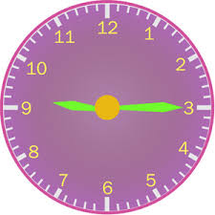 | Quarter past nine
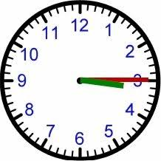 | Quarter past three

Activity 6 – My Day Time Game

You will need an analogue teaching clock with moveable hands and a dice.
- Each player starts at breakfast.
- Roll your dice and move onto the board.
- Read the time on the circle you land on.
- Create this time with your clock.
- If you get both correct, stay on your circle. If you get either wrong, move back to your previous position.
- The winner is the first person to go to sleep!

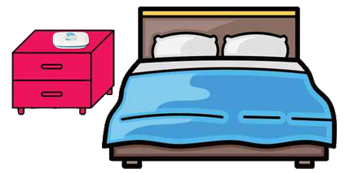
6 o’clock
8 o’clock
quarter past 3
half past 10
half past 5
Go back to the shop you forgot your bag.
7 o’clock
2 o’clock
quarter past 1

4 o’clock
3 o’clock
half past 12

12 o’clock

My Day Time Game
Stop at the shops. Miss a go.
half past 11
quarter past 10
2 o’clock

half past 8

quarter past 7

8 o’clock
1 o’clock

half past 9
7 o’clock
quarter past 2
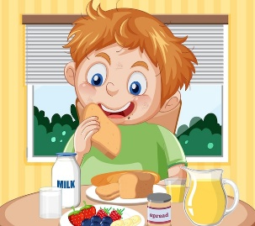Start
half past 1

quarter past 7

Bibliography
RoomRecess.com. (n.d.). Interactive Clock for Kids. Retrieved from https://www.roomrecess.com/Tools/InteractiveClock/play.html

