

Vowel Consonant (VC) Word Activities

VC words are simply words that follow the vowel- consonant (VC) pattern.
Example: at in
V C V C

Contents

Activity 1: VC Spy Game 3
Activity 2: Reading VC Words in Sentences 7
Activity 3: Snail VC Word Game 9
Activity 4 - VC Stairs 11
Bibliography 12

Activity 1: VC Spy Game

Resources:
Magnifying glass
Pencil
Evidence Record Printed

Activity:
Ask your child to find a VC word on the next page using the magnifying glass and record the word on their evidence record.
Now ask your child to make up a spy sentence using their VC word, e.g. ‘I saw the man at the shop’. Repeat activities until all thirteen words have been found.
A VC Spy badge can be awarded to your child!

I Spy...... 

am

an

on

us

up

it

in

is
at

as

if

am

of

Evidence Record:
Record the word you have found. Say the word to an adult. Tick off the evidence.
Evidence Words
Evidence Words

Cut out VC Spy badge when activity has been completed.
VC Spy
Award

Name:

Activity 2: Reading VC Words in Sentences
Use the pictures to help you when reading the sentences.
Alternative activity: Cut the pictures and sentences up and try to match them.
It is in the bin. |   (iHasco, 2019)
I am at a shop. |   (Freepik, 2023)
We can see a cow. |   (Freepik, 2023)
He went to school. |   (Freepik, 2023)
My mum is with me. |   (Freepik, 2023)
I can be a clown! |   (Freepik, 2023)
The cat is up in a tree | 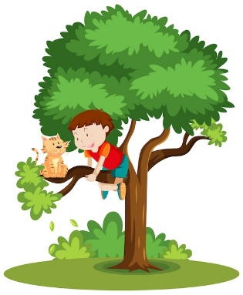  (Freepik , 2023)
I am at the park. | 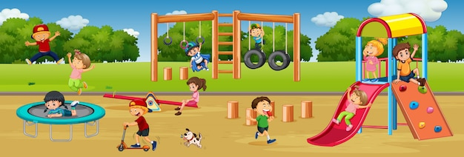  (Freepik, 2023)
It is an elephant. |   (Freepik, 2023)
He is on the bus. |   (Freepik, 2023)

Activity 3: Snail VC Word Game

You will need to use a dice and counters for each person playing.

1. Place your counters at ‘start’.
2. Each player rolls the dice and moves their counter onto the snail starting at ‘if’.
3. Read the word your counter lands on. If you can’t read the word, move back to your previous position on the board.
You can help your child read the word, first, so that they will know it for future success.
4. The winner is the first person to finish in the centre of the snail!

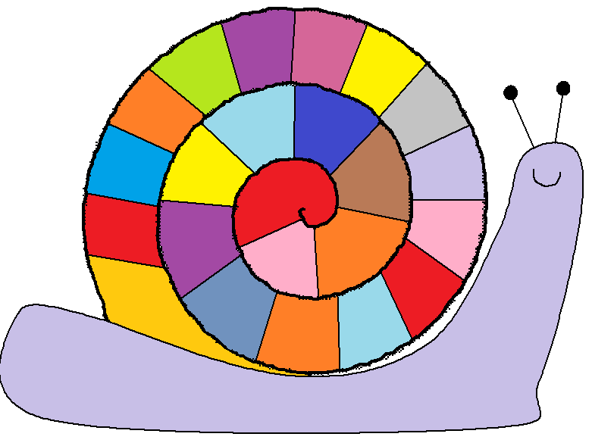
at
go
START
to
be
is
if
me
no
as
in
on
up
my
am
in
on
it
to
an
we
me
on
it
FINISH!

Activity 4 - VC Stairs

This game can be played with one or two players.
1. Take a set of post–it notes.
2. Write down your target sounds, one letter per post-it note.
3. Place each post-it note on different stairs.
4. Call out the sound and ask your child to climb the stairs to get the correct initial sound.
5. Extension: Call out words and ask your child to find the correct initial sound of the word / end sound of the word.
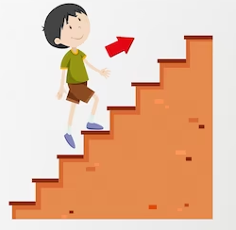

Bibliography
Freepik . (2023). Retrieved from Cat up a tree clipart: https://www.freepik.com/free-vector/boy-climbing-help-cat-thats-stuck-tree-cartoon-isolated_11691083.htm#query=cat%20up%20a%20tree%20clipart&position=0&from_view=search&track=ais
Freepik. (2023). Retrieved from https://www.freepik.com/search?format=search&query=clown%20dress%20upclipart
Freepik. (2023). Cow. Retrieved from https://www.freepik.com/search?format=search&query=cow.
Freepik. (2023). Mother and daughter clipart. Retrieved from https://www.freepik.com/search?format=search&query=mum%20and%20daughter%20clipart
iHasco. (2019). Lost in translation: Recycling signs - what do they actually mean? Retrieved from https://www.ihasco.co.uk/blog/entry/2293/recycling-signs-what-do-they-mean.

