EA Sensory Service 

Appendix 3: Examples of Speech to Text apps or live transcription apps*
- The Education Authority Sensory Service is not responsible for the content of the resources linked on this page nor does it constitute endorsement
Live Transcribe  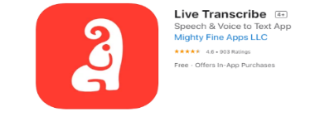  iOS | £4.99| 1 mistake  The iOS Live Transcribe app offers the option to quickly switch between typing and speaking, which not only makes it easier for a deaf person to understand a hearing person, but also for the deaf person to make themselves understood. There is no need to create an account.  Other features that set this app apart:  Offline mode, meaning it can be used in shops or buildings with limited signal.  A Flip Screen button, making it easier for the hearing person to see what they are saying before flipping it back for the deaf person to read.  A minor downside is that the typing option doesn’t do the same, so unless the deaf person wants to read upside down, the microphone will still be faced away from the hearing person speaking.  The offline mode and speak and type options show its potential as an app aimed at facilitating conversations, though its user interface is a bit clunky. | Live Transcribe (Android)  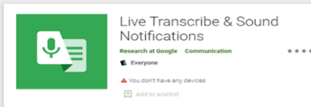  Android | free|2 mistakes  It starts recording as soon as it hears a voice and seems pretty good at prioritising the speaker closest to the phone over people further away. Not much punctuation apart from the full stop at the end of the sentence.  The Android Live Transcribe app is not created by the same developer as the iOS Live Transcribe app, but like the iOS Live Transcribe app this offers the option to type text as well, and no account is needed to use it.  Additional features that set this app apart:  Indicates when music is playing on the background or other sound effects such as laughter.  Has the option to hide swear words by replacing them with asterisks (***). This is useful when using the app with younger children. | Otter Voice Notes    iOS, Android | free and paid | 0 mistakes  Otter is an app but can also be run on a desktop or laptop. The free version offers 600 minutes of live transcription a month. For more minutes, there are paid versions.  The accuracy, punctuation, and user friendliness of the app are pretty good, but it’s a pity it cannot be used offline and that it doesn’t have an option to type dialogue which would be useful for deaf children and young people that don’t use their voice.  Features that make this app stand out:  Transcripts can be saved and edited. As you need to create an account, transcripts are saved into your account and can be shared with others.  Words can be added to vocabulary. We've used this to add jargon and people’s names which improved the accuracy of the transcript
Source: NDCS Blog ‘Apps to Help Conversation with Deaf Children and Young People’

