

Sensory Service

Enlarging Print for Students with Vision Impairment (VI)
For students who have a vision impairment (VI), it is often assumed that text needs to be enlarged. Although this is the case for many, it is not required for all students with a VI, and for some students, who have eye conditions that cause a reduction in field of vision, enlarged print may be detrimental. Please remember that not everyone with a VI has the same needs!
The size of a font is described in point size. Large print is generally 16 to 18 point size. Giant print is anything larger than this. Regular print is usually 10 or 12 point.
It is the role of the Qualified Teacher of the Vision Impaired (QTVI) to determine the appropriate print size for reading and it is essential that advice from the QTVI is understood and followed.
Students with VI need access to learning i.e. the student is provided with access to appropriate information in order to learn about a curriculum area.
However, they must also have optimum opportunities for learning to access i.e. the student is provided with the means by which they are able to access information independently.
These two approaches are not mutually exclusive. Each will be required at different stages and depending on the curriculum context. Teaching students access skills has important longer-term benefits for students with VI as they become independent adults.
The use of low vision aids or assistive technology to view printed material empowers the student to make their own adaptations. Devices such as e-readers, tablets and computers allow students to select the size that suits them best in any given situation and environment.
If a student becomes dependent on using large print, when low vision aids or other devices would allow them to read print efficiently, the student’s access to print materials is restricted to those situations where large print is available. Please refer to the Alternatives to large print paper copies section of this document.

Enlarging an original on a computer:
When a student requires a paper copy of enlarged font the best way is to get the original document and change the font size and spacing as necessary, directly on the computer. This can be done if staff have a digital copy of a worksheet or book or if you create a digital copy using Microsoft Office Lens, (further information on Office Lens is available on this website). Most documents will enlarge to 18 pt without effecting the format out too much. However, please remember:
- Keep to a plain font like Arial, consider making it bold and think about line spacing, 1.5 is best
- Not all fonts are the same size: Arial 14 pt is bigger than Times New Roman 14 pt and much easier to read because it does not have the serifs (flicks and feet on the letters)
- It is possible to use the feature below to alter the line spacing

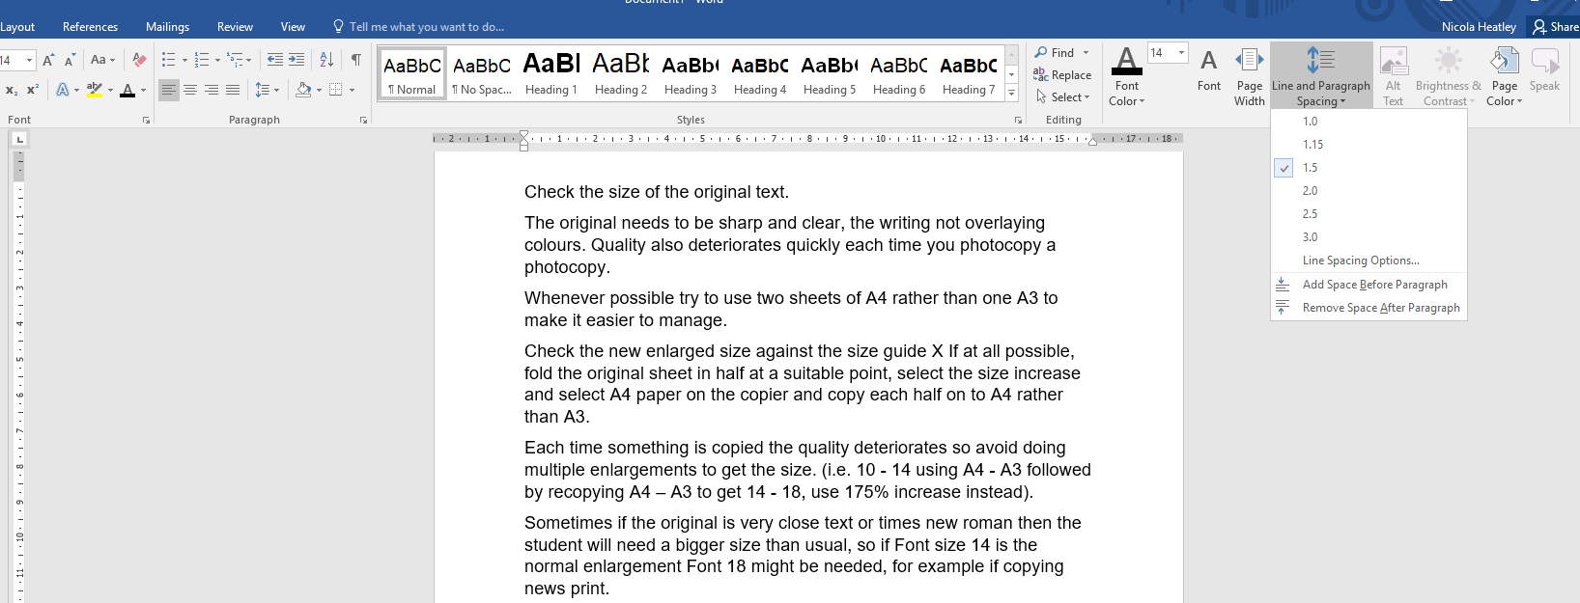

To enlarge sections of commercially books will first require scanning e.g. using Microsoft Office Lens or downloading from another source such as www.seeingear.org or RNIB Bookshare found at www.rnibbookshare.org/cms or by making a request for adaptation to the Regional Vison Resource Base. Guidelines for making RVRB requests are available on this website and should be discussed with the QTVI.
The RNIB have produced these Top tips for creating accessible print documents

Enlarging materials on a photocopier
Enlarging on a photocopier should be avoided where possible and only used when no other alternative is available.
If the text is faint or of poor quality, this is likely to get worse when enlarged on a copier, as are graphics and images. Any design features that are difficult for someone with sight problems to read such as italics are not resolved.
Students with VI should not be given photocopies on A3 size pages. These create several problems for the reader. An A3 document is unwieldy to read, carry and store, and this may be particularly difficult for someone who gets very close to the page to read. Materials that have had to be enlarged onto A3 pages should be cut and recopied onto an A4 page.
In general, A4 portrait is preferred for standard documents. However, some layouts may be clearer on larger paper or in landscape orientation. For example, using larger paper or a different orientation may make it possible to include the full width of a table, more columns of a spreadsheet, a whole diagram, or a complete map. The greater ease of comprehension this gives may outweigh the general unwieldiness of larger paper.
Where enlarging on a photocopier is unavoidable, please ensure that a photocopier that can provide clear, sharp, clean copies is used.
There is no magic formula regarding copying as the size is dependent upon the original font size. If enlarging documents for students who require a print size of Arial 18, it is important to understand that this cannot always be achieved by increasing from A4 to A3. This will only increase text by 6 font sizes (e.g. size 10 to 16) so you need a larger percentage increase to go from e.g. 8 to 18 (which is a 10 font size increase). Font size 8 pt increased to 18 pt is + 10 font sizes or 200%.
To increase with a photocopier:
+ 2 font sizes (e.g. 10pt – 12pt) 115%
+ 4 (e.g. 10pt – 14pt) 122%
+ 6 (e.g. 10pt – 16pt) 141%
+ 8 (e.g. 10pt – 18pt) 175%
+ 10 (e.g. 10pt – 20pt) 200%
(N or pt is a term for font size)

When enlarging try to remember the following:
- Check the size of the original text
- The original needs to be sharp and clear, the writing not overlaying colours. Quality also deteriorates quickly each time you photocopy a photocopy
- Check the new enlarged size against the size guide
- If possible, fold the original sheet in half at a suitable point, select the size increase and select A4 paper on the copier and copy each half on to A4 rather than A3
- Each time something is copied the quality deteriorates so avoid doing multiple enlargements to get the size. (i.e. 10 - 14 using A4 - A3 followed by recopying A4 – A3 to get 14 - 18, use 175% increase instead)
- Sometimes if the original is very close text or times new roman font style the student will need a bigger size than usual, so if font size 14 is the normal enlargement font 18 might be needed, for example if copying news print
- Make sure the copier’s glass surface is clean
- Use a copier with fresh toner or one that has a good supply of toner available to ensure quality of photocopy
- Apply pressure to a book’s spine to reduce centre margin problems
- Set the contrast button to darken the work being copied or lighten so that the text is clearer and better defined. This is especially important when you are photocopying a black and white textbook, a play or reading book
- Place a white sheet of paper behind small items to avoid using excess ink or getting grey or black shadows on copies
- Periodically check the finish of pages as they come off the copier to ensure you have captured all the text and images, have the book/ copier correctly aligned and have good colour contrast.

Alternatives to large print paper copies:
- Take a photograph on an iPad: The student can then ‘zoom in’ at the required magnification.
- Student uses magnifier (if provided by Low Vision Clinic) or a larger portable video magnifier, if provided by the QTVI.
- Source the text within RNIB Bookshare: Books can be downloaded in a range of accessible formats that can be read electronically or adapted to suit the personal reading requirements of the student.
  - RNIB Bookshare allows you to access books that require further modification to create large print paper copies. You can do this yourself, and RNIB Bookshare provides guidelines about modification. Bookshare have also produced a Getting Started Guide to support users in accessing their website. Additionally, from the RNIB Bookshare homepage select the Help Centre tab to access several training videos to support users in familiarising themselves with the service and to access the materials on the site.
- Email/ share the document PDF/ PowerPoint etc. electronically to an iPad/ student laptop or other assistive technology (AT) device.
- Use a scanner to scan the page/pages/book and share electronically to iPad/ student laptop or other AT device.
- Use a scanning app to edit and produce an appropriate font and text paper copy or an electronic version to share to the student’s device. Several iPad (and Android) apps can convert a text image to 'editable' text. Microsoft Office Lens is an App that allows you to convert to Word documents and PowerPoint in addition to PDFs. Office Lens uses your phone camera to take photos of pages, and then converts them to readable text using OCR. You can either have the app:
  - Use Immersive Reader to Read text aloud;
  - Enlarge text and/or;
  - Space out words for students with dyslexia or export them to word, pdf and other formats if you wish to send them electronically to a device (or to print a hard copy).
  - Office Lens converts not only physical documents to electronic formats but also text written on whiteboards in a classroom. Office Lens app is free and available for iOS, Android, and Windows. Further information about using Office Lens can be accessed on our Sensory Service website. The QTVI can also provide further guidance on using Office Lens.

Text Comparison Chart

This is Arial 8pt
This is Arial 10pt
This is Arial 12pt
This is Arial 14pt
This is Arial 16pt
This is Arial 18pt
This is Arial 20pt
This is Arial 24pt
This is Arial 30pt
This is Arial 36pt
This is Arial 40pt
This is Arial 48pt
This is Arial 60pt
and Arial 72 pt

