**EA Sensory Service**  The logo has a tulip shape image in blue, green and yellow, with the letters EA and word Education Authority t
o right of the image. 

# Understanding how the ear works

The ear is made up of three parts: the outer ear, the middle ear and the inner ear. These parts all work together to help us recognise sound.

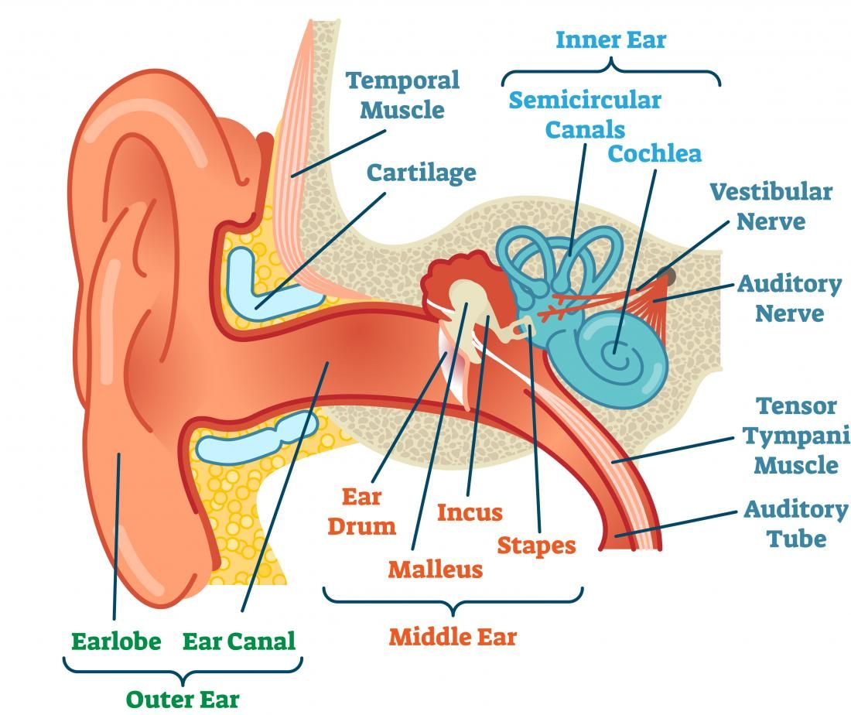

Source- MED-EL

## The outer ear

The outer ear (pinna) collects sound. The sound waves travel along the ear canal to the eardrum. The eardrum vibrates in response to the soundwaves and the vibrations are then transferred to the middle ear.

## The Middle Ear

The eardrum separates the outer ear from the middle ear. When sound waves hit the eardrum, it vibrates. The vibrations are passed across the middle ear by the ossicles; the three smallest bones in the body (the malleus, incus, and stapes). They may also be called the hammer, anvil and stirrup. These bones increase the strength of the vibrations and help the sound move along its journey into the inner ear.

Any problems in the **outer ear** (wax build up/blockage/microtia) or **middle** ear (glue ear) can result in a **conductive** hearing loss. **Conductive** hearing loss is often **temporary**.

## The Inner Ear

Vibrations come into the inner ear via the oval window and enter the cochlea. This is the curled tube that looks like the shell of a snail. The cochlea is filled with liquid which moves, like a wave, when the ossicles vibrate. It is also lined with thousands of tiny sound sensitive hair cells which move with the vibrations (like the movement of seaweed on the seabed when waves pass over it). As these hair cells move, they create nerve signals, a bit like small electrical charges. These signals are carried along the auditory nerve to the brain where they are interpreted as sound. This process is completed in milliseconds.

When there are changes in how the cochlea works, or when there are changes in how the auditory nerve transmits the signal, the result is **sensori-neural** hearing loss. **Sensori-neural** hearing loss is **permanent**.

## **The ear has two main functions which are closely connected:**

1. To collect sounds and convert them into signals that the brain can understand.

2. To help us keep our balance

## **Hearing and Deafness**

For an ear to work fully and allow us to pick up sound, all the described parts must work well. Deafness happens when one or more of these parts of the system is not working properly.

## Balance

Ears also help us to keep our balance. The brain takes in information from what we see and feel. Above the cochlea in the inner ear are the semi-circular canals; three loop shaped tubes. These are filled with liquid and movement sensitive hair cells. As we move, the liquid moves the tiny hairs which send messages to the brain about the head’s position. The brain then sends this information to the right muscles so that we keep our balance.

Visit this [link](https://www.medel.com/en-gb/about-hearing/how-hearing-works) to see a short video that may help you understand how hearing works.

For further advice please contact the Sensory Service via phone: 028 25 661 258 or email: sensoryservice@eani.org.uk