EA Sensory Service 

Advice for Radio Aids- Storage in Schools over the Summer break
- Please ensure that all components of the Radio Aid are stored together in a secure, cool and dry place over the summer break.
- Equipment should be clearly labelled with the pupil’s name and where possible, a named member of staff responsible for ensuring that the pupil’s teacher/ CA for the new academic year will know where this can be located at the beginning of the new term.
- It is important that the receivers do not go home attached to the hearing aids on the last day of term-unless a prior agreement has been made that the radio aid can go home with the pupil for the summer holidays. As receivers can be easily lost once they leave the school, we would encourage school staff to have a procedure in place on the last day of term to ensure this does not happen.
- Radio aid systems are valued at around £1500 and receivers are £500 each.
- Please report any faults to the Teacher of the Deaf before the Summer break, if possible.
Please record in the box below equipment that will be stored in your school.
Pupil Name:
Staff Member with responsibility for safe storage:
Location of Radio Aid: school or home
Teacher of the Deaf:

EQUIPMENT | Please check off as appropriate:
Radio Aid Transmitter & Lanyard  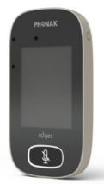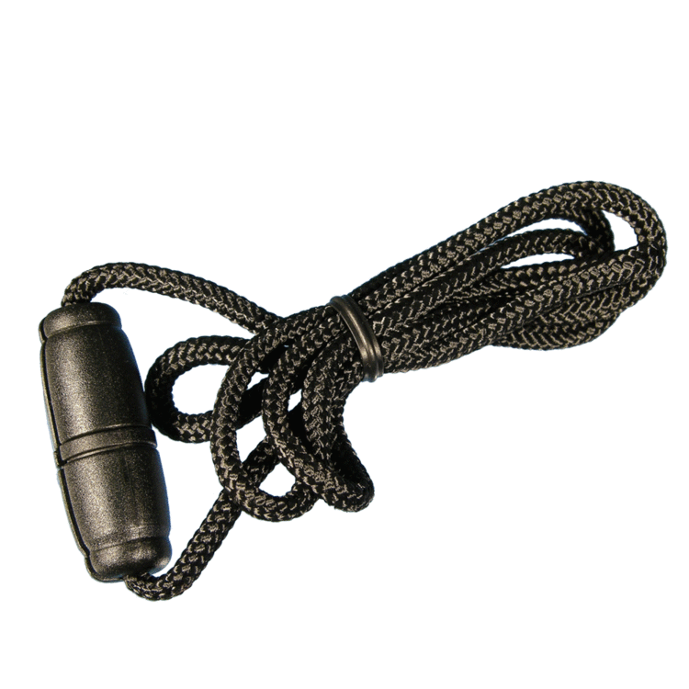 | ☐
2 x Receivers  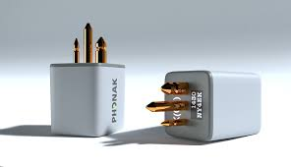 | ☐
2 x Shoes (*These are usually attached to the Receivers)  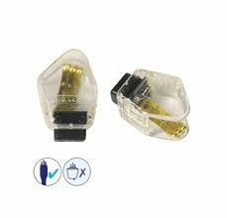 | ☐
Charger  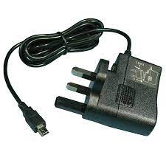 | ☐
Computer lead  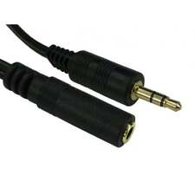 | ☐

This form should be returned to the school Principal/SENCo & to the Teacher of the Deaf

For further advice please contact the Sensory Service via phone: 028 25 661 258 or email: sensoryservice@eani.org.uk

