**EA Sensory Service** Education Authority Logo


## **Radio Aids Roger Inspiro**

Hearing aids and cochlear implant processors are essential pieces of equipment for deaf pupils. They enable them to hear the sounds of speech more clearly but they do not correct hearing in the same way that glasses correct vision. Hearing aids **do not**restore normal hearing.

There are three main problems when listening through a hearing aid/cochlear implant:

* Distance
* Background noise
* Reverberation or echoes

Hearing aids/cochlear implants also amplify unwanted background noise, in addition to the essential speech sounds. They work best within a radius of 1 metre. Beyond this, a pupil will experience difficulty in hearing their teacher’s voice.

For pupils with hearing aids/cochlear implants, the teacher's voice should ideally be 15-20dB above the background noise of the room, as it enters the child's ear. This is called the signal to noise ratio.

A radio aid system will help to overcome the problem of distance, and to improve the signal to noise ratio. This comprises a microphone and transmitter worn by the teacher, and receiver/s worn by the child, attached to their hearing aid or cochlear implant processor.

The microphone, worn close to the teacher’s mouth, picks up the teacher’s voice, and the sound is then transmitted to the child’s receiver. This enables the teacher’s voice to be received directly into the hearing aid or processor, wherever they are in the room, giving a more consistent and much improved signal to noise ratio.

Radio aids also help to reduce the effect of background noise, as the signal from the teacher’s voice is louder and stronger.

There are many different systems available commercially. The majority of radio aid systems currently used by the Sensory Service are Roger technology, the latest digital standard from Phonak.

The Qualified Teacher for the Deaf following discussion with the parents and the class teacher, will decide whether or not a radio aid system is appropriate. The Sensory Service will loan radio aid systems to pupils in schools, set them up, and train staff and pupils in their use and maintenance.

NDCS Technology on YouTube has a useful video on Radio Aids

Using the Roger Inspiro radio aid helps overcome the problem of unwanted background noise, sound reverberation and the distance between the speaker and the child with hearing impairment. It is essential that it is used appropriately. Benefit is dependent on those using it having a clear understanding of how to use it.

The system consists of a transmitter (the Roger Inspiro) and the receivers. The transmitter relays your voice directly into the receivers. The system enables direct, clear communication between the teacher and the deaf pupil.

### Transmitter (worn by teacher)

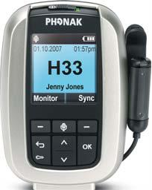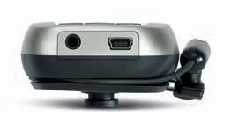

On/Off switch

colour LCD

iLapel microphone and clip

cable wrapper

up/down navigation

Soft Keys

keypad lock button

escape key

microphone mute button

-

Mini USB for Charging

3.5 mm audio input

### The receivers (worn by the pupil)

MicroMLxS

MLxi Roger X

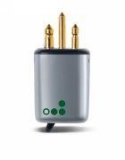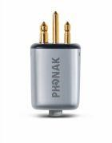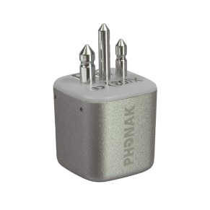

### How to use

* Wear on the belt with the clip or around the neck with the lavalier cord.
* Turn the transmitter on/off by sliding the button at the top.
* Check the battery is fully charged by looking at the battery image.
* Hold the transmitter near the pupil’s hearing aid, or near their chin if they have two hearing aids.
* Click the button under the word ‘Sync’. An ‘Identifying Receivers’ screen should appear, followed by a big tick. If everything is ok – press the back arrow.
* If receivers are not identified, check pupil’s hearing aids are working and receivers are pushed in fully. Changing hearing aid batteries often solves any problems.
* Clip the microphone to your clothing or to the lavalier cord. The transmitter microphone needs to be approximately 12cm or a hand-span from your mouth.
* The microphone will need to be muted on occasions using the mic/mute button.
* The Inspiro has a built in battery and should be charged after each school day to ensure it is fully charged for the next day.

### Guidance for Use

* The microphone should be MUTED when you are helping other individual pupils, – otherwise pupils with a hearing loss will continue to hear your voice directly into their ear which can be distracting. It should also be muted if you leave the room, otherwise the pupil will hear your private conversation.
* Speak clearly in a normal tone of voice and at a normal pace.
* It may be beneficial in class discussions to consider passing the transmitter to individual speakers.
* The transmitter can be used to relay audio signals from a variety of other devices, eg computer, CD/recorder/TV, etc using the lead supplied for this purpose. The teacher of the deaf can advise you about this.
* Use the radio aid system for school assemblies or if there are visiting speakers in the classroom.
* Avoid standing in a noisy place, such as next to an overhead projector or open window, as the microphone will pick up background noise and transmit this to the pupil. • Avoid letting the microphone knock against clothing or jewellery.
* Teenagers may be reluctant to use a radio aid system. This is partly because it is a nuisance carrying it around, giving it to the class teacher and taking responsibility for charging it daily and ensuring its safe keeping. Teenagers are also very self-conscious and don’t want to appear ‘different’ from their peers. They will require sensitive encouragement and support from their teachers to ensure the radio aid is well used.

### Troubleshooting

* Is the transmitter fully charged?
* Is the transmitter microphone cable fully unwound?
* Is the transmitter on the correct transmission frequency?
* Has the transmitter microphone inadvertently been muted?
* Have you replaced the pupil’s hearing aid batteries?
* If a problem remains unresolved, please contact the Sensory Service on 028 25661258.

For further advice please contact the Sensory Service via phone: 028 25 661 258 or email: sensoryservice@eani.org.uk