## Screen Mirroring with Collaborate Ultra

**Overview**

This information sheet outlines how to use Collaborate Ultra to mirror a screen from a desktop/laptop to a tablet.

**Presenter Instructions**

1. **Session Set-Up**
2. From the Chrome browser, log-in to MySchool and click Collaborate Ultra from the launch panel:

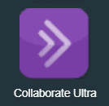

1. In Collaborate, click **Create a Session.**
2. Give the session a relevant name, and check the box to allow **Guest access**. This makes the Guest role and Guest link fields live. With the Guest role set to participant, copy the link that is displayed in the Guest Link box.
3. Under **Event Details**, select a **start time**. If the requirement is for an open-ended session or for a regularly timetabled session then select either **No end (open session)** or else **Repeat Session**. In the case of Repeat Session, the required details for a recurring session must be entered.

Under **Early Entry**, you may select no early entry for a session with a strict start time. For sessions with no end, this will not be important. It is worth noting that until you choose to share your screen, a viewer will only have access to an empty Collaborate space.

1. Once all settings have been entered as required, click **Save** to save your session settings.

You may now **send the Guest link** copied earlier by email to the required viewer. This can be done in advance, or at the time the pupil requires access. The link can be retrieved at any time by logging in to Collaborate Ultra and selecting the session settings.

1. **Running the session and sharing the screen**
2. When the presenter is ready to share their screen, they may relaunch Collaborate Ultra where the saved session will be available. Select the session and then select **Join Session** from the settings on the right.
3. Once the session has launched, open the **Collaborate Panel** by clicking the purple chevron in the bottom right of the screen. From here, select the **Share content** button to display the sharing options:

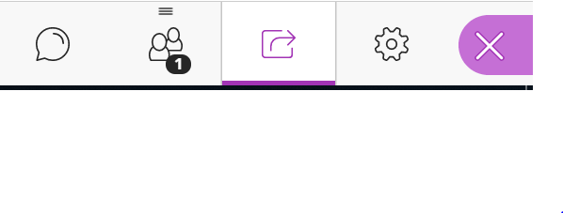

1. Select Share Application/Screen and choose what to share.

* **Your entire screen** will display whatever is visible on the screen.
* **Application Window** will only display the selected application and nothing else
* **Chrome Tab** will display whatever is visible within a tab in the Chrome browser and nothing else.

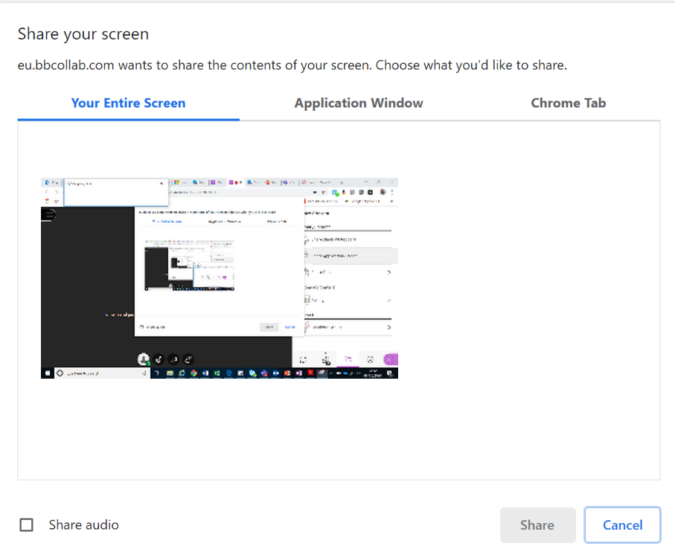

Select the required option and click **Share**. The viewer will now be able to view the content the presenter has chosen to share.

At any stage a presenter may stop sharing simply by clicking the **Stop Sharing** button.

**Viewer instructions**

When the presenter is ready to share the screen, the viewer should retrieve the URL sent by the presenter and open it in the browser (Safari on iPad). The viewer will be asked to enter their name and can then click **Join Session**. The viewer may be prompted to test camera and microphone settings, but these are not required for screen mirroring, so may be skipped.

When the presenter is sharing the viewer will be able to view the content being shared, in real time.

Note: If the presenter has set up a session with no end or as a repeating session, the viewer can save the URL and relaunch whenever it is needed.