**EA Sensory Service**  The logo has a tulip shape image in blue, green and yellow, with the letters EA and word Education Authority t
o right of the image. 

# The Audiogram

An **Audiogram** is a graphic representation of what we hear. An illustrative example of an audiogram can be found [here](https://www.theartofhearing.co.uk/post/what-is-an-audiogram).

This illustration shows a variety of everyday sounds plotted onto the Audiogram. The intensity **(loudness**) of sounds is plotted on the vertical axis, and measured in **decibels (dB)**. The frequency **(pitch)** of sounds is plotted on the horizontal axis, and measured in **Hertz (Hz)**. (Think of pitch on a piano: the low pitches are on the left, mid pitches in the middle and high pitches on the right.)

Every sound we hear has a particular loudness and pitch. For example, a lawnmower makes a sound that is about 100 decibels of intensity/loudness and is very low in frequency/pitch (about 260 Hz). A bird singing is about 10 decibels in intensity/ loudness and 6000 Hz in frequency/ pitch.

The illustration also shows where the sounds of human speech occur in English. Each sound is represented separately on the graph. You can see how speech is represented in a particular zone on the audiogram, right across the frequencies, from about 250Hz to 8000Hz. This is commonly referred to as the ‘speech banana’.

The low pitched (frequency) sounds like /u/, or the sound of a truck going by, are shown on the left side of the graph. High pitched sounds like /s/ and birds chirping, are on the right side of the graph.

When considering hearing loss, it is not enough to know that a child has a hearing loss; we need to know which sounds are affected and to what degree.

**Some examples of speech sounds and their frequencies are shown in the table below:**

| **Low Frequency Speech sounds** | **Middle frequency Speech sounds** | **High Frequency Speech sounds** |
| --- | --- | --- |
| (125 - 500Hz) | (500 - 2000Hz) | (2000 – 8000Hz) |
| ***a***as in h**a**t | ***ay*** as in pl**ay** | ***s*** as in **s**un |
| ***oo***as in f**oo**d | ***ee*** as in s**ee** | ***f*** as in **f**ace |
| ***ow***as in t**ow** | ***d*** as in **d**og | ***h*** as in **h**orse |
|  |  | ***th*** as in **th**in |

The loudness of any particular sound is measured in decibels (dB). In addition to knowing which sounds can be heard, it is important to establish how **loud** a speech sound has to be in order to be

Heard. Very quiet sounds are recorded towards the top of the graph in the Audiogram, with louder sounds recorded at the bottom.

The closer to the **top** of the audiogram the person’s responses are plotted, the **better** the person’s hearing.

The closer to the **bottom** of the audiogram the person’s responses are plotted, the **worse** that person’s hearing.

Hearing is tested across a range of sounds from low tones to high tones. **Hearing tests usually use frequencies, from 250 Hertz (Hz) – 8000 Hz, because they are the most important for understanding speech.**

The Audiologist may record your child’s hearing levels as an Audiogram. If so, the Audiologist will use O to represent the hearing level of the right ear, whilst X represents the left ear. Fig. shows an example of an audiogram of hearing in the normal range (up to 20 dB).

Fig. 1

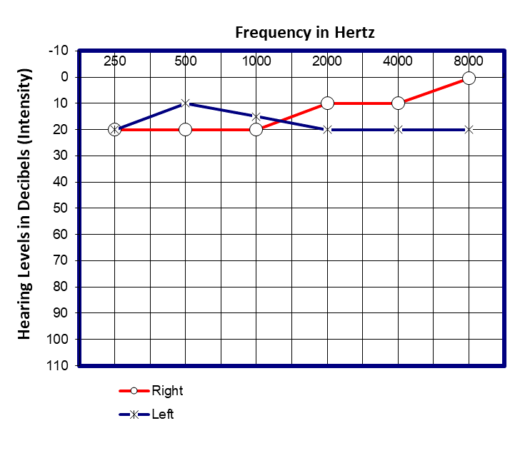

For further advice please contact the Sensory Service via phone: 028 25 661 258 or email: sensoryservice@eani.org.uk