Information for Parents and Carers about:
The Graduated Response

How the needs of children and young people (including those with Special Educational Needs - SEN) and or disabilities are supported across mainstream schools in Northern Ireland



Graduated Response - Information for parents and carers

‘All children are entitled to an education that is appropriate to their needs, promotes high standards and allows them to fulfil their potential’ (Draft CoP Schools’ Section)
The Graduated Response is the process schools should employ when assessing the needs of children and young people and providing appropriate provision. This provision should reflect increasing intensity as the child/young person moves through the stages of the Code of Practice.

What do we mean by SEN?
Who will help if my child needs extra support?
What are the broad areas of need?
What is the Graduated Response?
What is Whole School Educational Provision?
What is Special Educational Provision?
What is IPAMER?
What is a PLP?
What is Statutory Assessment?

What do we mean by SEN?
In the Education Order (NI) 1996, a child or young person is described as having special educational needs (SEN) if they have a significantly greater difficulty in learning than other children/young people which calls for special educational provision to be made for them that is additional to or different from educational provision which children/young people of a similar age receive in an ordinary school. A child/young person may also have SEN if they have a disability that calls for special educational provision to be made for them.

Who will help if my child/young person needs extra support?
Settings and schools have a person who is responsible for making sure children or young people with SEN get the right support. This person is called a Special Educational Needs Coordinator (SENCo)/Learning Support Coordinator (LSC). A SENCo/LSC will work with a child or young person’s teacher(s) to give advice and support.
If you think your child/young person might need more support with their learning, speak to your child/young person’s class teacher or SENCo/LSC.


What are the broad areas of need (SEN categories)?
Children/young people will have different types of SEN. The support and help a child or young person requires will depend on their needs. There are five overarching areas of need, and a child/young person may have needs across some or all these areas. Their needs may change over time.
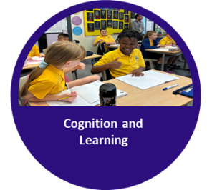 | Cognition and Learning  Children and young people across a range of ability can experience cognition and learning needs for a variety of reasons. They may learn differently than their peers and have difficulties accessing learning.
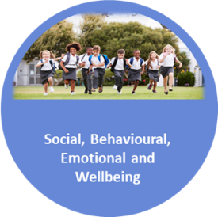 | Social, Behavioural, Emotional and Wellbeing  Difficulties with emotional regulation and/or social interaction and/or are experiencing mental health problems.
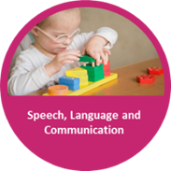 | Speech, Language and Communication  Is a broad category affecting speech, language and communication. Each of the 3 areas (SLCN) is dependent on the other and children may have difficulty with one, more or all aspects of speech, language and communication.
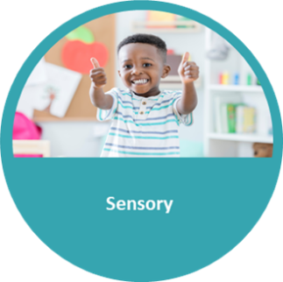 | Sensory  This includes vision, hearing, or multi-sensory impairments.
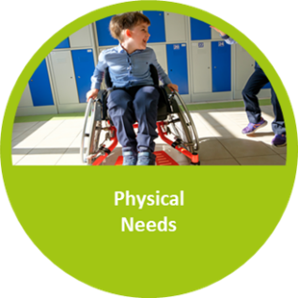 | Physical  This includes physical disabilities or sensitivities to aspects of the environment.

What is the Graduated Response?
Most children/young people with special educational needs and disabilities will be educated in mainstream schools or settings. The Graduated Response is the process schools should employ when assessing the needs of children and young people and providing appropriate provision. This provision should reflect increasing intensity as the child/young person moves from whole school educational provision through the stages of the Code of Practice if required. It provides a continuous six step cycle to identify, plan, action, monitor, evaluate and review in response to the progress the child/young person makes with their learning.

What is Whole School Educational Provision?
A whole school approach and ethos to promote inclusive practice is central to the Graduated Response. Whole school educational provision is at the start of the continuum of educational provision. All teachers, using their professional judgement, based on observations, assessments, and insight to the child or young person, should recognise and respond to the different abilities, aptitudes, interests, and diverse needs of their pupils through teaching and learning which offers a continuum of support.

What is Special Educational Provision?
Special Educational Provision is provision which is additional to or otherwise different from the educational provision which is normally provided to children/young people of the same age. Special Educational Provision should build upon effective differentiation in the classroom by intensifying whole school provision and focusing on supporting individual pupil needs. This is the whole school's responsibility.

What is IPAMER?
The Graduated Response expects schools to make full use of all their resources and provision before accessing increasingly specialist expertise.
The Graduated Response follows six steps: Identify, Plan, Action, Monitor, Evaluate and Review, as outlined in the draft SEN Code of Practice (2020).

Identify: Consider indicators of need within each SEN category, helping to identify priority learning needs of the child/young person. What does this pupil need right now?
Plan and Action: Consider strategies, interventions and provisions that can be used at whole school level and at stages 1 to 3 of the CoP. What will we do to meet this identified need?
Monitor, Evaluate and Review: the progress made within a set timeframe focusing on effective strategies and the impact of provision given to evaluate progress and agree next steps.

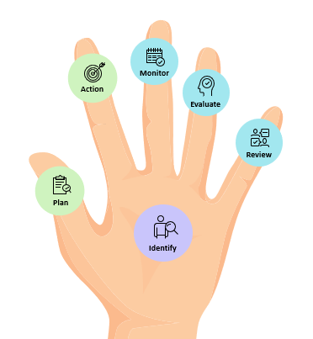


Parents/carers will be involved throughout the IPAMER process. Their views and the views of the child/young person are central to this cycle.

What is a PLP?
Schools use many teaching and learning strategies to cater for different abilities and ways of learning. However, if your child or young person does not make progress at the whole school level, the school may decide that special educational provision is needed, and their name will be added to the school’s SEN register. The SEN register holds specific information about each child/young person with SEN. Every child/young person who is listed on the school’s SEN register must also have a Personal Learning Plan (PLP).
The school will involve you in deciding what your child/young person’s priority needs are and what the content of their PLP should be. The school will also discuss what you can do to help support your child/young person at home. Only the school can decide if your child/young person should be placed on the SEN register and, if this decision is made, a PLP will be written to meet their needs.
A PLP will describe what strengths and difficulties your child/young person has and what the school is doing to best meet their needs.

Note: To prepare and keep a PLP for a child/young person with SEN is not a statutory duty for schools yet. Currently, some schools will use a similar planning document called an Individual Education Plan (IEP).

What is Statutory Assessment?
Statutory Assessment refers to a formal process aimed at identifying and addressing the special educational needs of children and young people. It determines any additional support required for a child or young person with SEN to adequately access the curriculum.

When does a child or young person undergo Statutory Assessment?
A child or young person may undergo Statutory Assessment when their educational needs cannot be met through the resources available within a mainstream school (Stage One of the Code of Practice) or through additional help from EA/Health (Stage Two of the Code). Typically, Statutory Assessment will be requested after a period of ongoing support has proved insufficient to meet the child or young person’s needs.

How is Statutory Assessment requested or referred?
A referral for statutory assessment may come from the school, the Educational Psychology Service, or a health care professional. Parents/carers of a child or young person may also make a request for consideration of a statutory assessment of educational needs. A referral or request for consideration of a statutory assessment does not automatically lead to a statutory assessment being initiated or to a statement of special educational needs being made.

Who can parents/carers or school staff speak to if more help or advice is needed?
The statutory Assessment and Review Service can be contacted for advice and information specific to children and young people who are undergoing the Statutory Assessment process or who have Statement SEN: Monday to Friday, 9am – 4.30pm. Telephone: 020 9031 7777 and select option 1. If known, you can contact your SEN Link Officer directly via email.
You can also contact the SEN Helpdesk to:
- Speak to the Statutory Assessment & Review Service with a specific query about a child – option 1.
- Request general advice about Special Educational Needs from the SEN Advice and Information Service – option 2.
- Speak to our SEN Support Services – option 3.
Everything you need to know about Statutory Assessment can be found on the EA website.

