Statutory Assessment Parent User Guide – Decision Point 1

Submitting Parental Consent and Representations after Notice of Consideration email issued.

This guide is for a parent/carer who receives an email from EA advising that a request for consideration of a Statutory Assessment has been submitted for their child.
It provides assistance on how to log onto the EA Connect portal, to submit parental representations and written evidence within 22 days of notice.

Example of email below:
Dear Parent/Guardian
Further to the request that Tester 2912’s educational needs should be assessed under the Education (Northern Ireland) Order 1996, the Education Authority is considering whether to make a statutory assessment.
In order for the Education Authority to make a decision, it will pay particular attention to evidence provided by you and that requested by the Education Authority from your child’s school, if Tester 2912 is enrolled at a school. Please click here Special Educational Needs and Disability (SEND) | SEND Plan for further information on the steps the Education Authority normally expects the school to have taken before such an assessment is requested. The Education Authority will also notify other relevant professionals who might later be asked for advice.
You have the right to make representations, and submit written evidence, to the EA within 22 days (from the date of this notice). The EA may take a decision before the expiry of the 22 days if we have your consent. You can make your representations, submit your evidence and provide your consent by following these steps:
Step 1: Create an account or login to EA Connect using the link https://connect.eani.org.uk/parent
Step 2: Select ‘Statutory Assessments’ on the Data Protection Statement or navigate to the Statutory Assessments menu item.
Step 3: If you have already created your child on EA Connect, click on ‘View Requests for Consideration’ to the right hand side of your child’s name. OR
If you have not created your child on EA Connect, add the child and then wait for up to 48 hours for the referral to show. Then click on ‘View Requests for Consideration’.
Step 4: On the table of requests, click on the request number and complete the details in the ‘Views of Persons with Parental Responsibility’ section.
Step 5: Click submit when completed.
Following consideration of all reports received and any representations or evidence that you send, the Education Authority will write to you again to let you know if the statutory assessment is required and, if so, the necessary arrangements. If you would like to discuss this further, to find out more information or get help with putting your views in writing please do not hesitate to contact me by calling the SEND Central telephone number 028 9031 7777 and choosing Option 1. For general SEN advice and information choose Option 2. The SEND Central telephone number is available weekdays from 9am to 4.30pm, excluding public holidays.
Further information is also available on the Education Authority’s website https://www.eani.org.uk/.
The Education Authority must make its decision whether to carry out a statutory assessment by Monday, 17 November 2025.
If there are exceptional personal circumstances affecting you or Tester 2912 or if you or Tester 2912 are going to be absent from Northern Ireland for a minimum of four weeks before Monday, 17 November 2025 which may delay the return of the information requested, please contact me using the contact details above. Any delay may have an impact on the overall timeframe.
If the Education Authority decides that a statutory assessment is not appropriate at this time, you will be informed of the reason for the decision.
The Education Authority aims to work in partnership with parents and schools and to resolve any concerns, however, you may wish to access the Dispute Avoidance and Resolution Service (DARS) as an independent means of resolving any disagreement (Tel: 028 90726060).
If you would like to discuss this further, to find out more information or get help with putting your views in writing please contact me via email or by calling on 028 9598 5960.
Yours sincerely
SEN Link Officer
- Using Google Chrome or Microsoft edge use the URL below:
https://connect.eani.org.uk/parent
- Enter your login details.
- Read the Data Protection Statement, tick the confirmation box and select. 
- Select Statutory Assessment:
The Statutory Assessment window opens:
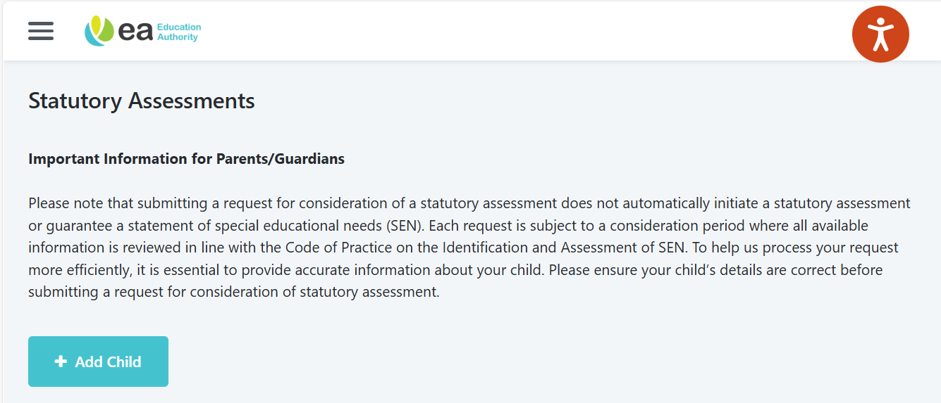
If your child DOES NOT APPEAR on your portal, select + Add Child button and enter their details on the form.
Example of a completed form:
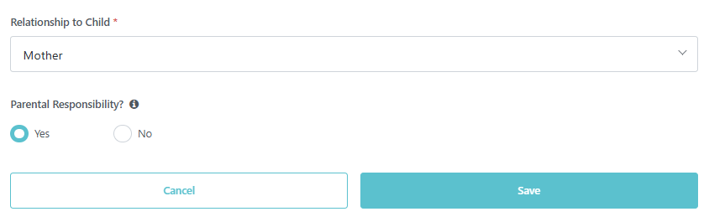
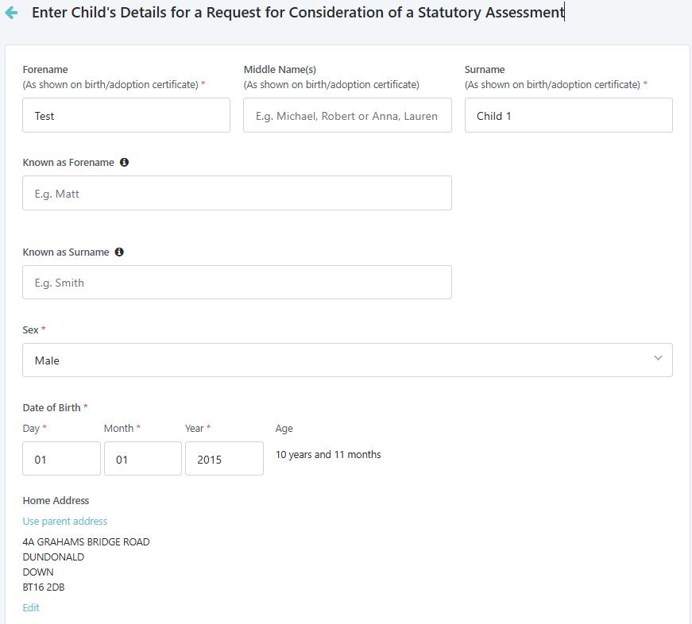
- Select the View requests for Consideration link which is beside or below your child’s name.
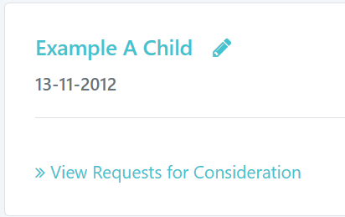
- A new screen will open displaying Statutory Assessment Requests. Open the request using the blue reference number.
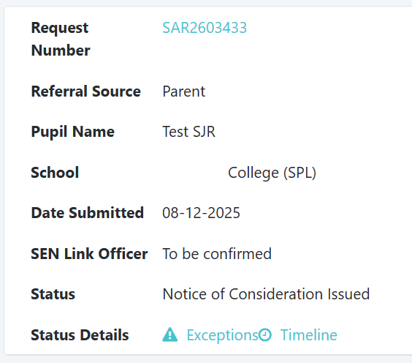
- RESPONSES MUST BE SUBMITTED BEFORE THE 22 DAY EXPIRY DATE.

Example of completed form below:

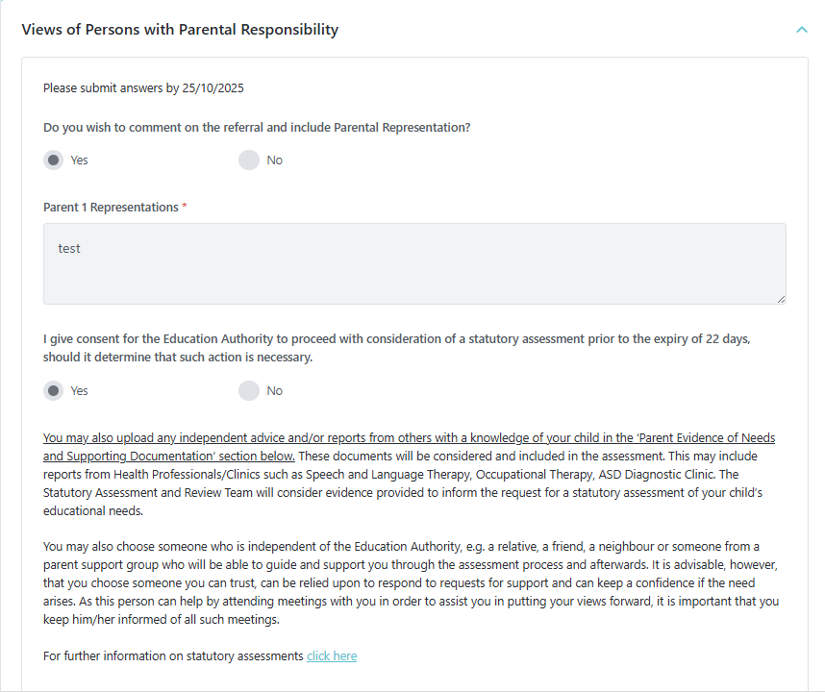
- To upload Parent Evidence of Needs and Supporting Documentation – select + Add Document button, upload required documentation and select Save.
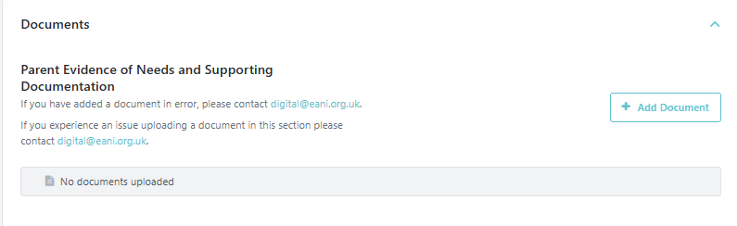

- Examples of document types available are listed below. Any type not detailed can be uploaded as an ‘Other’ type.
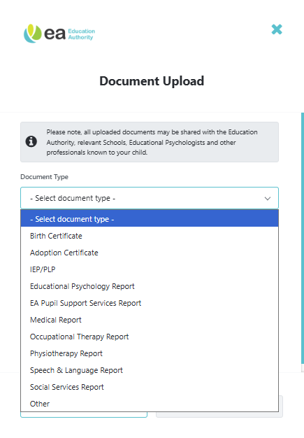

Statutory Assessment Process Timeline (26 weeks)

The status of the request can be viewed on the Timeline at any stage.

To view the Timeline, select the link from the Statutory Assessment Requests page as shown below:

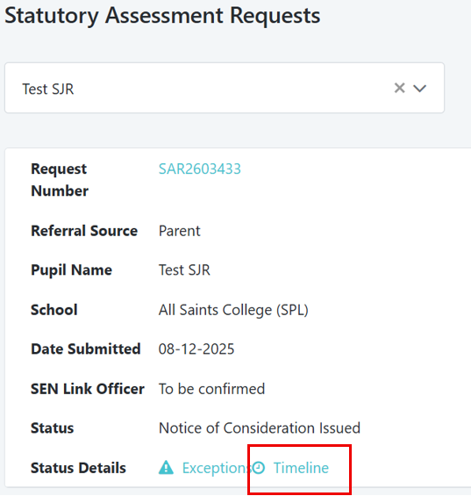

Example of the Timeline showing the Statutory Assessment Process at Received status:

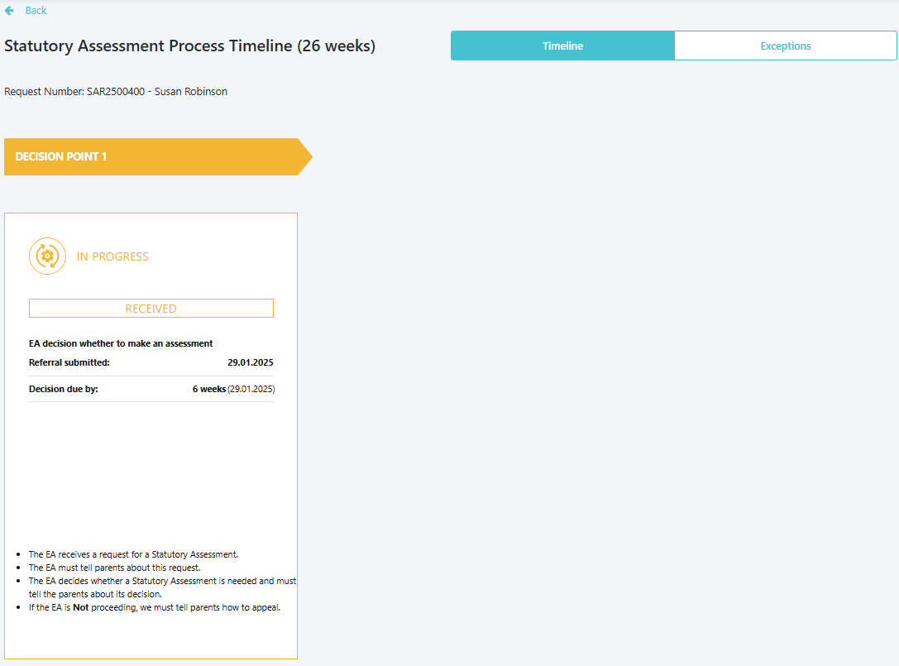

Example of the Timeline showing the Statutory Assessment Process at Notice of Consideration Issued status:

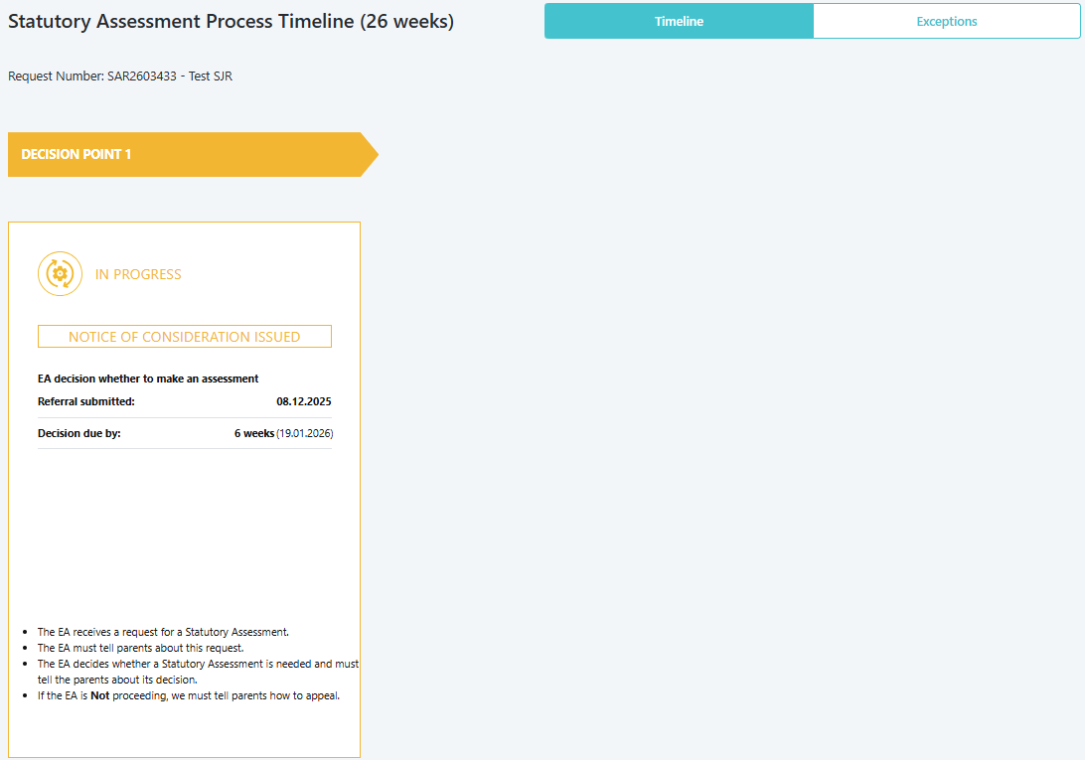

Example of the Timeline showing the Statutory Assessment Process at Under Consideration status:

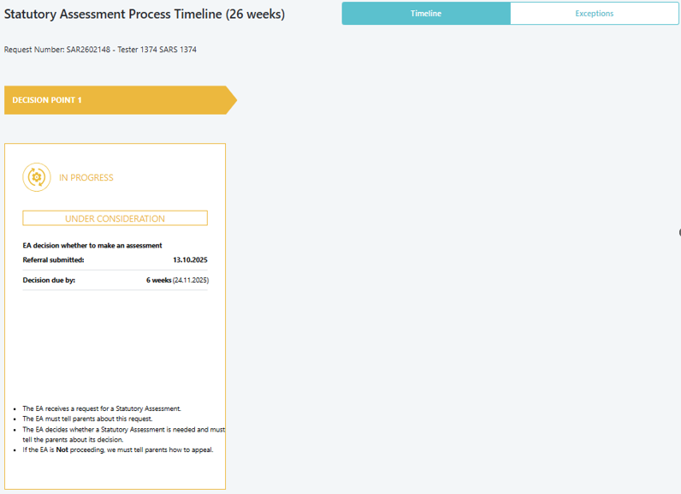

END OF DECISION POINT 1.

