Statutory Assessment Parent User Guide – Decision Point 2

SUBMITTING PARENT INFORMATION AND VIEWING THE ADVICES REQUESTED BY EA AFTER NOTICE OF DECISION EMAIL ISSUED

This guide is for a parent/carer who receives an email from EA advising that a Notice of Decision to proceed to request further advices from school, parents and other professionals for their child.
It provides assistance on how to log onto EA Connect portal to submit A Parental Information form which will support the request.

Example of email below:

Dear Parent/Guardian
On 30/09/2025 the Education Authority wrote to tell you that it was considering whether to assess Child Name educational needs. The Education Authority has now decided to carry out a statutory assessment.
If you provided parental representations/evidence, these are accessible to the appropriate professionals who will provide advice on Child Name as part of the assessment.
The Education Authority will seek advice from your child’s school (if enrolled), a Designated Medical Officer, Educational Psychologist, and other relevant professionals, who may contact you directly to make the necessary arrangements. You may wish to be present on these occasions. However, in some circumstances, e.g. a classroom observation, it may be more helpful to assess your child under normal classroom conditions without you in attendance. If you have any concerns about this, please speak to the professional concerned.

Your views about Child Name are also very important to the assessment. You can complete the Parental Information which will help you to put your views in writing. You may leave parts out or add anything you feel to be important.
Please complete the Parental Information within 6 weeks – not later than 19/11/2025. If the Education Authority does not hear from you by this date, it will assume you will not be submitting information.
You can complete the information using the following steps:
Step 1: Create an account or login to EA Connect using the link https://connect.eani.org.uk/parent
Step 2: Select ‘Statutory Assessments’ on the Data Protection Statement or navigate to the Statutory Assessments menu item.
Step 3: If you have already added your child on EA Connect, click ‘View Requests for Consideration’ next to your child’s name. OR
If you have not yet added your child, please add them first. Please note: It can take up to 48 hours for the referral to appear after adding your child. This is because the Education Authority needs time to match your child’s details. Once available, click on ‘View Requests for Consideration’.
Step 4: On the table of requests, click on the request number and go to the section titled Parental Information.
Step 5: Select the Parental Information Form button to open the form.
Complete any relevant sections and click submit when finished.
If you would like to discuss this further, to find out more information or get help with putting your views in writing please do not hesitate to contact me by calling the SEND Central telephone number 028 9031 7777 and choosing Option 1. For general SEN advice and information choose Option 2. The SEND Central telephone number is available weekdays from 9am to 4.30pm, excluding public holidays.
Further information is also available on the Education Authority’s website https://www.eani.org.uk/.
When all the advice has been received the Education Authority will inform you of its decision. Please note that should the Education Authority decide to issue a Proposed Statement, copies of any advice which is given, including your own information, will be circulated to all those who have been asked to contribute to the assessment.
Yours sincerely
SEN Link Officer

Using Google Chrome or Microsoft edge use URL below:
EA Connect - Login
- Enter your login details.
- Read the Data Protection Statement, tick the confirmation box and select. 
- Select Statutory Assessment:
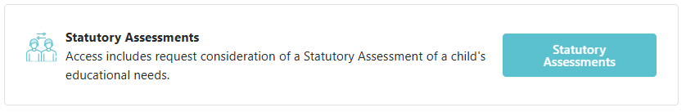

Statutory Assessment window opens:

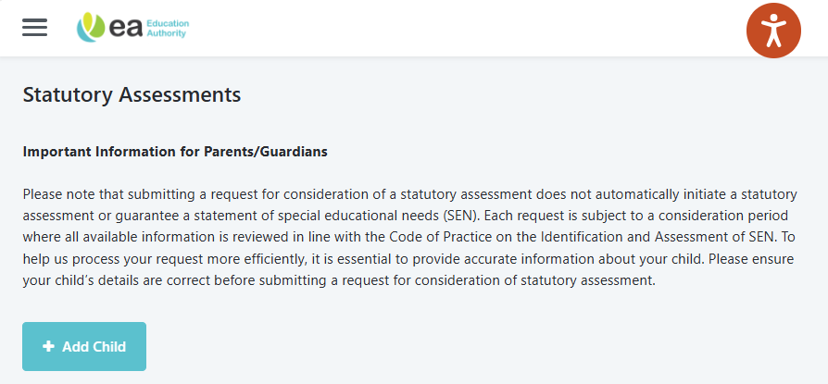

- Select View requests for Consideration and a new screen appears.
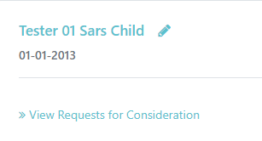

- To view Advices Requested by Education Authority select this button.

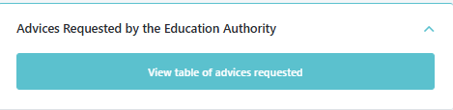

- This will show the advices that EA have requested and when and if reminder emails have been issued.
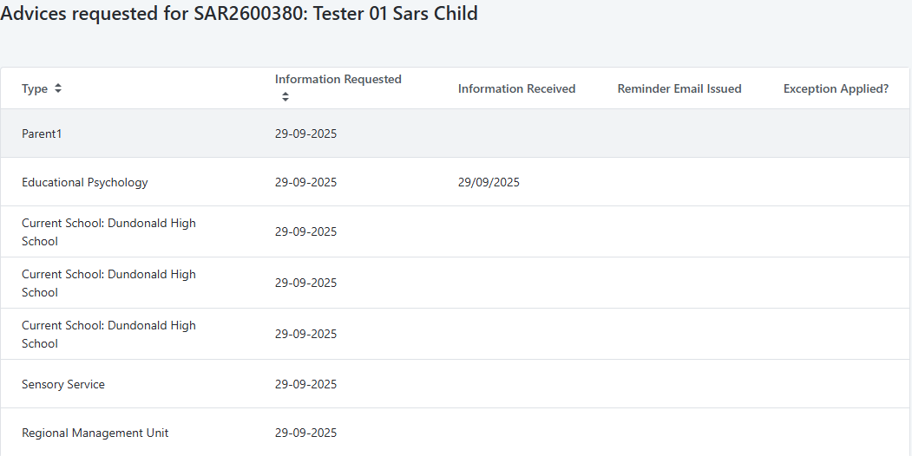

- To complete the Parent Information form, select button below and a new screen displays.

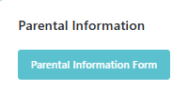

- Complete the questions as required.

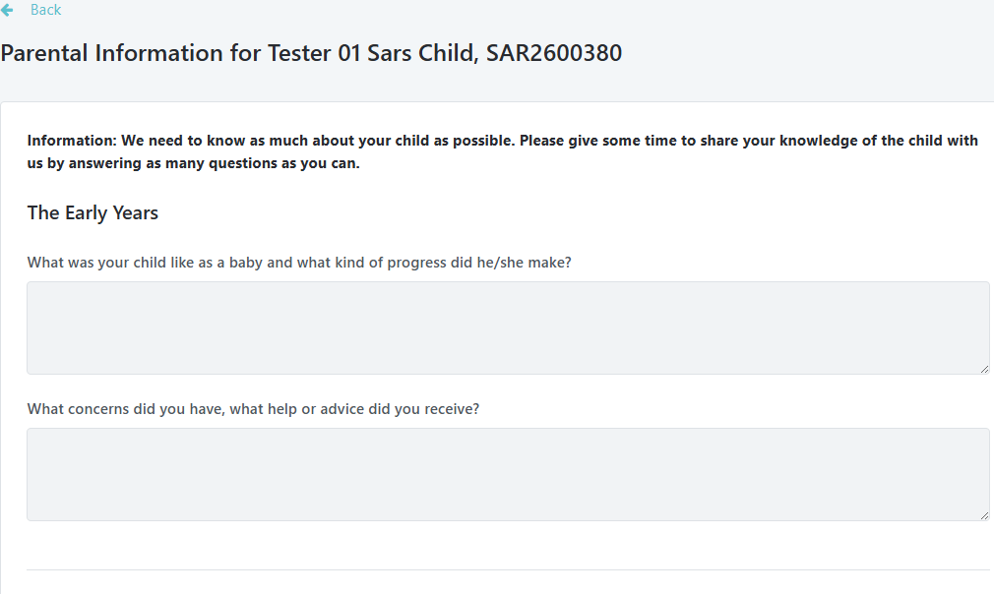
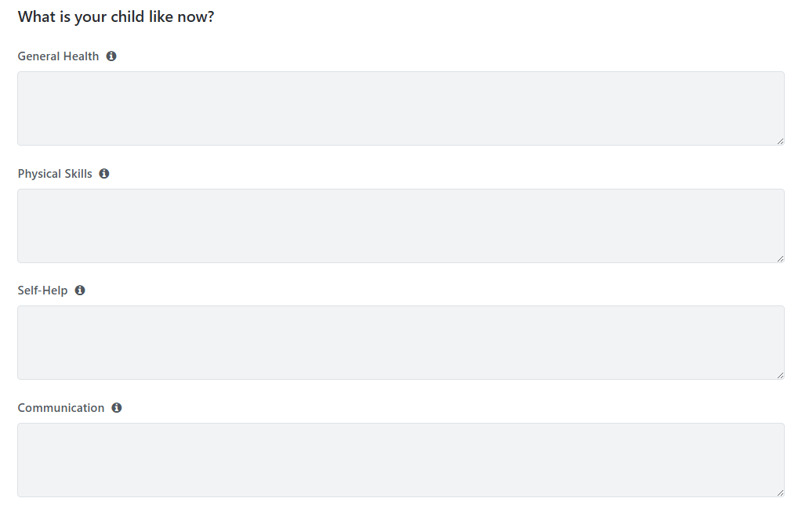
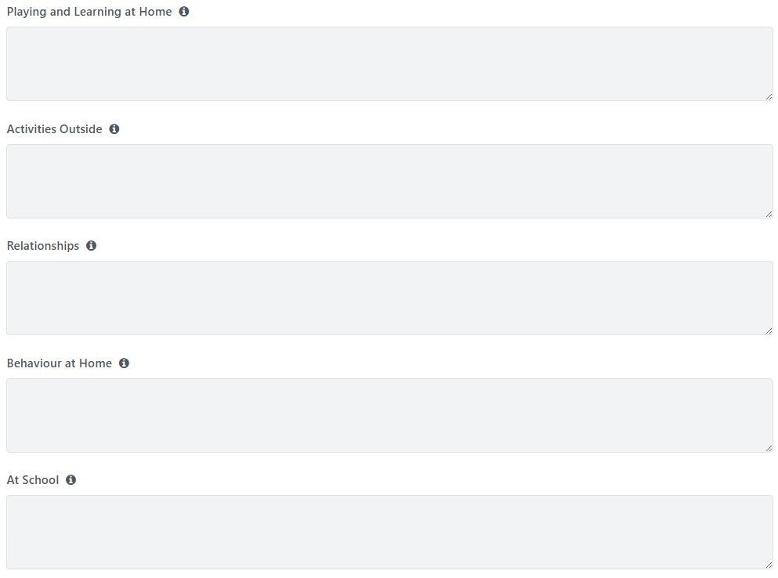
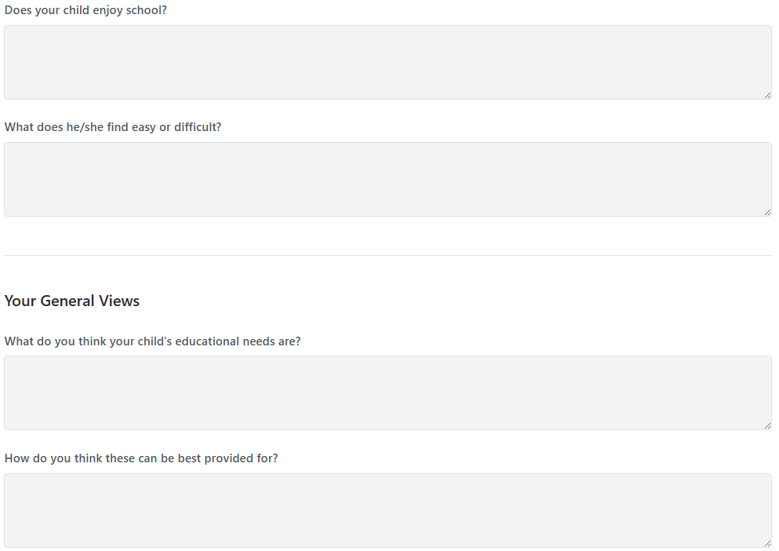

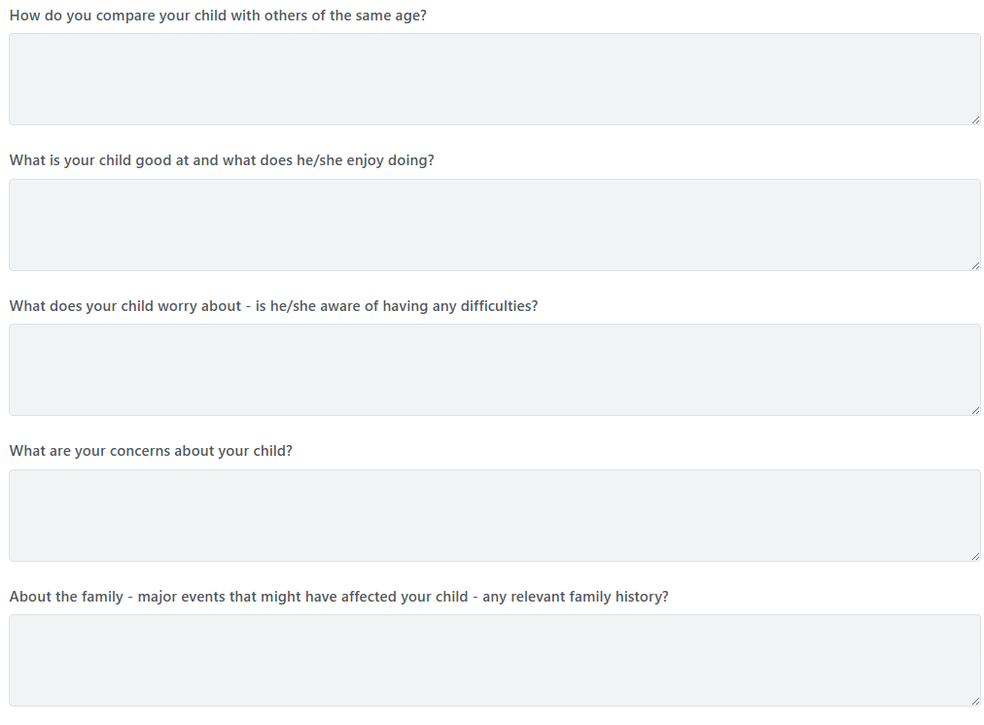
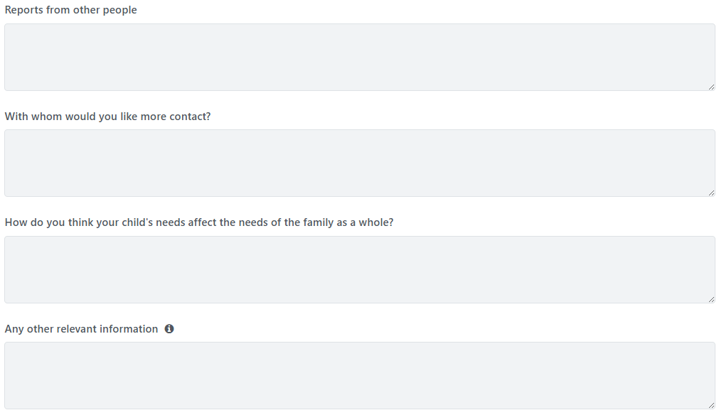
- To upload Parental Information Documentation – select Add Document button and upload required documentation and select Save.

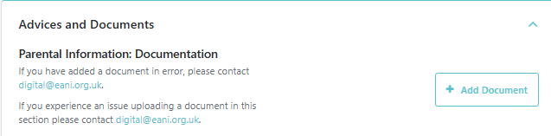

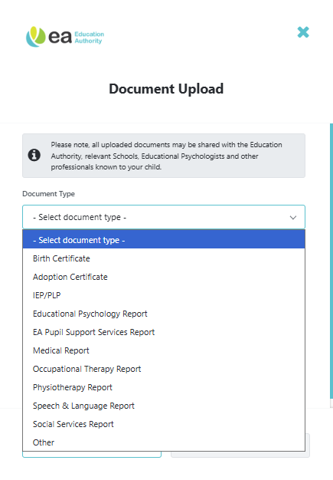

Statutory Assessment Process Timeline (26 weeks)

The status of the request can be viewed on the Timeline.
- To view select Timeline button.
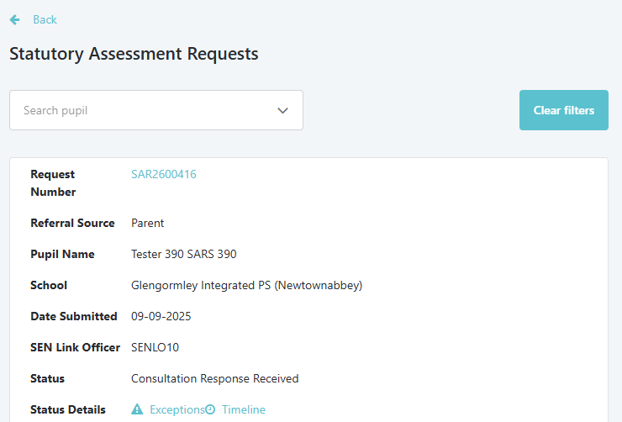

TIMELINE SHOWING STATUTORY ASSESSMENT PROCESS AT ASSESSMENT STARTED STATUS

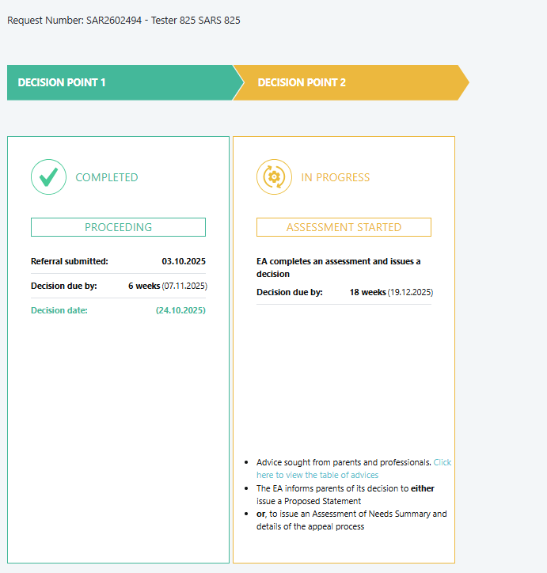

TIMELINE SHOWING STATUTORY ASSESSMENT PROCESS AT ADVICES RECEIVED – UNDER CONSIDERATION STATUS

