Statutory Assessment Parent User Guide – Decision Point 3

SUBMITTING PARENTAL CONSIDERATION OF PROPOSED STATEMENT

This guide is for a parent/carer who receives an email from EA advising that a decision to Proceed or Not to Proceed to Proposed Statement has been made for their child.
This guide provides assistance on how to log onto EA Connect portal to either:
- View and download an Educational Needs and Support Summary Document or submit parental information form which will support the request;
- View and download a Proposed Statement and provide Parental Consideration of Proposed Statement.

Example of email for Not Proceeding with Statement below:
Dear Parent/Guardian
The Education Authority has completed a statutory assessment of Child Name's educational needs.
After careful consideration of all the reports and professional advice received, the Education Authority has concluded that a Statement of Special Educational Needs is not required. This decision is based on the outcome of the assessment, which found that Child Name does not present with special educational needs that require provision beyond what is ordinarily available in a mainstream school setting. You can now view the outcome of the assessment, including the Educational Needs and Support Summary and the professional advice received, by logging in to EA Connect or by accessing the secure link below:
http: SECURE LINK
To ensure the security of your child’s information, you will be asked to verify your identity by entering your email address and your child’s date of birth.
These documents will also be shared with the Principal of Child Names’s school and the professionals involved in the assessment, to support their understanding of your child’s educational profile and ensure appropriate support continues, if needed.
If you wish to discuss the outcome of the assessment, please do not hesitate to contact me by email or by calling SEND Central telephone number 028 9031 7777 and choosing Option 1. For general SEN advice and information choose Option 2. The SEND Central telephone number is available weekdays from 9am to 4.30pm, excluding public holidays.
Further information is also available on the Education Authority's website https://www.eani.org.uk/.
If you do not agree with the Education Authority’s decision, you have the right to appeal to the Special Educational Needs and Disability Tribunal. You must do so within two months of receiving this notification. The Tribunal can be contacted at: Tribunal Hearing Centre,2nd Floor, Royal Courts of Justice, Chichester Street, Belfast, BT1 3JF Tel: 028 9072 4847
You may wish to access the Dispute Avoidance and Resolution Service (DARS), Global Mediation, 5559 Adelaide Street, Belfast, BT2 8FE (Tel: 028 9072 6060, Email: DARS@globalmediation.co.uk). Using the DARS does not affect your rights or prevent you from appealing to the Tribunal at the same time as any disagreement resolution.
Yours sincerely
SEN Link Officer

Example of email for Proceeding with a Proposed Statement below:
Dear Parent/Guardian
I am pleased to inform you that the Proposed Statement of Special Educational Needs for Child Name is now available to view.
You can access the Proposed Statement and all professional advice received during Child Name's assessment by clicking the secure link below or by logging into EA Connect.
https: SECURE LINK
To ensure the security of your child's information, you will be asked to verify your identity by entering your email address and your child's date of birth.
If you want to meet us to talk about the Proposed Statement, you need to contact us within 15 days of receiving this email. This is not the Final Statement. You have the right to request changes and provide your views. It is important that you complete and submit your response through EA Connect within 15 days (Friday, 31 March 2026).
What do you need to do:
Log in to EA Connect and complete the following steps on the Section called Parental Consideration of Proposed Statement.
•Review the Proposed Statement and supporting professional advice.
•Indicate whether you agree or disagree with the content.
•Provide comments or request changes.
•Submit your school preference.
•Indicate your preferred method of contact (if applicable).
Structure of the Proposed Statement
The Proposed Statement is divided into six parts:
Part 1: Introduction
Part 2: Special Educational Needs
Part 3: Special Educational Provision (including objectives and monitoring arrangements)
Part 4: Placement
Part 5: Non-Educational Needs
Part 6: Non-Educational Provision
School Preference
In this section you can tell me where you think Tester 303 should be educated. You can tell us which grant aided school or grant aided special school you would like Child Name to go to and the reasons why. To help you decide, a list of all the grant aided schools in the area is available on request.
If you suggest the name of a grant aided school, we must name the grant aided school, whether mainstream or special, in Part 4 of the statement unless
(a) the school is unsuitable to Child Name's age, ability or aptitude or to their special educational needs, or
(b) the attendance of Child Name at the school would be incompatible with the provision of efficient education for the children with whom they would be educated or the efficient use of resources.
If you think that Child Name should attend a non grant aided special school or an independent school you can suggest the name of a school and tell me why you think the school should be named in Child Name's Statement.
Parent Representations
You may make representations about the Proposed Statement.
•You may within 15 days of this email make representation and request that a meeting be arranged with an Officer of the Education Authority to discuss your preference of school or the contents of the Proposed Statement.
•If you attend a meeting with us to discuss this Statement after receiving this email you will have another within 15 days from that meeting to suggest a school.
•Within 15 days of such a meeting you may make further representations, or if you disagree with any part of the assessment, require the Education Authority to arrange a meeting or meetings to discuss the advice used in the assessment with the person who gave the advice or someone else they suggest, or any other person the Education Authority considers is the appropriate person to discuss it with you. We can arrange more than one meeting if necessary, if you disagree with more than one part of the advice.
•Within a final within 15 days from the last meeting you may make further comments to us.
Once all these stages are finished we will send you a Final Statement that will have Part 4 completed and, as appropriate, amendments made as a result of representations.
If you do not complete the Parental Consideration section on EA Connect or contact us within 15 days, the Education Authority may proceed to name a school in Part 4 and issue the Final Statement accordingly.
Consultation on Specifying Name of School in the Statement
When we are considering specifying the name of a grant aided school in the statement we will send a copy of the Proposed Statement to the school in question in order to consult with the Board of Governors.
Any Questions or Concerns
If you have any questions or concerns about this process, or disagree with any part of the statement, you may wish to seek advice from the SEND Central telephone service. Call 028 9031 7777 and choose from either Option 1 for your local SARS Office, or Option 2 for general SEND advice and information. The SEND Central telephone number is available weekdays from 9am to 4.30pm, excluding weekends and public holidays.
You may also wish to make use of the Dispute Avoidance and Resolution Service (DARS) [DARS - Global Mediation](https://www.globalmediation.co.uk/service/dars/), Global Mediation, 55 59 Adelaide Street, Belfast, BT2 8FE (Tel: 028 9072 6060, Email: DARS@globalmediation.co.uk, which may help to avoid and resolve disputes between you and the Education Authority.
Right of Appeal
Using the Dispute Avoidance and Resolution Service (DARS) does not prevent you from appealing to the Special Educational Needs and Disability Tribunal about Parts 2, 3 or 4 of the Statement at the same time. Your rights are not affected and an appeal to the Tribunal can take place at the same time as any disagreement resolution.
When you receive the final statement, if you disagree with Parts 2, 3 or 4 you can appeal to the Special Educational Needs and Disability Tribunal. The Tribunal can hold a hearing to decide what should be in these parts of Tester 303's Statement. You have two months from receiving the Final Statement to appeal to the Tribunal, the address of which is Tribunal Hearing Centre, 2nd Floor, Royal Courts of Justice, Chichester Street, Belfast BT1 3JF. Tel: 028 9072 4847 or 028 9072 4886. Email: SENDIST@courtsni.gov.uk.
If you have any questions, now or at any time, about this process or about the Statement itself, please contact me to discuss or to make an appointment to meet with me.
Yours sincerely
SEN Link Officer

Login to EA Connect using Google Chrome or Microsoft edge with the URL below:
https://connect.eani.org.uk/parent/
- Enter your login details.
- Read the Data Protection Statement, tick the confirmation box and select.


- Select Statutory Assessments.
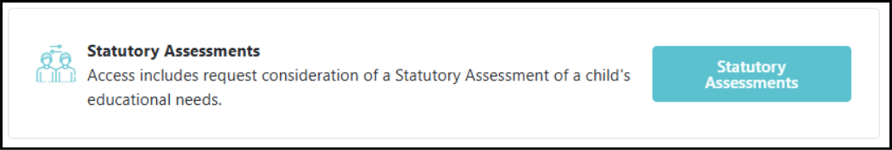

IF DECISION IS NO STATEMENT
- The Educational Needs and Support Summary Document can be viewed and downloaded from the portal.
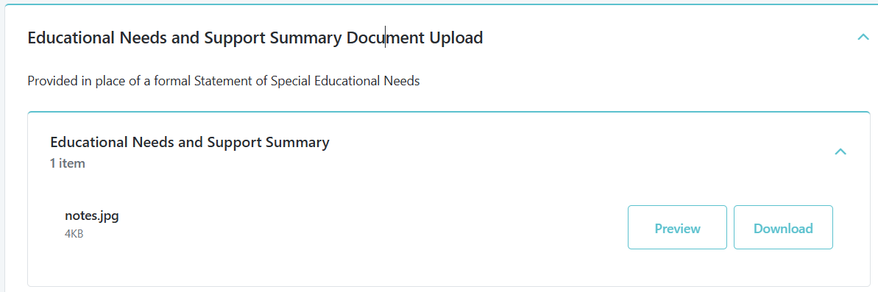

IF DECISION IS PROCEED TO PROPOSED STATEMENT

- The Proposed Statement is available to download on EA Connect portal.
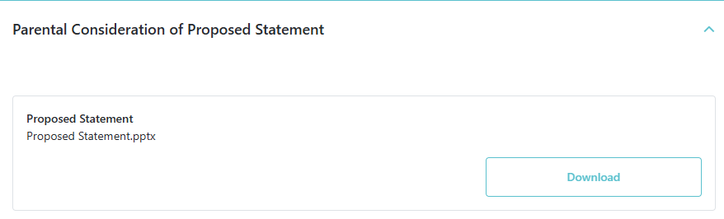
- To complete the Parental Consideration of Proposed Statement – complete form below:
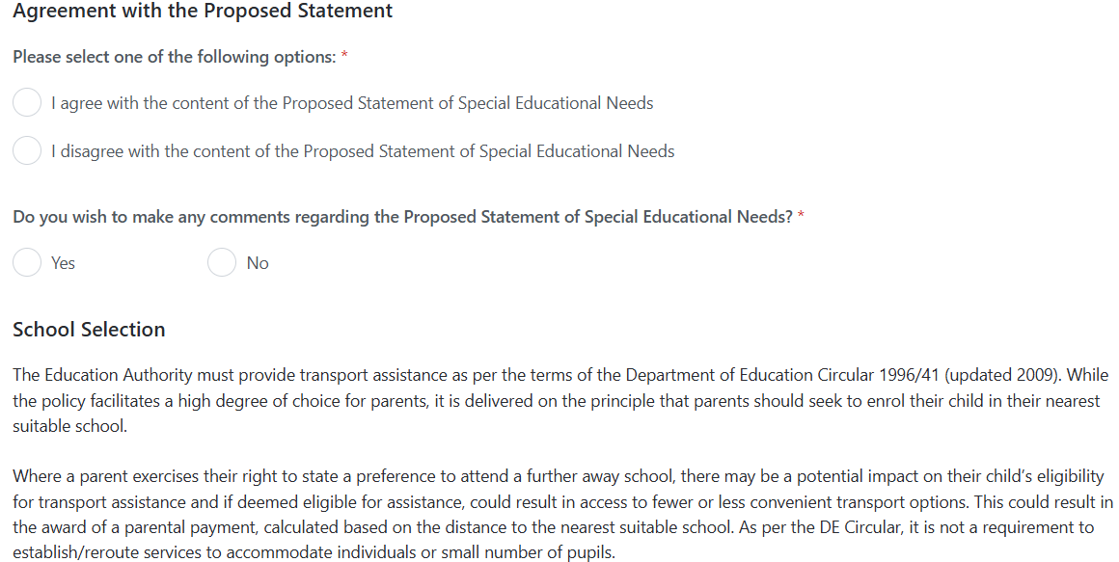
- Select School Type and then the school wish to nominate as preference:
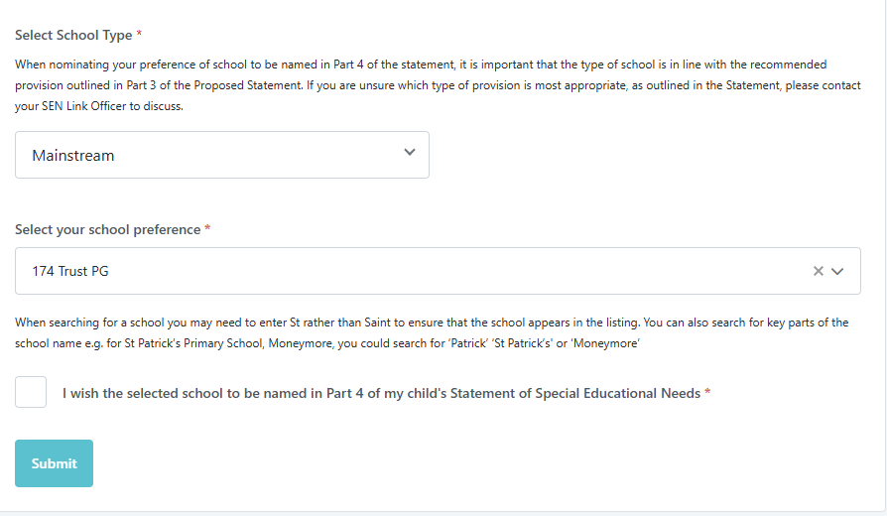
- To upload Parent: Proposed Statement – click Add Document.
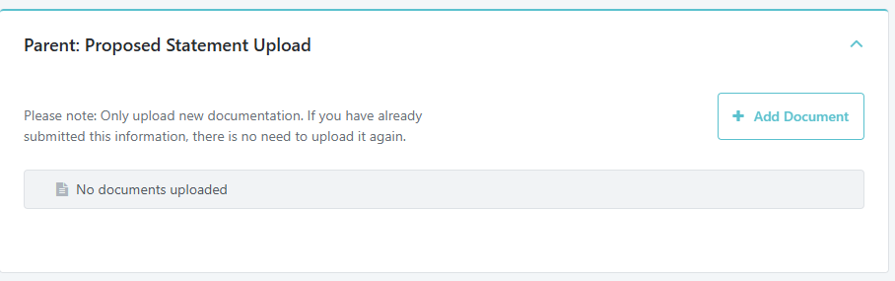

Statutory Assessment Process Timeline (26 weeks)
The status of the request can be viewed on the Timeline.
- To view select Timeline button.
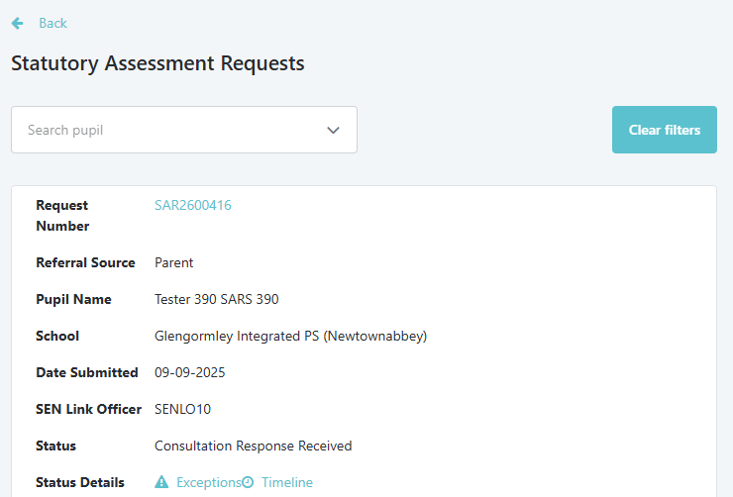
Timeline showing No Statement
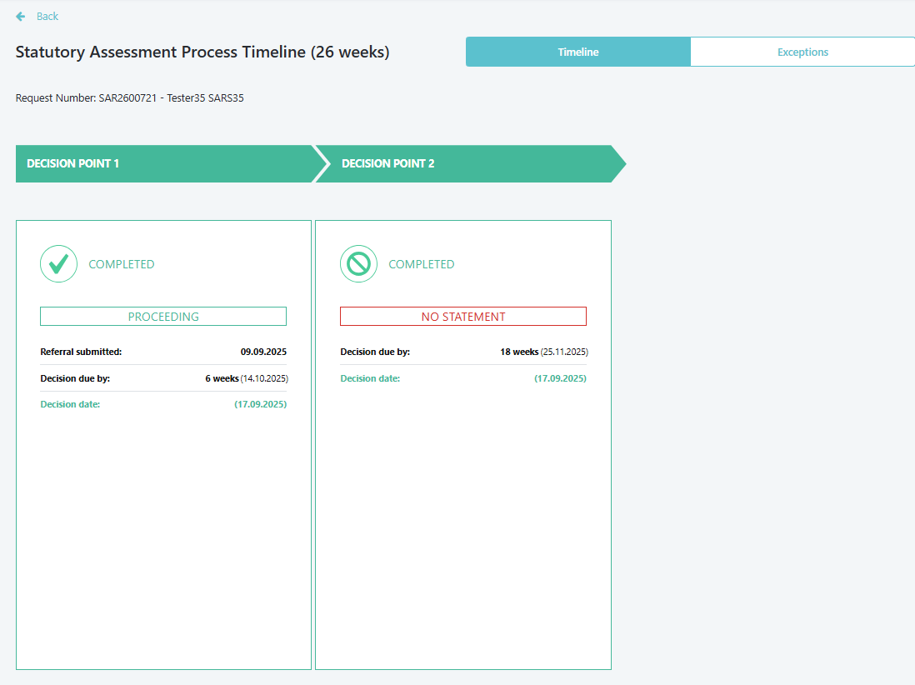

Timeline showing Proposed Statement

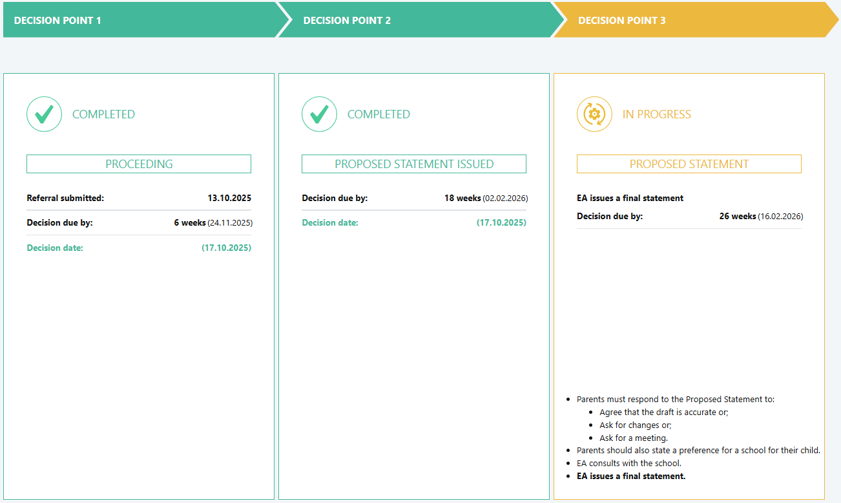

Timeline showing Consultation Response Received from School

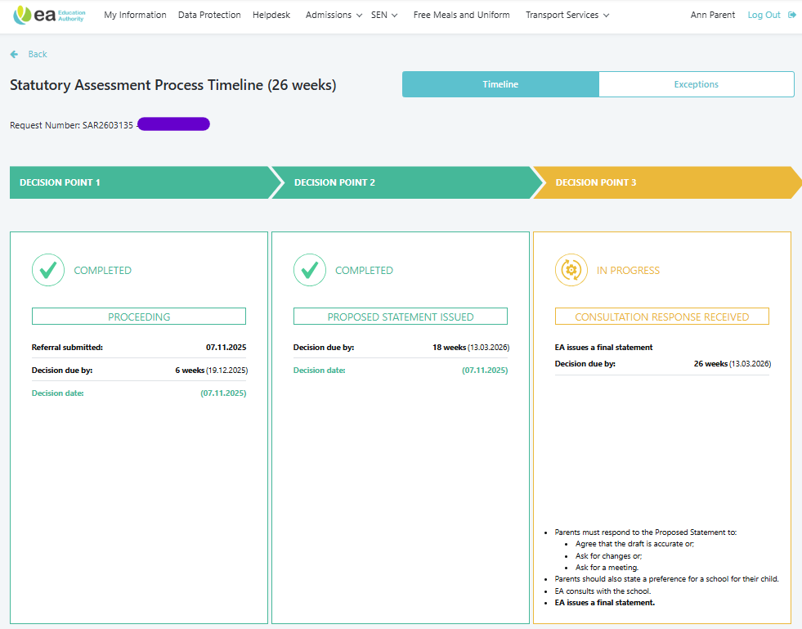

Timeline showing Final Statement issued.

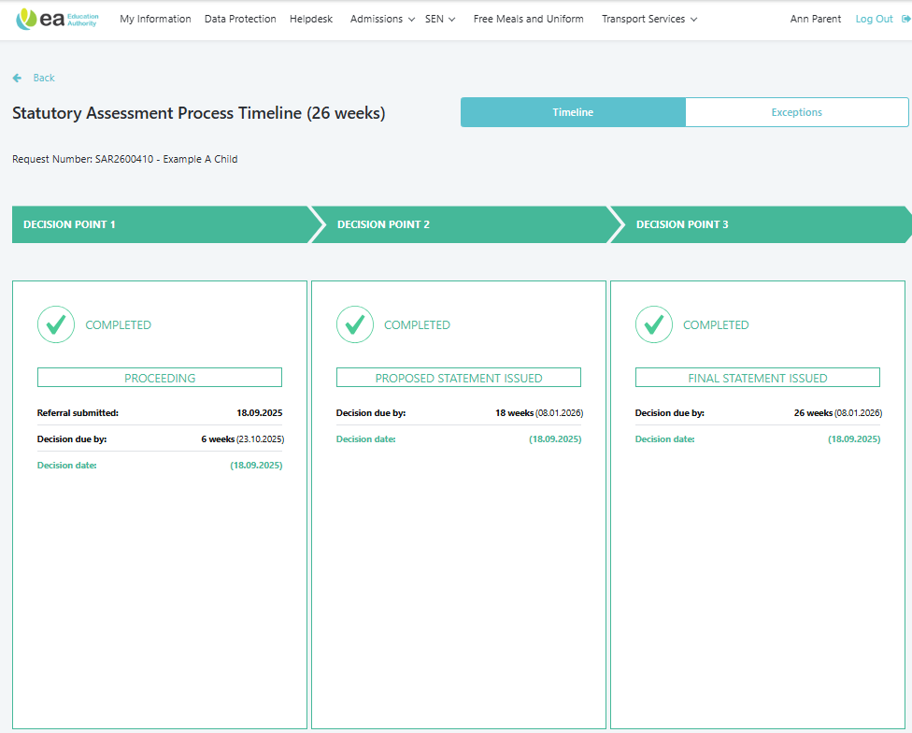

Final Statement Issued

Once a final school has been agreed, parent will receive email with unique link to access Final Statement and available to view on EA Connect.
Example email below:
Dear Parent/Guardian
I am pleased to inform you that the Final Statement of Special Educational Needs for Child Name is now available.
You can access the Final Statement and all professional advice received during Child Name’s statutory assessment by clicking the secure link below or by logging into EA Connect.
https:SECURE LINK
To ensure the security of your child's information, you will be asked to verify your identity by entering your email address and your child's date of birth.
Once you have read the statement, if you disagree with:
(a) the description in Part 2 of the Statement of Child Name's special educational needs; or
(b) the description in Part 3 of the Statement of the special educational provision to be made for the purpose of meeting Child Name's needs; or
(c) the school, if any, named in Part 4 of the Statement; or
(d) the decision, if any, not to name a school in the Statement;
you have the right under Article 18 of the Education (Northern Ireland Order)1996 to appeal to the Special Educational Needs and Disability Tribunal. If you wish to do so you must lodge an appeal within two months of receipt of this email. Details of how to appeal may be obtained from The Special Educational Needs and Disability Tribunal, Tribunal Hearing Centre, 2nd Floor, Royal Courts of Justice, Chichester Street, Belfast BT1 3JF - Telephone 028 9072 4847 or 028 9072 4668. Email: SENDIST@courtsni.gov.uk
In addition, you may wish to contact the Dispute Avoidance and Resolution Service (DARS), Global Mediation, 55-59 Adelaide Street, Belfast, BT2 8FE (Tel: 028 9072 6060, Email: DARS@globalmediation.co.uk). This does not affect your right to appeal to the Tribunal.
Child Name's needs will be reviewed every year and you will be invited to contribute written advice and to attend the review meeting. If it is proposed to amend the Statement in any way or to cease it you will be informed and have a right to make your views known.
If you require at any time further information or advice about your child's special educational needs, either contact the Principal of Child Name's school or contact me by calling the SEND Central Telephone number 028 9031 7777 and choosing Option 1. For general SEN advice and information, choose Option 2. The SEND Central telephone number is available weekdays from 9am to 4.30pm, excluding public holidays.
Yours sincerely
SEN Link Officer

- Click on link in email and the below screen will appear.
- The Final Statement is available to preview or download.

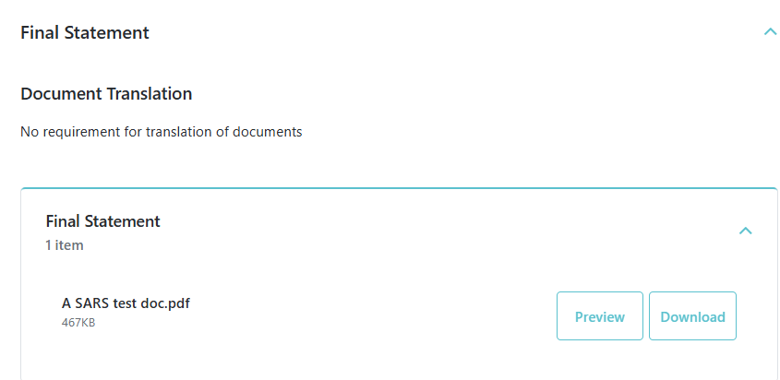

Statutory Assessment with Exceptions added.

- Select the Exceptions button to view details of Exceptions applied.
