SCHOOLS STATUTORY ASSESSMENT - Quick Reference Guide

SUBMITTING A REQUEST FOR CONSIDERATION OF A STATUTORY ASSESSMENT

Login to EA Connect (using option A or B detailed below):

Option A
- From the EA website, Statutory Assessment | SEND Plan click EA Connect Login button.

- Enter your login details and accept the GDPR statement.

Option B
- Open Google Chrome or Microsoft Edge.
- Go to the https://connect.eani.org.uk/school/Login
- Enter your login details and accept the GDPR statement.
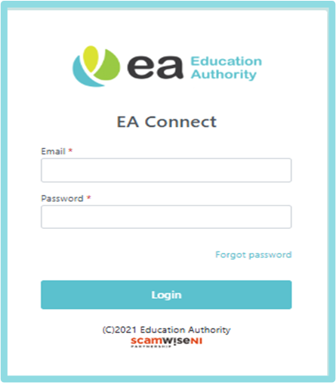

Access Statutory Assessment Screen
- Select Menu → Statutory Assessment.

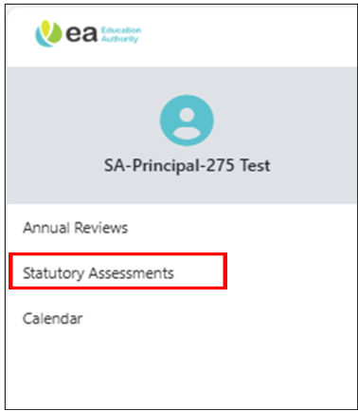
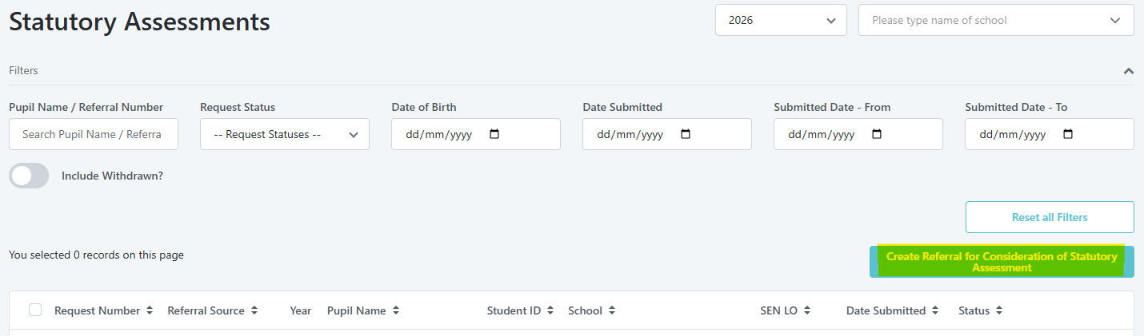
- Click ‘Create Referral for Consideration of SA’.

Step 1 – Before You Start
- Review information provided regarding requirements for submitting a referral request.
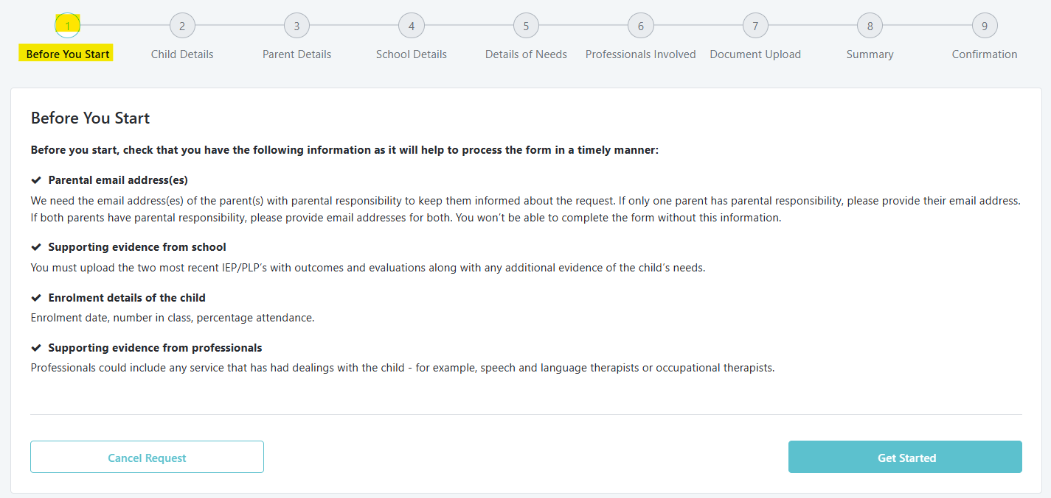
- Click Get Started.

- Select your school from the dropdown list in the pop-up received → Continue.
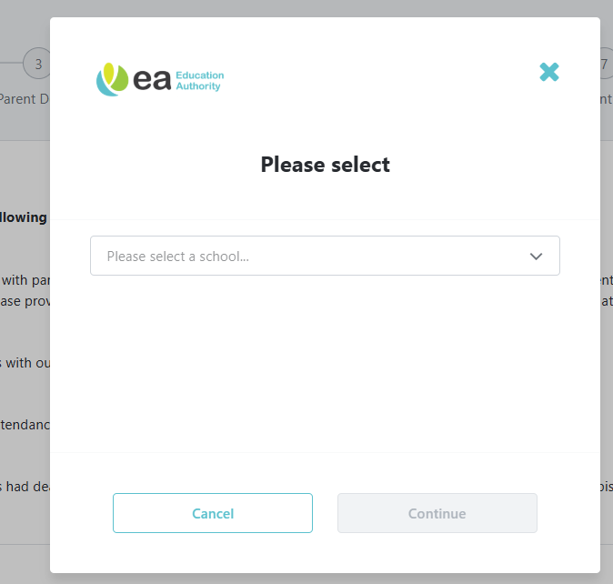

Step 2 – Child Details
- Search for pupil name by typing the name → select the pupil from the displayed pupils. The pupil data will auto-populate with data from EMS.
IMPORTANT: If you are unable to find the pupil, please contact digital@eani.org.uk.
- Complete all mandatory fields (marked with *).
- Note: Red banner with information will be displayed if referral already exists.
- Note: Cannot resubmit a referral if < 6 months since Final/Amended Statement.
- Can resubmit if ≥ 6 months.
- Click Save to save progress, or Next to save and continue to next step.

Field Name | Mandatory/  Optional | Notes
Pupil | Mandatory | Select the pupil from the list.
Name | Auto-populated | Based on pupil selection.
Date of Birth | Auto-populated | Based on pupil selection.
Age | Auto-calculated | Display only.
Sex | Auto-populated | Based on pupil selection.
Address | Auto-populated | Based on pupil selection.
Spoken Language | Mandatory | Select the language spoken at home.
Does the parent need their documents translated? | Mandatory | Options: Yes / No
Are there any orders under Child Care Law which affect the child? | Mandatory | Options: Yes / No / Don’t Know
Are there any family circumstances which the Education Authority should be aware of when making contact? | Mandatory | Options: Yes / No / Don’t Know
Health Number (if known) | Optional | Enter if available.
Name of HSC Trust | Mandatory | Select from list (e.g., Belfast, Northern, etc.).
Does the child receive any support from a HSC Trust Service(s)? | Mandatory | Options: Yes / No / Don’t Know

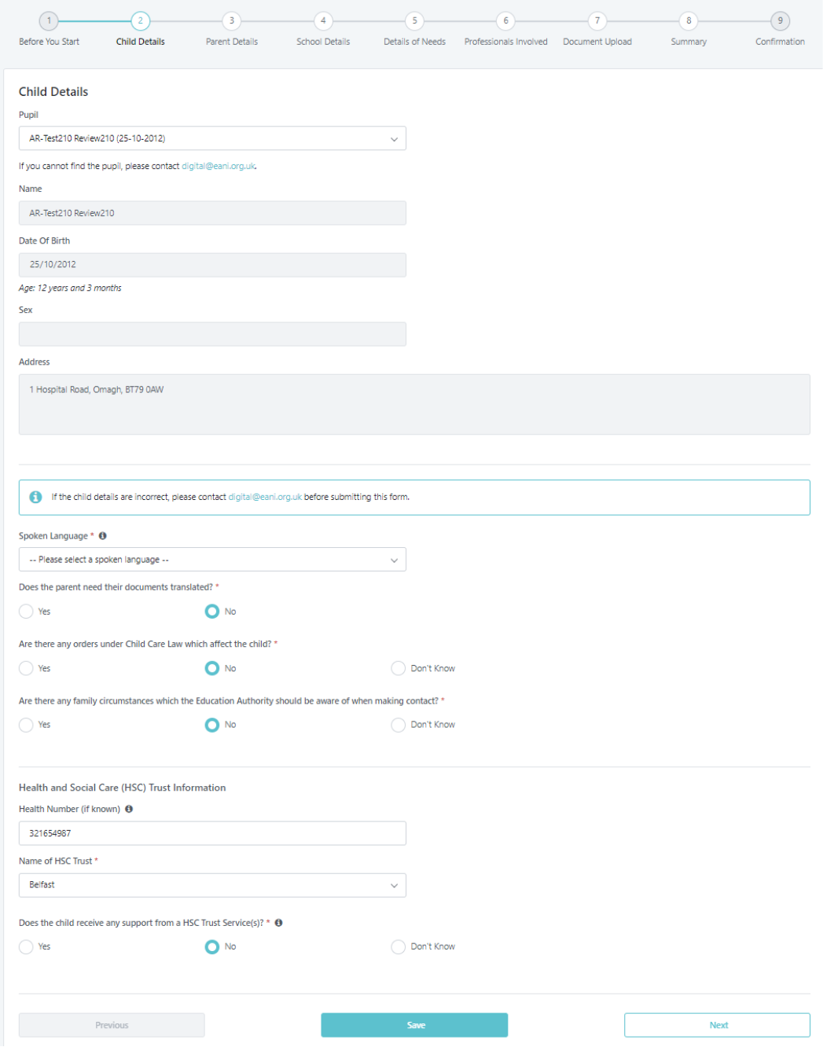

Step 3 – Parent Details
- Complete all mandatory fields.
IMPORTANT! If a 2nd parent is known, even when living at same address as parent 1, they MUST be added to the referral request at this point as they cannot be added later.
- To add second parent → click link, add information on second parent:
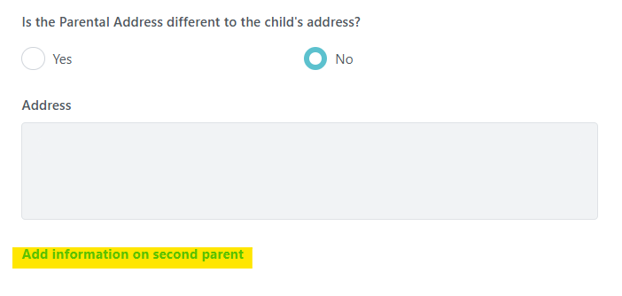
- Click Next to continue.
Important Note.
Provide details of the parent(s) with parental responsibility to keep them informed about the request. If only one parent has parental responsibility, provide their details. If both parents have parental responsibility, provide details for both. If the child is under the care of social services, provide details of the social worker or relevant contact person.

Parent Mandatory fields:
Field Name | Mandatory/Optional | Notes
First Parent – First Name | Mandatory | Enter first name.
First Parent – Surname | Mandatory | Enter surname.
Relationship to Child | Mandatory | Select from dropdown (e.g., Mother, Father).
Contact Number | Mandatory | Enter phone number.
Email Address | Mandatory | Must be valid and current.
Confirm Email Address | Mandatory | Must match Email Address.
Is the Parental Address different to the child’s address? | Mandatory | Select Yes or No.
Address | Auto-populated | If Yes, enter new address manually or use Find Address.

Second Parent Details mandatory fields (if applicable):
Field Name | Mandatory/Optional | Notes
First Name | Mandatory if second parent details provided | Enter first name.
Surname | Mandatory if second parent details provided | Enter surname.
Relationship to Child | Mandatory if second parent details provided | Select from dropdown.
Contact Number | Mandatory if second parent details provided | Enter phone number.
Email Address | Mandatory if second parent details provided | Must be valid and current.
Confirm Email Address | Mandatory if second parent details provided | Must match Email Address.
Is the Parental Address different to the child’s address? | Mandatory if second parent details provided | Select Yes or No.
Address | Optional | Enter manually or use Find Address if Yes selected.

Example of a completed Sole Parent with Parental Responsibility.
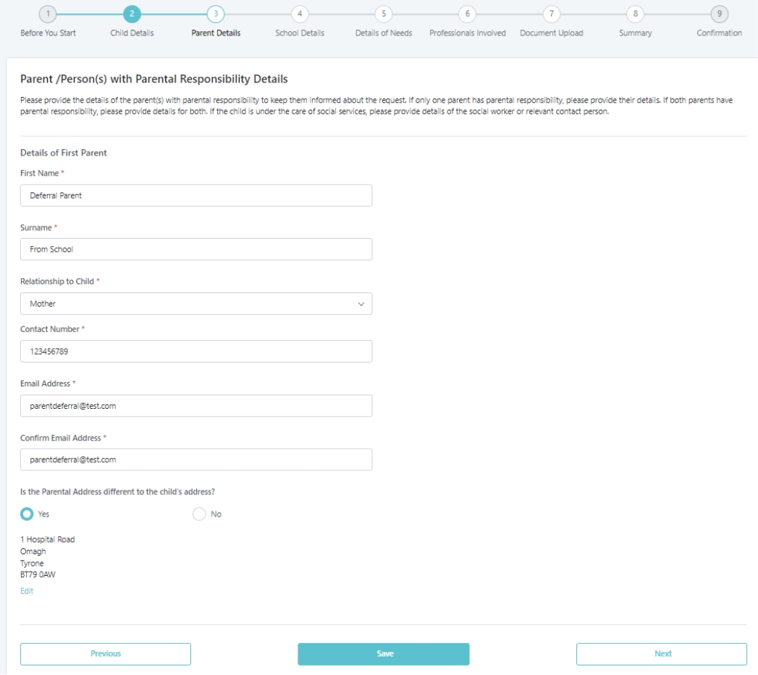
Example of both parents having Parental Responsibility:
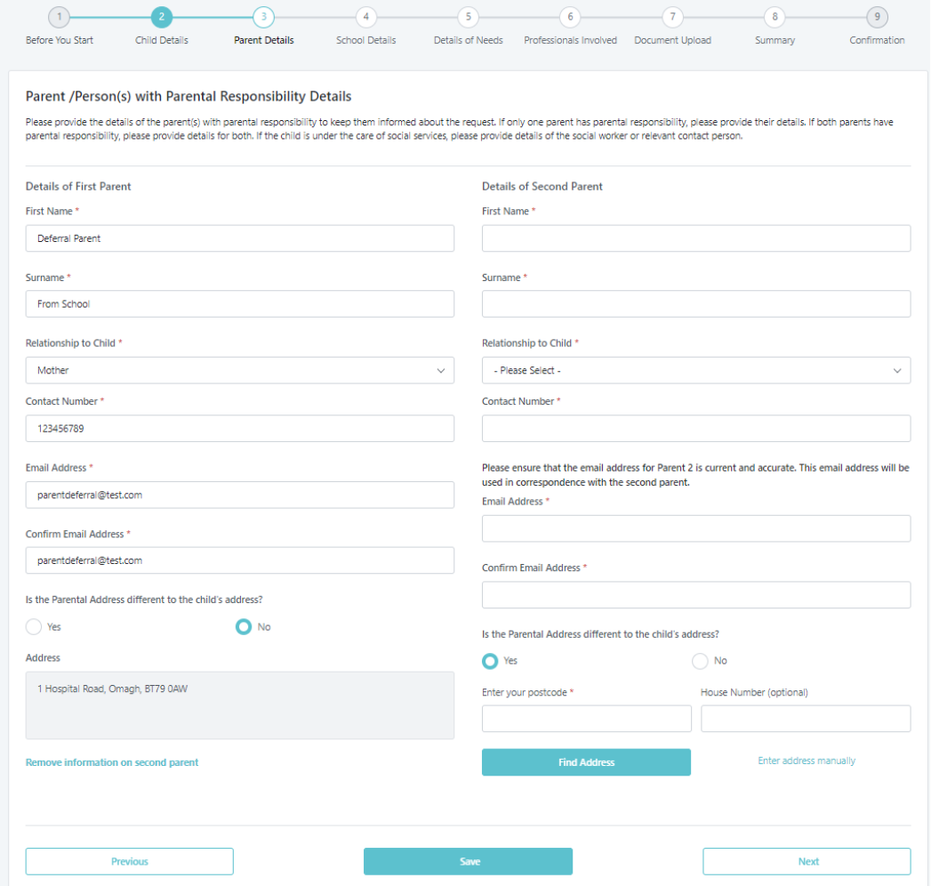

Step 4 – School Details
- Current year group and school will auto-populate from EMS.
- Add up to 2 previous schools if needed.
- Click Previous, Save, or Next to continue to next step.

Mandatory data fields.
Field Name | Mandatory/Optional | Notes
Current year group | Auto-populated | Displays current year group.
Is the Current year group correct? | Mandatory | Select Yes or No.
Current School | Auto-populated | Displays current school name.
Date Enrolled | Mandatory | Enter date in DD/MM/YYYY format.
Number in class | Optional | Enter number of pupils in class.
Attendance | Optional | Enter attendance percentage.
Has the child attended a different school within the past 12 months? | Mandatory | Select Yes or No.
Name of previous school | Mandatory if Yes selected | Enter previous school name manually.

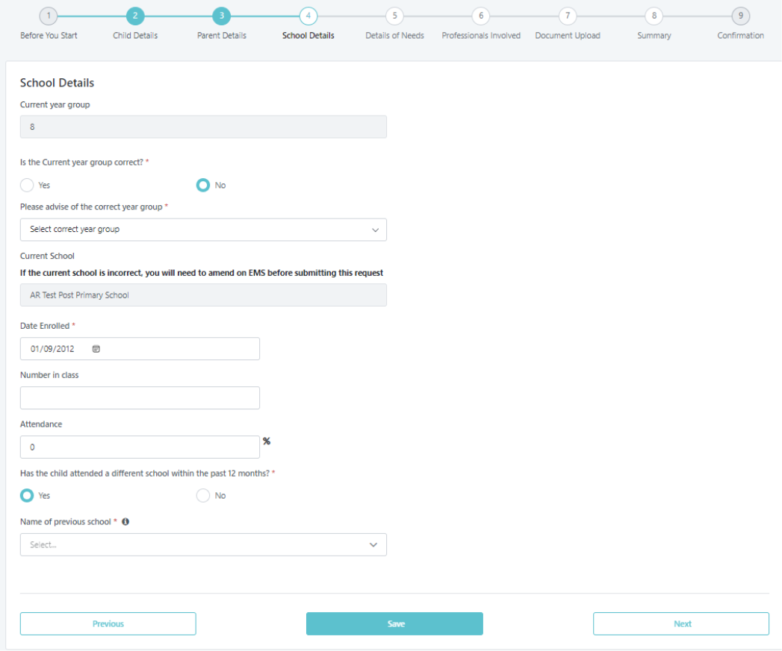

Step 5 – Details of Needs
- Complete as required.
- Selecting Yes may show extra questions.
- Add Standardised Test Results via + Add new line.
- Click Previous, Save, or Next.
Field Name | Mandatory/Optional | Notes
Is the child on the SEN Register? | Mandatory | Select Yes or No. If Yes, select SEN Stage
Is the child known to EA Educational Psychology Service? | Mandatory | Select Yes or No. If No, provide reasons in the text box below.
What needs does the pupil have? | Mandatory | Tick all that apply:
Is the child currently on your medical register? | Mandatory | Select Yes, No, or Don’t Know.
Details of primary medical diagnosis | Mandatory if Yes selected | Choose from dropdown (e.g., Complex Healthcare Needs).
Outline the impact of the learning difficulty and/or disability in school | Mandatory | Provide a detailed description (up to 3000 characters). Include:
Has the school implemented all appropriate internal and external special educational provision? | Mandatory | Provide a detailed description (up to 3000 characters). Include:
Most recent Standardised Test Results | Mandatory if +Add new line selected | Enter details. Add as many tests as required.

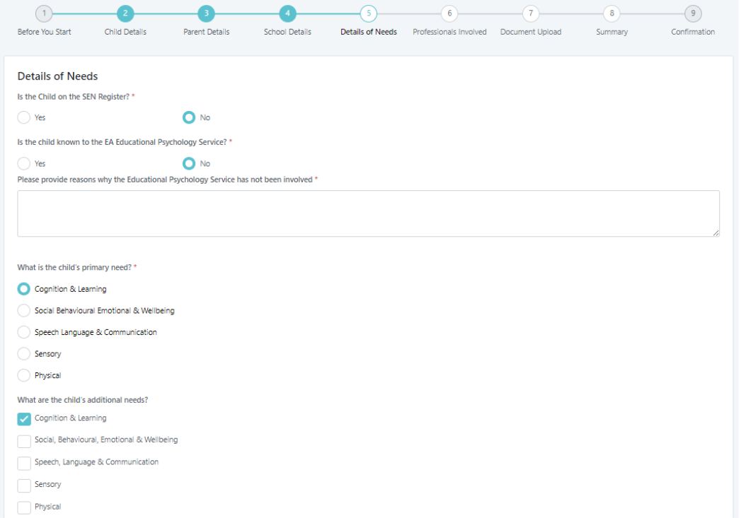
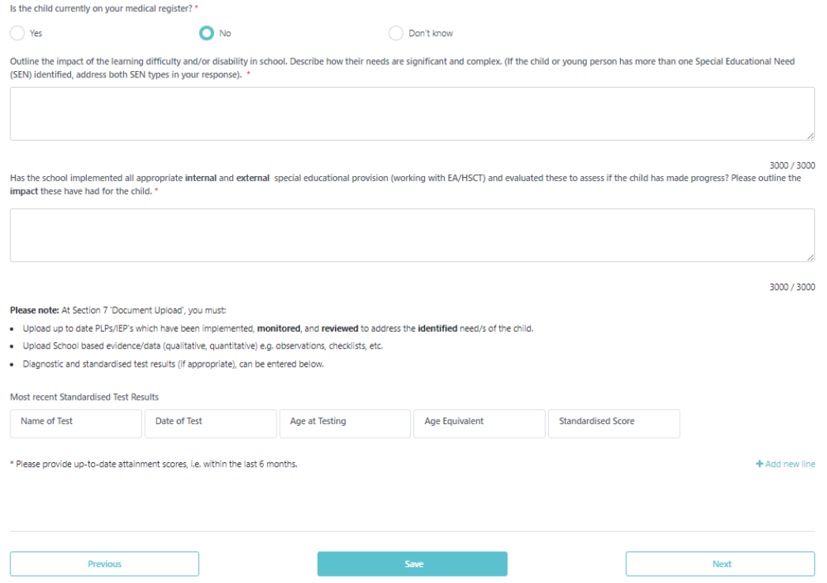

Step 6 – Professionals Involved
- Answer questions as necessary. Note, some answers may result in additional questions/options appearing.
- Complete details as required.
- Click Previous, Save, or Next to continue to next step.
Field Name | Mandatory/Optional | Notes
Is the child known to any professionals? | Mandatory | Select Yes or No. If Yes, additional options will appear to specify which professionals.
Has there been a request for involvement from the EA SEND Support Service? | Mandatory | Select Yes, No, or Don’t Know. If Yes, a dropdown list appears (e.g., Autism Advisory Intervention Service, SEN Early Years Inclusion Service).
Is the child known by one of the Health and Social Care Trust Services? | Mandatory | Select Yes, No, or Don’t Know. If Yes, a dropdown list appears (e.g., CAMHS, Speech and Language Therapist).
Is the child known to any other professionals? | Mandatory | Select Yes or No. If Yes, provide details in the text box that appears.

Example of a completed section displaying the additional questions when an answer is selected.
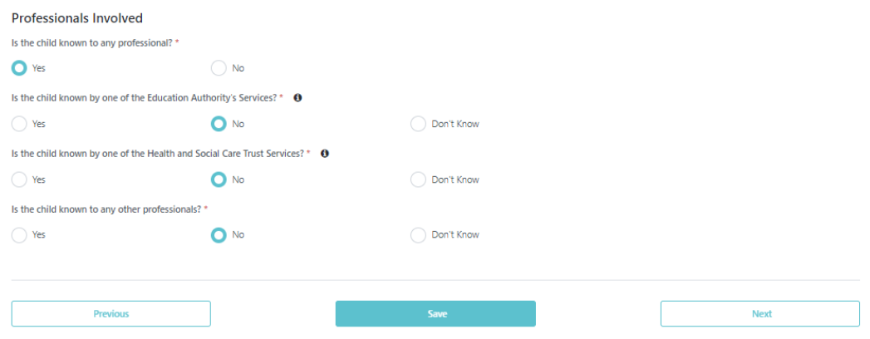
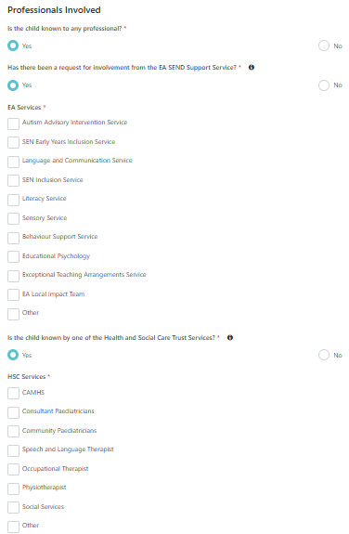

Step 7 – Document Upload
- Upload a minimum of TWO documents using the button, + Add Document.
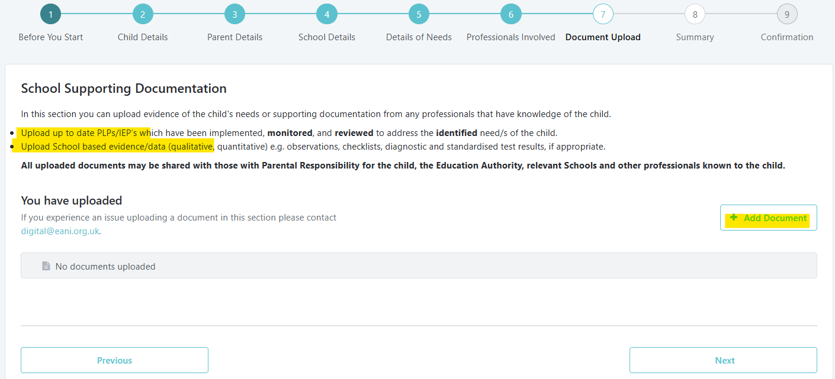

- Click Previous or Next to continue to next steps.

Field Name | Mandatory/Optional | Notes
Document Type | Mandatory | Select from dropdown. If selected, options appear such as:IEP/PLP, Educational Psychology Report

Step 8 - Summary
- Pop-up will be displayed stating the review is not yet submitted. Select close.
- Any incomplete areas will be marked in orange, and complete areas in green.
- Expand dropdown arrow to complete incomplete fields.
- You will not be able to submit the referral request until all sections are complete and green.
- Click Next to continue to submit the request.
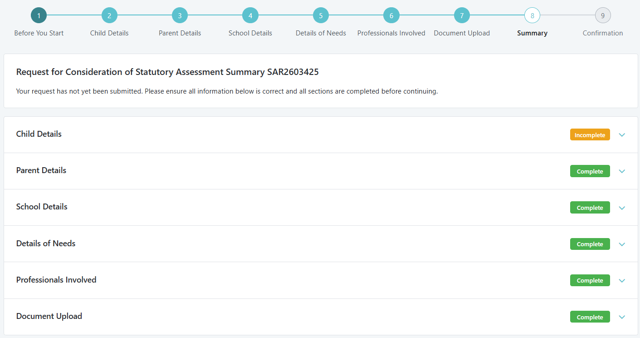

Step 9 - Submit and Confirmation
- Review the Data Protection Statement.
- Enter the Principal’s name.
- Click Previous, Save and Exit, or Submit.
- Click submit → confirmation message will be received including a reference number.
- Click Close to return to list of requests.
Field Name | Mandatory/Optional | Notes
Data Protection Statement | Mandatory | Must be reviewed before submission. Confirms compliance with GDPR and explains how personal information will be processed and shared.
Principal Name | Mandatory | Displays the name of the principal responsible for the submission.
Principal Signature | Mandatory | Digital confirmation that the principal approves the referral.
Date of Submission | Mandatory | Automatically recorded when the form is submitted.
Referral Form Submitted Successfully Banner | Auto-generated | Green banner confirms successful submission.
Confirmation Pop-up | Auto-generated | Displays message: Request for consideration of statutory assessment has been submitted.

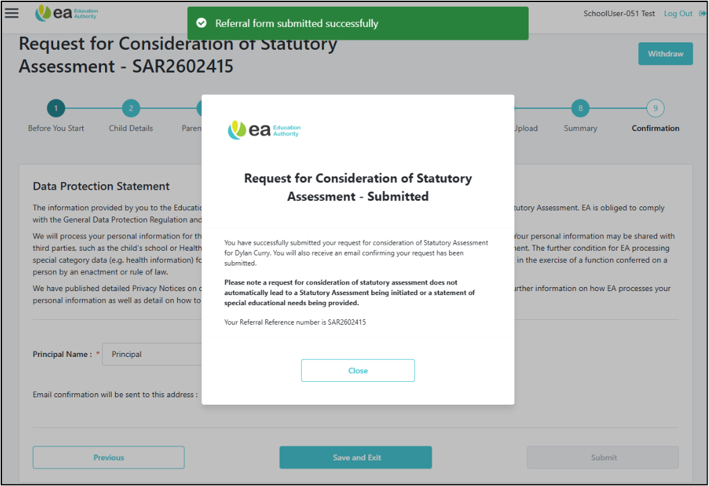

***This marks the end of your submission process. No further action is required until EA SARS reviews the request and emails you with next steps regarding the Notice of Consideration.***

