SCHOOLS STATUTORY ASSESSMENT - Quick Reference Guide

DECISION POINT 1

Contents
- Notice of Consideration email received.
- Login.
- Access Statutory Assessment Screen.
- Complete School Documentary Evidence (if required).
- Add any additional relevant documents (if required).

School - Decision Point 1, Outline Process

Request for Consideration of a Statutory Assessment received.

Parent submitted referral:
- EA verify parent responsibility.
- EA review the request.
- EA Issue a Notice of Consideration email (including a copy of email issued to parent) within 5 working days.

Referral submitted by any other source:
- EA issue a Notice of Consideration email (including copy of email issued to parent) within 5 working days.
- EA verify parental responsibility.
Request to complete School Documentary Evidence within 22 days.

Login to EA Connect, navigate to Statutory Assessment screen and select pupil referral to open.
Navigate to School Documentary Evidence section and select Add Documentary Evidence. Complete and submit form. (Note: if the school requested the SA, you can add additional information if required).
Ability to add any additional relevant documents.

EA Decision Point: Proceed or Not Proceed.
- Not Proceeding: Email to school. End of Decision Point 1.
- Proceeding: Moves to Decision Point 2.

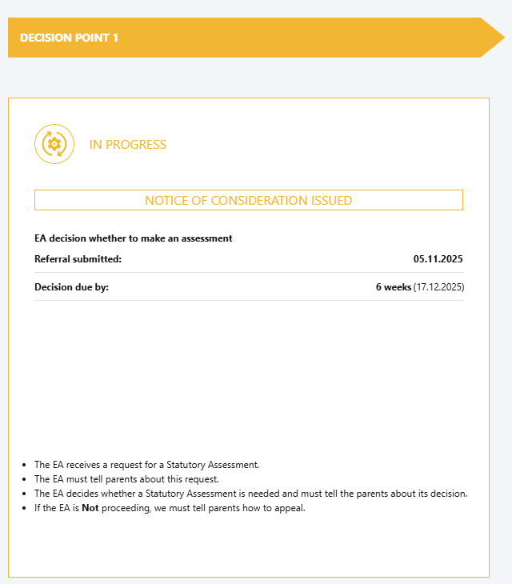
Decision Point 1
- The EA receives a request for a Statutory Assessment.
- The EA must tell parents about this request.
- The EA decides whether a Statutory Assessment is needed and must tell the parents about its decision.
- If the EA is Not proceeding, we must tell parents how to appeal.

COMPLETING THE SCHOOL EVIDENCE FORM AFTER NOTICE OF CONSIDERATION ISSUED
Once a parent referral has been received and parental responsibility has been verified, school will receive the email below. The CURRENT SCHOOL will need to log on to EA Connect to complete the School Documentary Evidence form.
Example of Notice of Consideration emails to Current School
Subject: Notice of Consideration of a statutory assessment of educational needs (reference number).
Dear Principal / SENCo,
The Education Authority has issued a Notice of Consideration of a Statutory Assessment of <Pupil Forename and Surname> Educational Needs to parents. Particular attention will be paid to any evidence provided from professionals involved with the child.
If the Education Authority decide to proceed with the statutory assessment, you will be contacted again in due course requesting your professional advice on this child.
The Education Authority may take a decision before DATE < 22 days after referral submitted> if it has obtained the consent in writing of the person on whom the notice was served.
In the interim however, the Education Authority wishes to seek written evidence from you including an assessment of <Pupil Forename>’s learning difficulties and an account of the special educational provision that has been made for her/him at the school based stages of the code of practice. Accordingly, you should complete the pro forma on EA Connect within 22 days, and upload copies of all individual Education Plans/Personal Learning Plans and reports outlining the measures taken by the school to address any identified needs.
- Log on to EA Connect using the link https://connect.eani.org.uk/school/.
- Navigate to the ‘Statutory Assessment’ page.
- Click on the referral number on the table to open the referral.
- Under the ‘School Documentary Evidence’ section, a button ‘Add School Documentary Evidence’ is available.
- Click on this button and complete the form.
- Select ‘Save and Submit’ when all details have been recorded.
Yours sincerely,
SEN Link Officer
The following email was issued to the parent:
Dear Parent/Guardian,
Further to the request that <PUPIL FORENAME>'s educational needs should be assessed under the Education (Northern Ireland) Order 1996, the Education Authority is considering whether to make a statutory assessment.
In order for the Education Authority to make a decision, it will pay particular attention to evidence provided by you and that requested by the Education Authority from your child's school, if <Insert Pupil Forename> is enrolled at a school. Please click here Special Educational Needs and Disability (SEND) | SEND Plan for further information on the steps the Education Authority normally expects the school to have taken before such an assessment is requested. The Education Authority will also notify other relevant professionals who might later be asked for advice.
You have the right to make representations, and submit written evidence, to the EA within 22 days (from the date of this notice). The EA may take a decision before the expiry of the 22 days if we have your consent. You can make your representations, submit your evidence and provide your consent by following these steps:
Step 1: Create an account or login to EA Connect using the link https://connect.eani.org.uk/parent/ .
Step 2: Select ‘Statutory Assessments on the Data Protection Statement and on the Statutory Assessments page click on ‘View Requests for Consideration’ button to the right hand side of your child details.
Step 3: On the table of requests, click on the request number and complete the details in the ‘Views of Persons with Parental Responsibility’ section.
Step 4: Click submit when completed.
Following consideration of all reports received and any representations or evidence that you send, the Education Authority will write to you again to let you know if the statutory assessment is required and, if so, the necessary arrangements. If you would like to discuss this further, to find out more information or get help with putting your views in writing please do not hesitate to contact me by calling the SEND Central telephone number 028 9031 7777 and choosing Option 1. For general SEN advice and information choose Option 2. The SEND Central telephone number is available weekdays from 9am to 4.30pm, excluding public holidays.
Further information is also available on the Education Authority's website http://www.eani.org.uk.
The Education Authority must make its decision whether to carry out a statutory assessment by DATE .
If the Education Authority decides that a statutory assessment is not appropriate at this time, you will be informed of the reason for the decision and of your right of appeal to the Special Educational Needs and Disability Tribunal.
The Education Authority aims to work in partnership with parents and schools and to resolve any concerns, however, you may wish to access the Dispute Avoidance and Resolution Service (DARS) as an independent means of resolving any disagreement (Tel: 028 90726060).
Using either the Advice and Information Service or the DARS does not affect your rights or prevent you from appealing to the Tribunal at the same time as any disagreement resolution.
Yours sincerely,
SEN Link Officer.

Once a non-school referral has been received, school will receive the email below. The CURRENT SCHOOL will need to log on to EA Connect to amend the School Documentary Evidence form, if they submitted the request or complete the School Documentary Evidence form, if it was submitted by Educational Psychology, Sensory Service, EA on behalf of HSCT, or a Parent Paper request.
Subject: Notice of Consideration of a statutory assessment of educational needs (reference number).
Dear Principal / SENCo,
The Education Authority has issued a Notice of Consideration of a Statutory Assessment of <Pupil Forename and Surname>'s Educational Needs to parents. Particular attention will be paid to any evidence provided from professionals involved with the child. Any relevant information you wish to be considered should be uploaded on EA Connect.
If the Education Authority decide to proceed with this assessment, you will be contacted again in due course requesting your professional advice on this child.
The Education Authority may take a decision before DATE <22 days after referral submitted> if it has obtained the consent in writing of the person on whom the notice was served.
Yours sincerely,
SEN Link Officer.
The following email was issued to the parent <First Name and Surname of the parent>
Dear Parent/Guardian,
Further to the request that <PUPIL FORENAME>'s educational needs should be assessed under the Education (Northern Ireland) Order 1996, the Education Authority is considering whether to make a statutory assessment.
In order for the Education Authority to make a decision, it will pay particular attention to evidence provided by you and that requested by the Education Authority from your child's school, if <Pupil Forename> is enrolled at a school. Please click here Special Educational Needs and Disability (SEND) | SEND Plan for further information on the steps the Education Authority normally expects the school to have taken before such an assessment is requested. The Education Authority will also notify other relevant professionals who might later be asked for advice.
You have the right to make representations, and submit written evidence, to the EA within 22 days (from the date of this notice). The EA may take a decision before the expiry of the 22 days if we have your consent. You can make your representations, submit your evidence and provide your consent by following these steps:
Step 1: Create an account or login to EA Connect using the link https://connect.eani.org.uk/parent/ .
Step 2: Select ‘Statutory Assessments' on the Data Protection Statement or navigate to the Statutory Assessments menu item.
Step 3: If you have already created your child on EA Connect, click on ‘View Requests for Consideration’ to the right hand side of your child’s name. OR
If you have not created your child on EA Connect, add the child and then wait for up to 48 hours for the referral to show. Then click on ‘View Requests for Consideration’.
Step 4: On the table of requests, click on the request number and complete the details in the ‘Views of Persons with Parental Responsibility’ section.
Step 5: Click submit when completed.
Following consideration of all reports received and any representations or evidence that you send, the Education Authority will write to you again to let you know if the statutory assessment is required and, if so, the necessary arrangements. If you would like to discuss this further, to find out more information or get help with putting your views in writing please do not hesitate to contact me by calling the SEND Central telephone number 028 9031 7777 and choosing Option 1. For general SEN advice and information choose Option 2. The SEND Central telephone number is available weekdays from 9am to 4.30pm, excluding public holidays.
Further information is also available on the Education Authority's website http://www.eani.org.uk.
The Education Authority must make its decision whether to carry out a statutory assessment by DATE .
If the Education Authority decides that a statutory assessment is not appropriate at this time, you will be informed of the reason for the decision and of your right of appeal to the Special Educational Needs and Disability Tribunal.
The Education Authority aims to work in partnership with parents and schools and to resolve any concerns, however, you may wish to access the Dispute Avoidance and Resolution Service (DARS) as an independent means of resolving any disagreement (Tel: 028 90726060).
Using either the Advice and Information Service or the DARS does not affect your rights or prevent you from appealing to the Tribunal at the same time as any disagreement resolution.
Yours sincerely,
SEN Link Officer.

- Login.
Option A:
- On the EA website, click EA Connect Login under Statutory Assessment | SEND Plan.
- Enter your login details and accept the GDPR statement.


Option B:
- Open Google Chrome or Microsoft Edge.
- Go to the EA Connect - Login.
- Enter your login details and accept the GDPR statement.
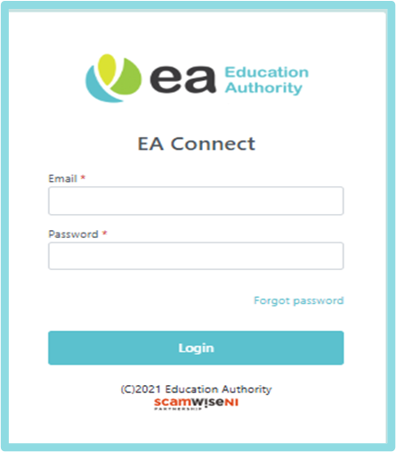

- Access Statutory Assessment Screen:
- Select Menu → Statutory Assessment.
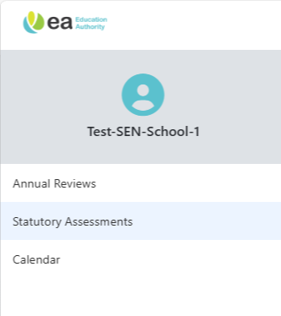
PLEASE NOTE: If this is a school referral, you do not need to complete the School Documentary Evidence form.
Select the Statutory Assessment Request number. 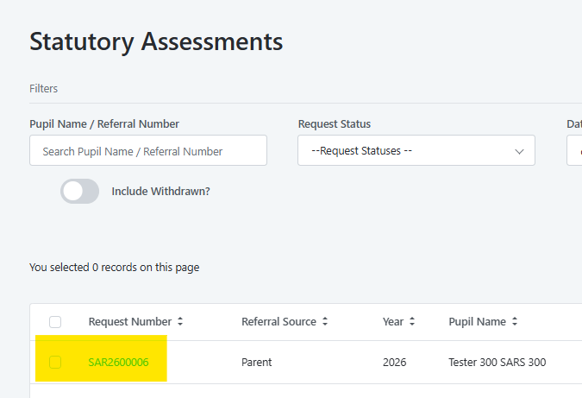
A new screen will appear as below:
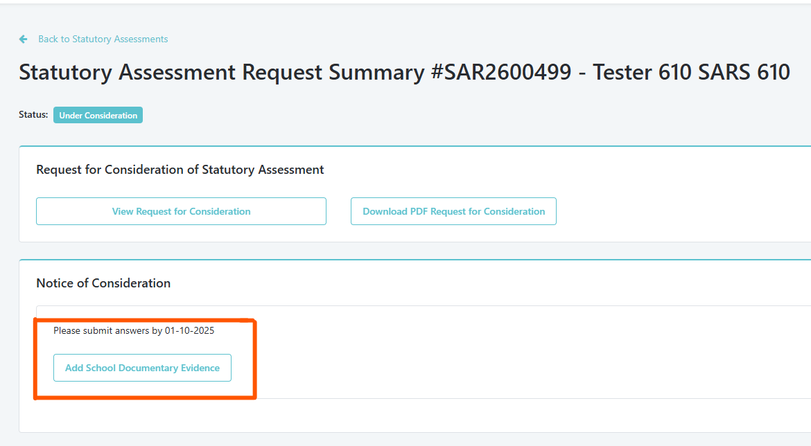
Select Add School Documentary Evidence form button and complete as required.
Mandatory fields are detailed in the table below:
Field Name | Mandatory/Optional | Notes
Is the child on the SEN Register? | Mandatory | Select Yes or No. If Yes, select SEN Stage
Is the child known to EA Educational Psychology Service? | Mandatory | Select Yes or No. If No, provide reasons in the text box below.
What needs does the pupil have? | Mandatory | Tick all that apply:
Is the child currently on your medical register? | Mandatory | Select Yes, No, or Don’t Know.
Details of primary medical diagnosis | Mandatory if Yes selected | Choose from dropdown (e.g., Complex Healthcare Needs).
Outline the impact of the learning difficulty and/or disability in school | Mandatory | Provide a detailed description (up to 3000 characters). Include:
Has the school implemented all appropriate internal and external special educational provision? | Mandatory | Provide a detailed description (up to 3000 characters). Include:
Most recent Standardised Test Results | Mandatory if +Add new line selected | Enter details. Add as many tests as required.

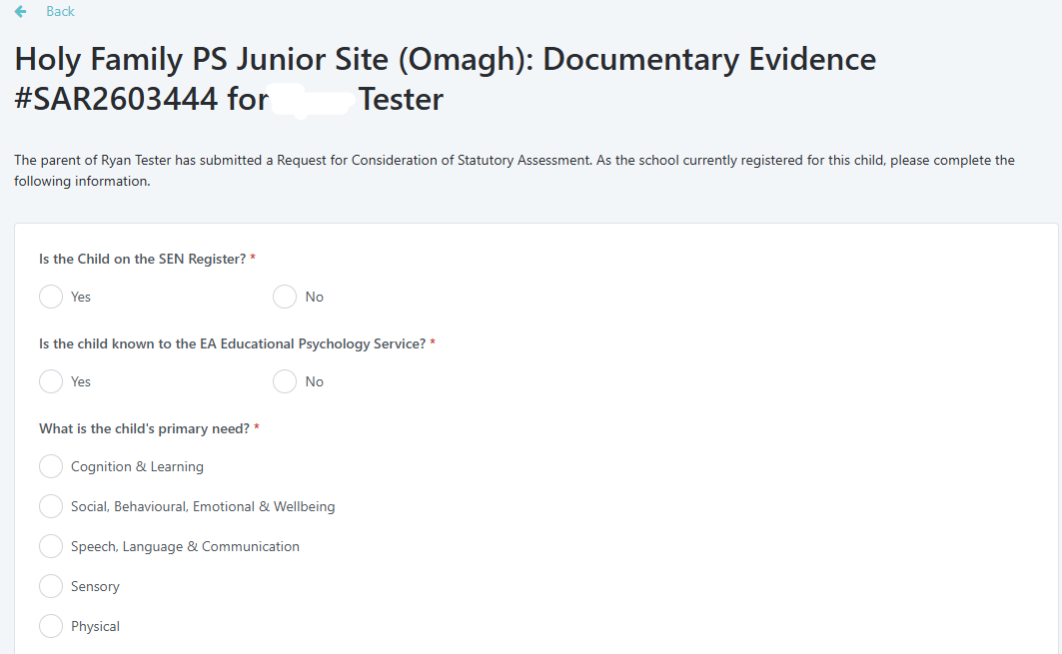
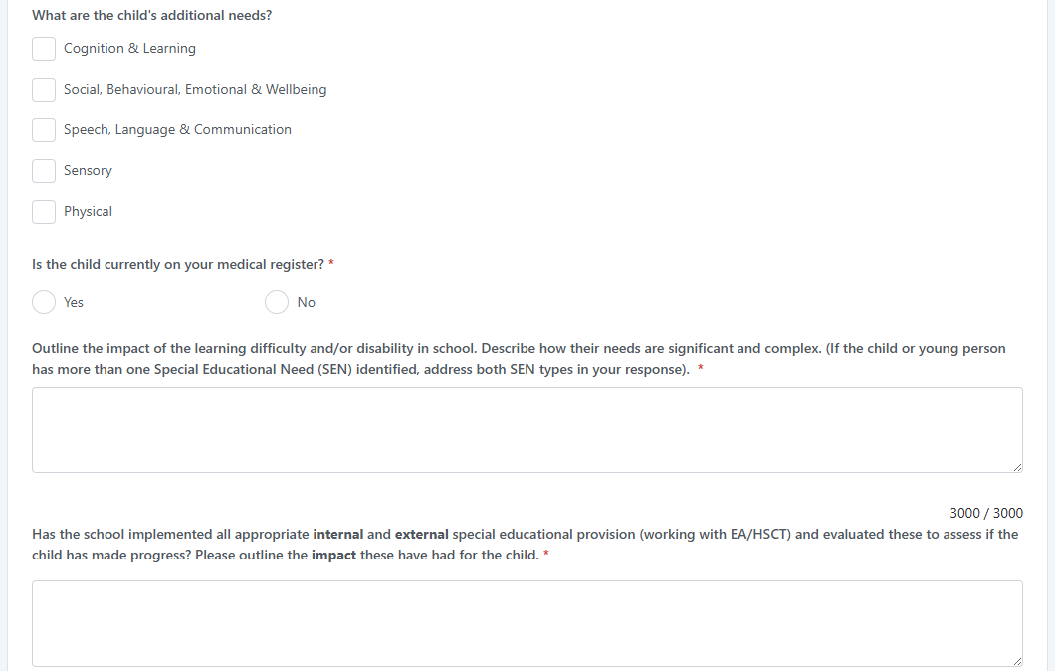
To add a Standardised Test for pupil, select Add New Line. This line can be removed by using the bin icon.
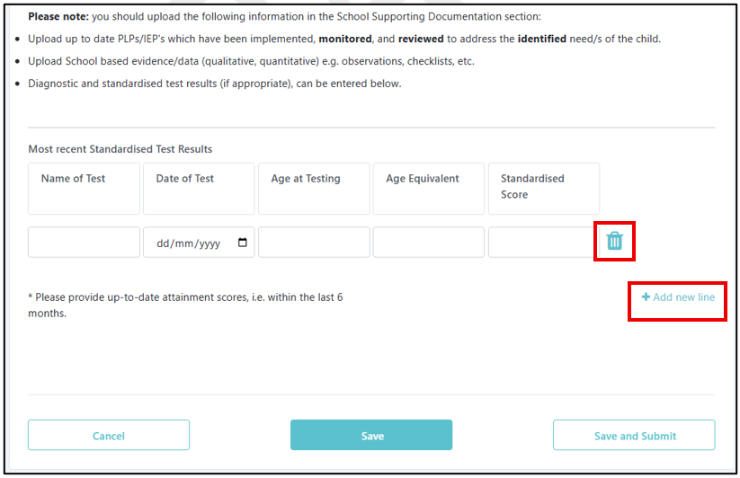
To Save – select:

To Submit – select:

Once submitted a timestamp will appear under the School Documentary Evidence form and will be available to view.

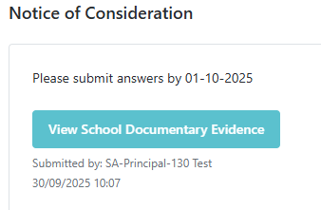
Documents can be uploaded under Documents – School Supporting Documentation section:
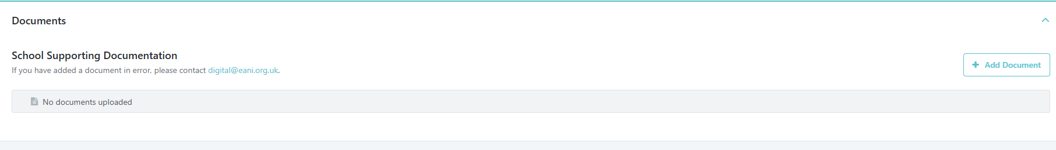
Select Add Document - A pop up will appear and can save document:
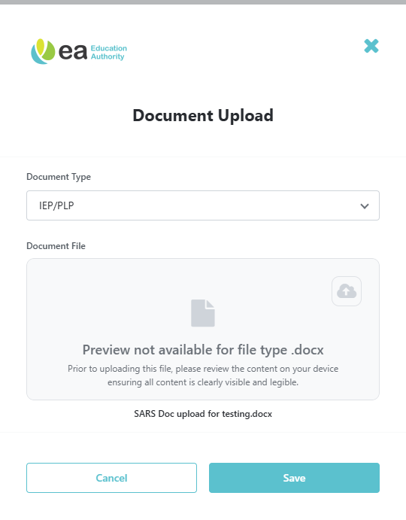
EA will consider all information provided during this stage, which lasts up to 6 weeks from the date the request was submitted.
If EA decides not to proceed with the statutory assessment, EA must:
- Email parents with guidance on how to appeal.
- Notify any other relevant stakeholders.
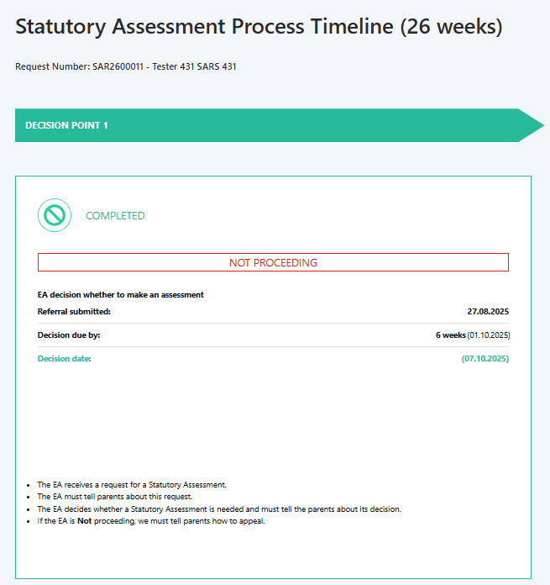
Email subject defined as Notice of decision not to make a Statutory Assessment of Educational Needs (Reference number)
Dear Principal / SENCo,
Please see below details of the Notice of decision not to carry out a statutory assessment for above named child.
X is reported to be independent in meeting his/her• medical needs. However, should you continue to have concerns you should discuss these with the class teacher and/or the school Special Educational Needs Coordinator (SENCo)/Learning Support Coordinator (LSC).
The Education Authority aims to work in partnership with parents and schools and to avoid and prevent potential problems from developing into major disagreements. If you would like to discuss this decision, please do not hesitate to contact me by calling the SEND Central telephone number 028 9031 7777 and choosing Option 1. For general SEN advice and information choose Option 2. The SEND Central telephone number is available weekdays from 9am to 4.30pm, excluding public holidays.
Further information is also available on the Education Authority's website https://www.eani.org.uk/.
Yours sincerely,
SEN Link Officer.
---
The following email was issued to the parent:
Dear Parent/Guardian,
On 16/10/2025 the Education Authority wrote to tell you that it was considering whether to assess pupil name educational needs. Details relating to the considerations for a statutory assessment were set out in Explanatory Notes on EA Connect.
The Education Authority has given careful consideration to all evidence received in relation to pupil name needs and has decided not to make a statutory assessment of his/her educational needs at this time.
The evidence presented indicates that pupil name educational needs can be met from within the resources (including external specialist support) normally available in a mainstream school/setting.
The reason the decision was taken to not proceed is outlined below:
X is reported to be independent in meeting his/her• medical needs. However, should you continue to have concerns you should discuss these with the class teacher and/or the school Special Educational Needs Coordinator (SENCo)/Learning Support Coordinator (LSC).
The Education Authority aims to work in partnership with parents and schools and to avoid and prevent potential problems from developing into major disagreements. If you would like to discuss this decision, please do not hesitate to contact me by calling the SEND Central telephone number 028 9031 7777 and choosing Option 1. For general SEN advice and information choose Option 2. The SEND Central telephone number is available weekdays from 9am to 4.30pm, excluding public holidays.
Further information is also available on the Education Authority's website https://www.eani.org.uk/.
As advised in our email dated 16/10/2025 you have the right of appeal to the Special Educational Needs and Disability Tribunal. You must lodge an appeal within two months of receipt of this email. Details of how to appeal may be obtained from the Special Needs and Disability Tribunal, Tribunal Hearing Centre, 2nd Floor, Royal Courts of Justice, Chichester Street, Belfast BT1 3JF, Telephone 028 9072 4847.
Parents, however, may wish to access the Dispute Avoidance and Resolution Service (DARS), Global Mediation, 5559 Adelaide Street, Belfast, BT2 8FE (Tel: 028 9072 6060, Email: DARS@globalmediation.co.uk). Using the DARS does not affect your rights or prevent you from appealing to the Tribunal at the same time as any disagreement resolution.
Yours sincerely,
SEN Link Officer.

THIS MARKS THE END OF DECISION POINT 1.

