SCHOOLS STATUTORY ASSESSMENT - Quick Reference Guide

Decision Point 2 (10 weeks).
- Assessment started - Advice sought from parents and professionals.
- The EA informs parents of its decision to either issue a Proposed Statement
- Or, to issue an Assessment of Needs Summary and details of the appeal process.

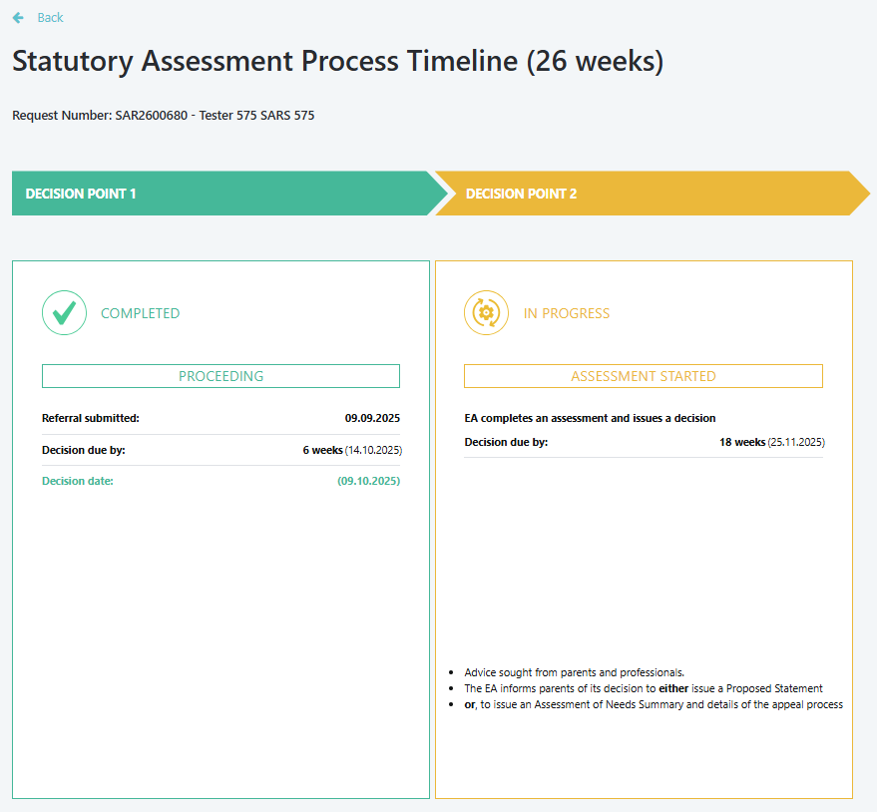

School - Decision Point 2, Outline Process

School receives email confirming the assessment is proceeding.

Login to EA Connect, navigate to Statutory Assessment screen and select pupil record.
Pupil’s current school completes Educational Advice Form within 6 weeks.

Navigate to Educational Advice section. Select Educational Advice Form: Current School – Review and Submit.
Review previously submitted ‘School Documentary Evidence’ information, add any new details if required, then enter date and sign to confirm accuracy.
Pupil’s Previous School (if attended within last 12 months). Upon request, completes Educational Advice Form within 6 weeks.
Navigate to Educational Advice section. Select Educational Advice Form: Previous School – Review and Submit.
Upload any additional relevant documents.

EA reviews advice from all professionals and parents and makes a decision.
EA Decision Point Outcome:
- No Statement - Educational Needs and Supporting Summary issued. End of Decision Point 2.
- Proceeding: Moves to Decision Point 3.

AFTER NOTICE OF DECISION EMAILS ISSUED – CURRENT SCHOOL:
Once the Notice of Decision email has been issued, the Current School will need to log on to EA Connect to declare that the information in the School Documentary Evidence is correct.
Example of Notice of Decision email sent to current school:
Statutory Assessment of Educational Needs: Request for Educational Advice (Reference number)
Dear Principal / SENCo
The Education Authority has decided to carry out a statutory assessment of Tester 610 SARS 610's educational needs.
As part of the assessment, the Education Authority is required to seek advice relating to the educational, medical, psychological, or other features of the case which may be relevant to Tester 610's educational needs. I would therefore be grateful if you could complete the Educational Advice on EA Connect within 6 weeks of the date of this email. You can complete the advice by following these steps:
•Log on to EA Connect using the link https://eani-uat.outsystemsenterprise.com/School,
•Navigate to the ‘Statutory Assessment’ page,
•Click on the referral number on the table to open the referral,
•Navigate to the ‘Educational Advice’ section,
•Complete the Educational Advice form and submit.
This advice will become part of the statutory assessment documentation and will be circulated to those with parental responsibility and other professionals.
In accordance with Regulation 6(3) of the Education (Special Educational Needs) Regulations (NI) 2005, where appropriate, you should consult such persons who have relevant knowledge of, or information relating to, the child, or appear to you expedient to consult. If you yourself have not taught Tester 610 within the last twelve months, your advice should be given after consultation with those teachers who have so taught Tester 610.
You will also be able to view the parental representation and/or evidence submitted by the person(s) with parental responsibility on EA Connect in the section called ‘Notice of Consideration’ by clicking on the button 'View Parental Representations'.
Yours sincerely,
SEN Link Officer.

- Login:
Option A
- On the EA website, click EA Connect Login under Statutory Assessment | SEND Plan.
- Enter your login details and accept the GDPR statement.


Option B
- Open Google Chrome or Microsoft Edge.
- Go to the EA Connect - Login.
- Enter your login details and accept the GDPR statement.
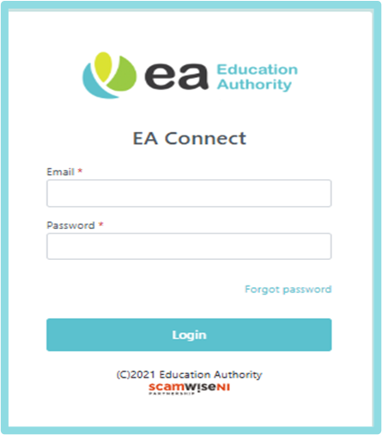

- Access Statutory Assessment Screen
- Select Menu → Statutory Assessment.
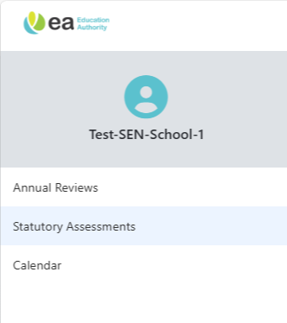

Select the Statutory Assessment Request number: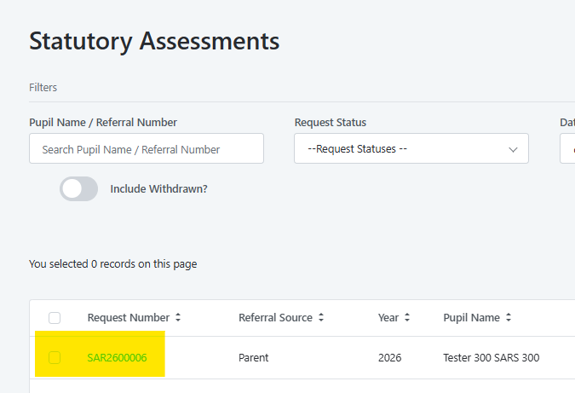
Navigate to Statutory Assessment request and select the Educational Advice form under Educational Advice section.
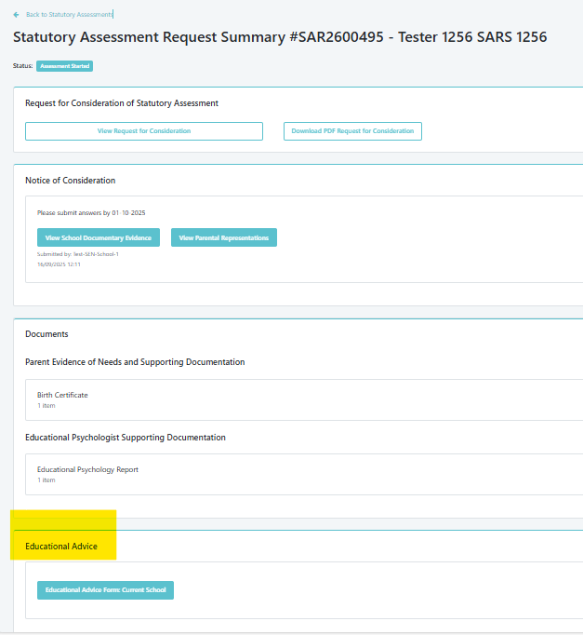
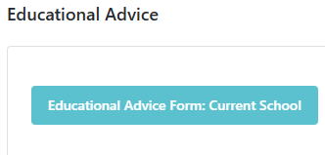
The Educational Advice form will be pre-populated with the information provided by the current school prior.
Submit Declaration – enter name, role and date will be pre-populated and Submit.
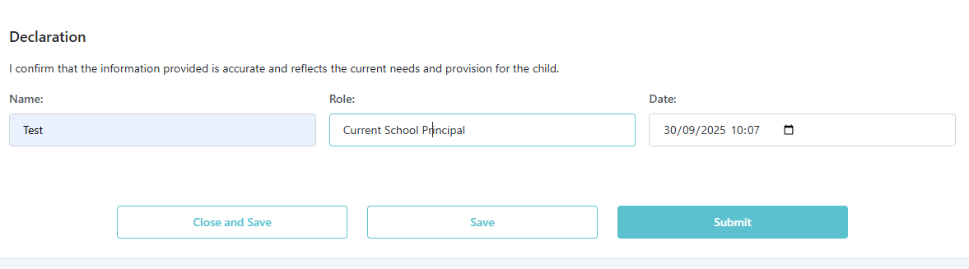
Documents can be uploaded in Advices and Documents – Educational Advice Document Upload section.
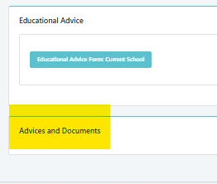

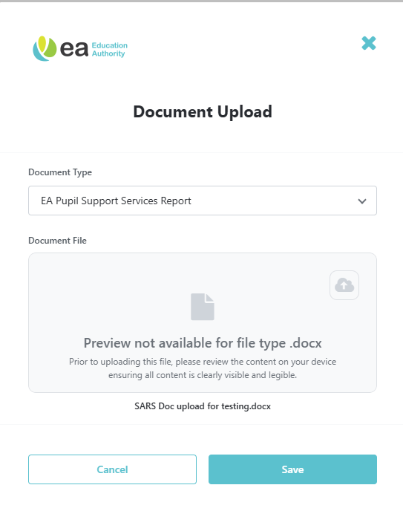
Click on Add Document and Save.

AFTER NOTICE OF DECISION EMAILS ISSUED – PREVIOUS SCHOOL(S)
If the pupil had attended a previous school(s) – the previous school(s) will need to log on to EA Connect to complete the School Documentary Evidence and declare the information contained in the form is correct.
Example of Notice of Decision email sent to Previous School(s):
Statutory Assessment of Educational Needs: Request for Educational Advice from previous school SAR2601587
Dear Principal / SENCo,
The Education Authority has decided to carry out a statutory assessment of Pupil name educational needs.
As part of the assessment, the Education Authority is required to seek advice relating to the educational, medical, psychological, or other features of the case which may be relevant to Pupil name educational needs. As Pupil name attended your school within the last 12 months, I would therefore be grateful if you could complete the Educational Advice on EA Connect within 6 weeks of the date of this email. You can complete the advice by following these steps:
•Log on to EA Connect using the link https://eani-uat.outsystemsenterprise.com/School,
•Navigate to the ‘Statutory Assessment’ page,
•Click on the referral number on the table to open the referral,
•Navigate to the ‘Educational Advice’ section,
•Complete the Educational Advice form and submit.
This advice will become part of the statutory assessment documentation and will be circulated to those with parental responsibility and other professionals.
In accordance with Regulation 6(3) of the Education (Special Educational Needs) Regulations (NI) 2005, where appropriate, you should consult such persons who have relevant knowledge of, or information relating to, the child, or appear to you expedient to consult. If you yourself have not taught Pupil name within the last twelve months, your advice should be given after consultation with those teachers who have so taught Pupil name.
Yours sincerely,
SEN Link Officer.

Log in to EA Connect and Navigate to Statutory Assessment Dashboard as before and click on Statutory Assessment Request Number.
Under Educational Advice section select the button below:
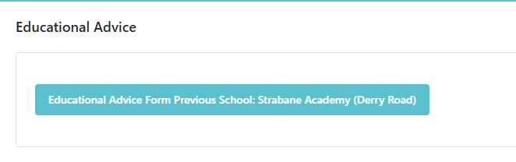
A new form will be displayed for the Previous School(s) to complete and declare the information is correct and submit.
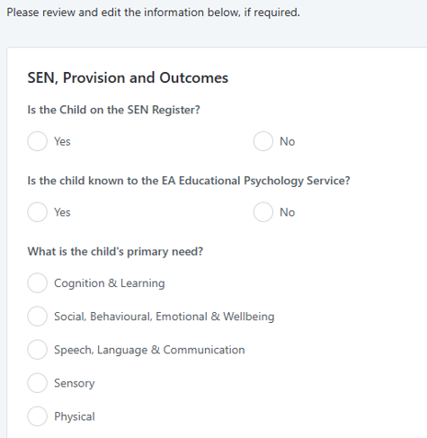
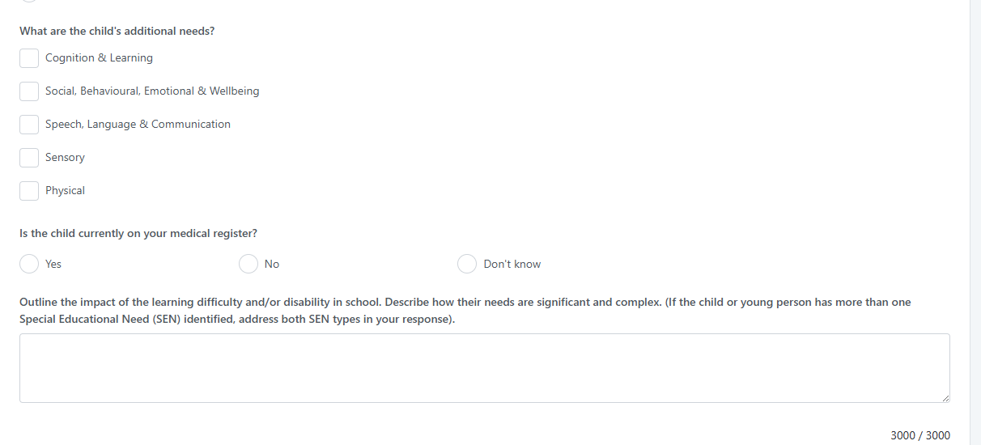
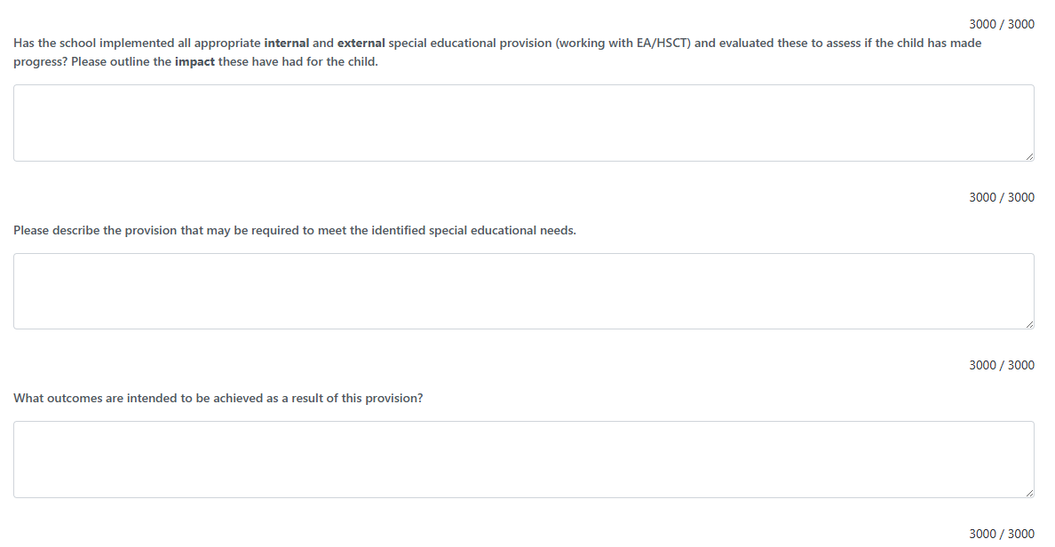
To add a Standardised Test for pupil, select Add New Line. This line can be removed by using the bin icon.
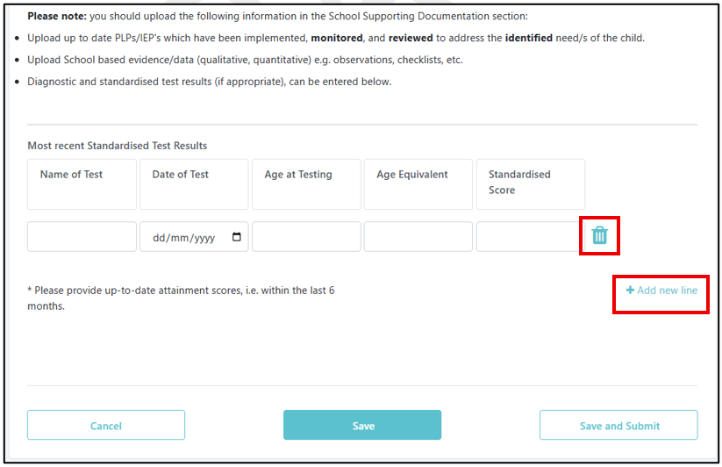
To Save – select.

To Submit – select.

Once submitted school will be able to view the Educational Advice form.
Documents can be uploaded in Advices and Documents – Educational Advice Document Upload – Click on Add Document and Save.

IF DECISION IS NOT TO PROCEED WITH STATEMENT
School will receive an email and a copy of an Educational Needs and Support Summary Document (previously known as Note in Lieu).
Example of No Statement email to school:
Outcome of Statutory Assessment SAR2600393
Dear Principal/SENCo,
The Education Authority has completed a statutory assessment of Child B’s educational needs.
After careful consideration of all the reports and professional advice received, the Education Authority has concluded that a Statement of Special Educational Needs is not required. This decision is based on the outcome of the assessment, which found that Child does not present with special educational needs that require provision beyond what is ordinarily available in a mainstream school setting.
An Educational Needs and Support Summary has been prepared to outline the findings of the assessment and, along with the professional advice provided, is intended to support your understanding of Child ’s educational profile and to help inform any ongoing or future support within the school setting. We encourage you to continue monitoring Child ’s progress and to implement appropriate support strategies in line with your school’s SEN provision.
All relevant documentation is available to view on EA Connect. Please log in at https://eani-uat.outsystemsenterprise.com/School to access these documents.
If you wish to discuss the outcome of the assessment, please do not hesitate to contact me by email or by calling SEND Central telephone number 028 9031 7777 and choosing Option 1. For general SEN advice and information choose Option 2. The SEND Central telephone number is available on weekdays from 9am to 4.30pm, excluding public holidays.
Further information is also available on the Education Authority's website https://www.eani.org.uk/
Yours sincerely,
SEN Link Officer.

School logs into EA Connect portal and navigates to Statutory Assessment Dashboard and selects Statutory Assessment Request number.
At the bottom of the page, there is a section titled Educational Needs and Support Summary Document Upload.
The school can view and download the Educational Needs and Support Summary Document by clicking on the arrow.
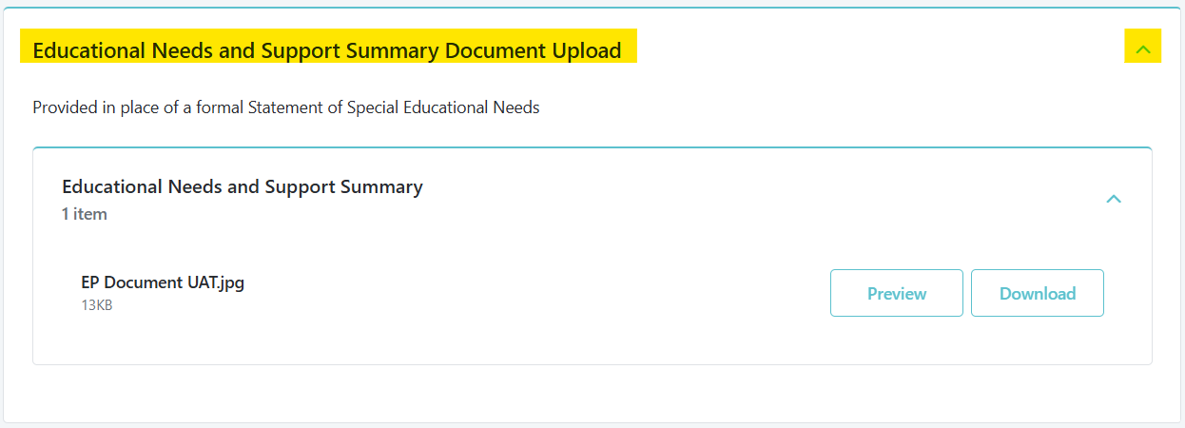

END OF DECISION POINT 2.

