SCHOOLS STATUTORY ASSESSMENT - Quick Reference Guide

Decision Point 3
- Parents must respond to the Proposed Statement to:
  - Agree that the draft is accurate or;
  - Ask for changes or;
  - Ask for a meeting.
- Parents should also state a preference for a school for their child.
- EA consults with the school – this can be current or future school.
- EA issues a final statement.

School - Decision Point 3, Outline Process

School receives email confirming EA is consulting about placement.

Login to EA Connect, navigate to Statutory Assessment screen and select pupil record.
Is this the pupil’s current school or proposed future school?
Review proposed placement details and confirm ability to meet the child’s needs.
Submit response via EA Connect within the 15 day timeframe.


EA will consider the school’s response and either issue a Final Statement naming the school, or explore an alternative placement. Even if a school indicates it cannot provide the required provision, the EA may still name that school in the Final Statement.

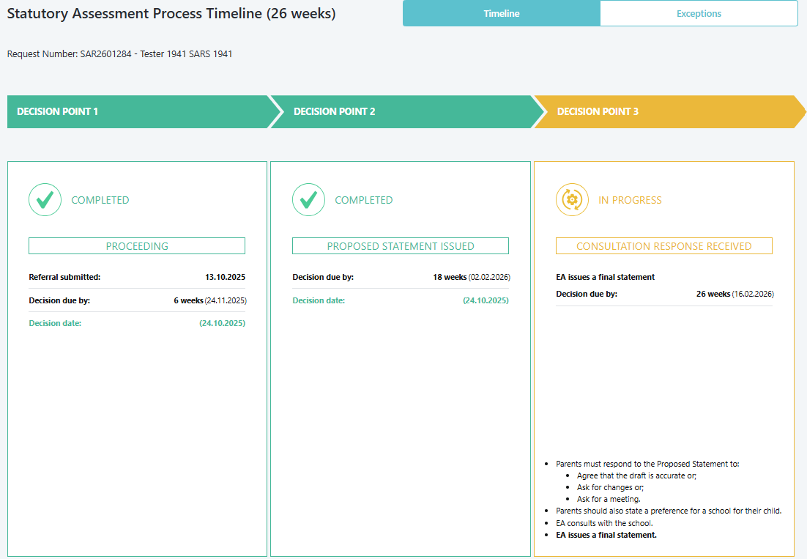

- Login:
Option A,
- On the EA website, click EA Connect Login under Statutory Assessment | SEND Plan.
- Enter your login details and accept the GDPR statement.

Option B,
- Open Google Chrome or Microsoft Edge.
- Go to the EA Connect - Login
- Enter your login details and accept the GDPR statement.
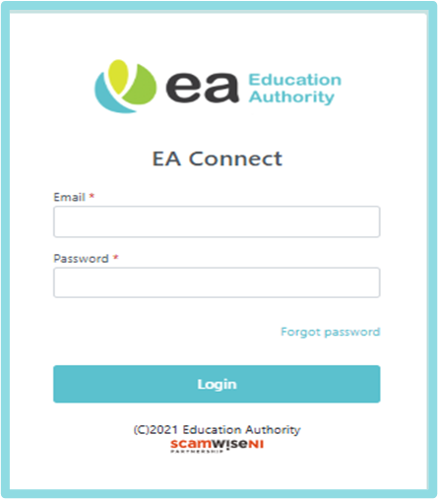

- Access Statutory Assessment Screen :
- Select Menu → Statutory Assessment.
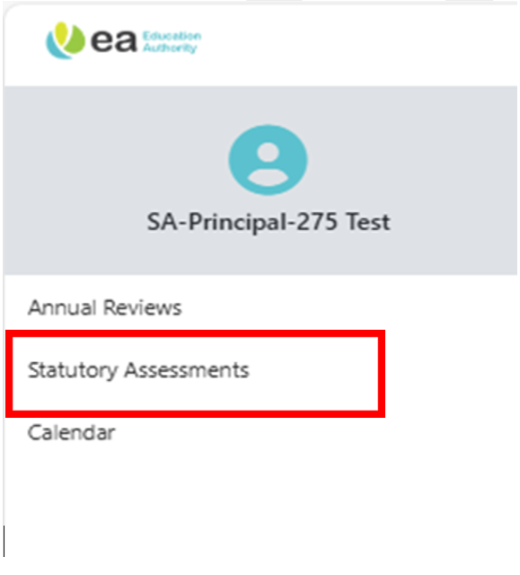

IF DECISION IS TO PROCEED WITH STATEMENT
Statutory vs Non-Statutory Settings:
In a statutory setting (e.g., controlled, maintained, or grant-aided schools), when the Education Authority completes a statutory assessment, it must legally consult the Board of Governors of the school it proposes to name in the child’s Statement. This consultation is carried out through EA Connect, where schools review the Proposed Statement and submit comments. In contrast, a non-statutory setting (e.g., independent or private schools) will receive a separate email and form to provide their consultation response.
Example consultation email:
Dear Principal/SENCo,
The Education Authority has completed a statutory assessment of SEN Tester SA Tester 11’s educational needs and you can access the Proposed Statement and all professional advice received during SEN Tester’s assessment by logging into EA Connect.
The Education Authority is considering specifying the name of your school in the child’s Statement and has a duty to consult the Board of Governors of your school.
In accordance with Article 7(3) of the Education (Northern Ireland) Order 1996, (‘the 1996 Order’), a child with a Statement of Special Educational Needs shall be educated in a mainstream school unless that is incompatible with:
(a) the wishes of their parents; or
(b) the provision of efficient education for other children with whom they would be educated.
Your Board of Governors will only be able to rely on the exception in Article 7(3)(b) if it can show that there are no reasonable steps that it could take to prevent the incompatibility with the provision of efficient education for other children with whom SEN Tester would be educated. Clear evidence must be provided to justify why no reasonable steps can be taken and it is envisaged that it will only be possible to demonstrate this in a small number of cases.
Furthermore, in accordance with Schedule 2 paragraph 5 of the 1996 Order, parents have a right to express a preference for the grant aided school they wish their child to attend. The Education Authority shall comply with this request and will name the parents’ preferred school in Part 4 of the Final Statement unless:
(a) the school is unsuitable to the child’s age, ability or aptitude or to their special educational needs; or
(b) the attendance of the child at the school would be incompatible with the provision of efficient education for the children with whom they would be educated or the efficient use of resources.
In carrying out this consultation exercise the Education Authority would therefore invite you to carefully consider the Proposed Statement of Special Educational Needs and to provide the Education Authority with your comments on the Consultation Form. Any comments you make will be considered by the Education Authority.
What do you need to do:
Log in to EA Connect using the link https://connect.eani.org.uk/school and complete the following steps:
- Navigate to the ‘Statutory Assessment’ page,
- Click on the referral number on the table to open the referral,
- Review the Proposed Statement and supporting professional advice,
- Complete the ‘School Consultation Form’ in the ‘School Consultation’ section,
- Select ‘Submit’ once all details have been recorded.
If you do not respond to the Education Authority within 15 days of receipt of this email, the Education Authority will proceed on the basis that you have no comments to make and the name of your school will be specified in Part 4 of the Statement of Special Educational Needs.
Yours sincerely
SEN Link Officer

School logs into EA Connect portal and navigates to School Consultation section.
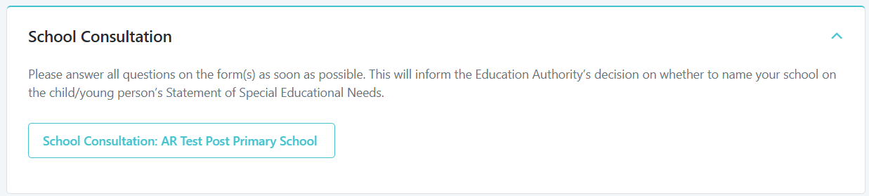
A form will appear for the school to complete and can select to Save and Close or Submit.
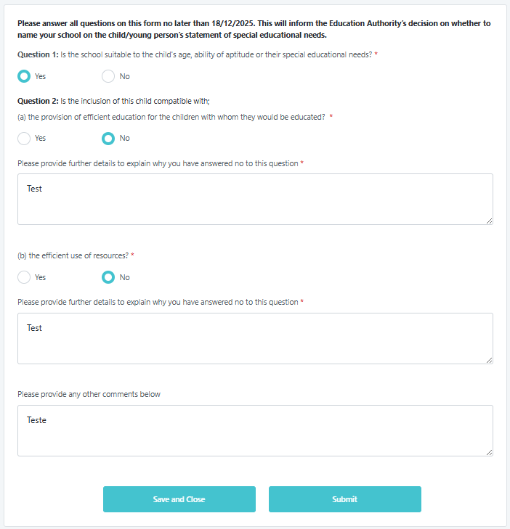

Following the consultation process, the Education Authority may determine to name your school in the child’s Statement. Should this occur, you will receive formal notification (example email below), and the Education Authority will provide a response addressing the concerns outlined in your submitted consultation form.
Subject: Notification of Placement Decision Following Consultation SAR260000
“Dear Principal/SENCo
I refer to your response to the Education Authority’s (EA) consultation for placement for <pupil forename and surname>, <DOB>.
The EA’s Statutory Assessment & Review Service (SARS) notes that the school is of the view that a place cannot be arranged for < pupil forename and surname>.
The placement of children with a Statement of Special Educational Needs is managed by the Statutory Assessment and Review Service (SARS) in accordance with the legislative requirements provided for by the Education and Libraries (Northern Ireland) Order 1986 and the Education (Northern Ireland) Order 1996. Article 44 of the Education and Libraries (Northern Ireland) Order 1986 sets out the general principle that:
‘so far as is compatible with the provision of efficient instruction and training and the avoidance of unreasonable public expenditure, pupils shall be educated in accordance with the wishes of their parents’.
Paragraph 5 of Schedule 2 to the Education (Northern Ireland) Order 1996 provides as follows:
Where (the authority) makes a statement in a case where the parent of the child concerned has expressed a preference in pursuance of such arrangements as to the grant-aided school at which he wishes education to be provided for his child, the (authority) shall specify the name of that school in the statement unless -
The school is unsuitable to the child’s age, ability or aptitude or to his special educational needs, or,
The attendance of the child at the school would be incompatible with the provision of efficient education for the children with whom he would be educated or the efficient use of resources.
The second of the two exceptions is only available to the Board of Governors of the school if it can be shown that there are no reasonable steps that could have been taken to prevent the admission of the pupil with a statement of special educational needs being incompatible with the provision of efficient education for other children. The threshold established through Case Law in terms of incompatibility with the efficient use of resources or incompatibility with efficient instruction is extremely high. The Education Authority must name the parents’ preferred school in Part 4 of the statement unless there is clear evidence that there are no reasonable steps that could be taken to prevent such an incompatibility.
Having considered the reasons outlined in the returned consultation form, the EA would wish to address the concerns raised as follows:
<Reason(s) added here>
SARS therefore considers that <pupil forename and surname> would be appropriately placed in < School Name> and that their special educational needs can be met through the provision as outlined in their statement of special educational needs.
SARS will proceed to issue a Final/Amended Statement of Special Educational Needs naming <school> in Part 4 and confirm placement for <pupil forename> to their parents. <Pupil forename>'s special educational needs and progress will continue to be monitored and kept under review through the Annual Review process.
Yours sincerely
SEN Link Officer

Final Statement issued

The current and new school will be sent emails to confirm the final statement for the pupil.
Example of email sent to Current School:
Final Statement of Special Educational Needs SAR2602024
Dear Principal/SENCo
The Final Statement of Special Educational Needs for SEN Tester: SAR2602024 is now available.
You can view the Final Statement and all professional advice received by clicking the secure link below or by logging into EA Connect:
https://connect.eani.org.uk/school/
To ensure the security of the information, you will be asked to enter the child or young person's surname, and date of birth.
If you have any further queries, please contact me directly.
Yours sincerely
SEN Link Officer

Example of email sent to New School:
Final Statement of Special Educational Needs SAR2602024
Content of email defined as:
Dear Principal/SENCo
The Final Statement of Special Educational Needs for SEN Tester: SAR2602024 is now available.
You can view the Final Statement and all professional advice received by clicking the secure link below or by logging into EA Connect:
https://connect.eani.org.uk/school/
To ensure the security of the information, you will be asked to enter the child or young person's surname, and date of birth.
If you have any further queries, please contact me directly.
Yours sincerely
SEN Link Officer

The schools can click on the link in the email and enter in the child’s surname and date of birth to access the Final Statement and Advices and Documents for the pupil.
Alternatively, the schools can log into EA Connect and access the ‘Final Statement’ and ‘Advices and Documents’ and click on arrows on right hand side to access any of the sections.
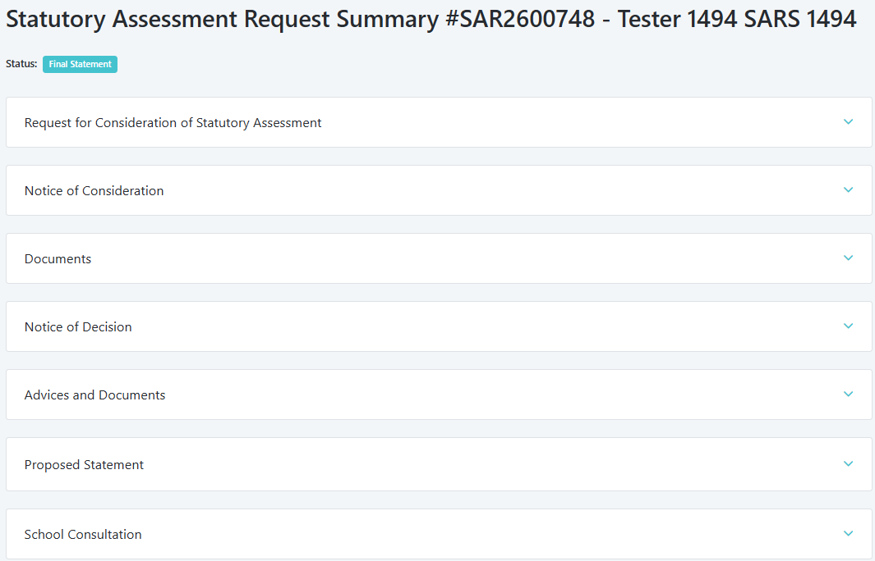

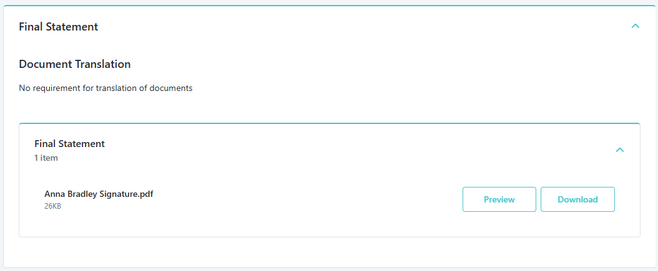
END OF DECISION POINT 3.

