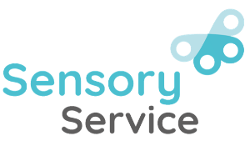
EA Sensory Service – Vision Impairment

Hemianopia

What is hemianopia?

- Hemianopia is a condition that causes blindness in one half of the visual field.
- Hemianopia affects the visual fields in both eyes. It is characterised by a visual field loss on the same side, in both eyes, e.g., right-sided hemianopia means that vision is lost on the right visual field in both eyes. This is different from having blindness in one eye (monocular vision)
- It is sometimes known as homonymous hemianopia
- Hemianopia can affect the right or left side.
- Visual acuity in remaining visual field may be normal.
- It is a type of cerebral vision impairment (CVI). Hemianopia is caused by problems in the brain, often by strokes, tumours and other conditions that affect the areas of the brain that process visual information.
- This means that Hemianopia is caused by a problem in the brain rather than any structural problem with the eyes.

What are the effects of hemianopia?

- Children with a hemianopia will often adopt a head posture to shift their remaining field of vision to the middle.
- Visual field restrictions mean that the pupil may not be aware of people or objects in their affected field, and they may be inclined to bump into objects on their “non-seeing” side, especially when in an unfamiliar environment.
- Children with right-sided hemianopia have difficulty reading left-to-right efficiently, because they cannot see the next few letters or words, as they move their eyes along the page.
- Children with left-sided hemianopia can have difficulty finding the next line of text or beginning of lines or words.
- Safety during mobility is an especially important consideration for pupils with visual field loss. Visual Field loss impedes safety when crossing roads, it makes individuals vulnerable to colliding with doorframes, or objects that protrude on their “non seeing” side, and it can make it exceedingly difficult to navigate in crowded areas etc.

What can help?

- Ensure correct positioning in classroom allowing the student to access the board or teacher without having to turn their head.
- Individuals often develop head turns or tilts to aid in scanning into the “non-seeing” field. Consistent head turns/tilts can indicate that they have found their own way to adapt to the field loss. The child may tilt a page they are reading or writing on to see the whole surface better.
- When facing the front of the classroom and the teacher, seat the child with a right field loss to the RIGHT facing the front, with the teacher on their LEFT. Seat the child with a left field loss to the LEFT facing front with the teacher on their RIGHT.
- Ensure that the student is aware of the entire piece of paper on which she/he is writing or drawing.
- When reading, mark materials so that the reader will know where to start or stop e.g., putting a green dot at the start of a line and a red dot at the end of a line.
- A line along the right margin of a page will help with right side vision loss.
- Turn the paper by 90 degrees, so that the eyes can read down rather than horizontally.
- Cover the beginning of words or lines as you read
- Put a finger at the end of each line of reading
- Columns of text may be easier to read than whole pages of un-columned text.
- Reading words that scroll across a screen. This website has a tool to help with this
- Placement of the keyboard for computer use should be so that neither the keyboard nor the computer screen is far in the non-seeing field. Placement should be consistent so that the student can anticipate where to look and place the fingers for typing.
- Children should be encouraged to carry out a systematic approach to scanning at various distances and across activities and environments to check for potential hazards.

Hemianopia simulations

The images below simulate right sided hemianopia. The third image shows what someone with right sided hemianopia will see compared to someone with a full visual field as simulated in image one.
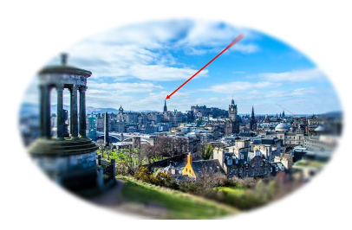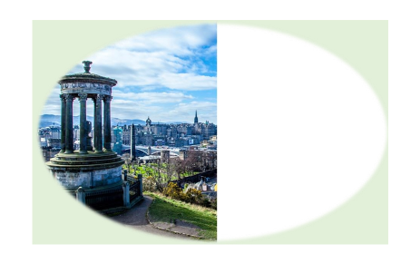

The images below simulate right and left sided hemianopia.
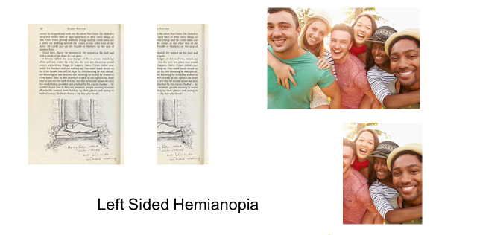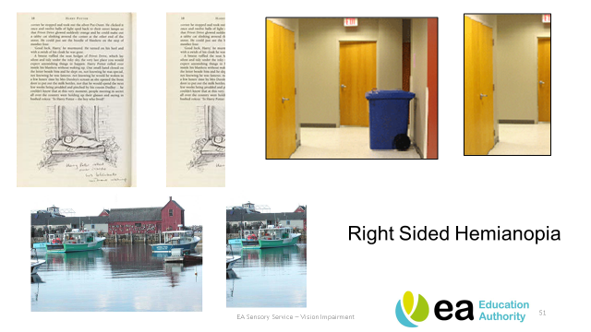
When a child is referred to the Sensory Service, a Qualified Teacher of the Vision Impaired (QTVI) will assess their functional vision within the school environment and provide advice to the school regarding strategies for curriculum access and independent learning.

Useful contacts

EA Sensory Service
Tel: 028 9031 7777- Select Option 2
Email: sensoryservice@eani.org.uk

Website: Vision Impairment and Deafness | SEND Plan (eani.org.uk)

